

City University of Hong Kong

Department of Computer Science

CS3343 Software Engineering Practice

2024 - 25 Semester A

**CityU Cinema System**

**Test Report**

**Group 2**

**Name SID**

CHAN Ka Hong 57845658

FUNG Wing Ho 56755919

LAW Lok Hang 57842515

NG Ka Ho 56652261

WONG Tsz Kin 57847086

Contents

**1. Testing Module Organization** 3

**2. Testing Plans and Strategies** 3

**2.1 White Box Testing: Bottom-up Approach** 3

**2.2 Black-box Testing: System Test** 5

**3. Test Coverage** 5

**4. Test Cases** 5

# **1. Testing Module Organization**

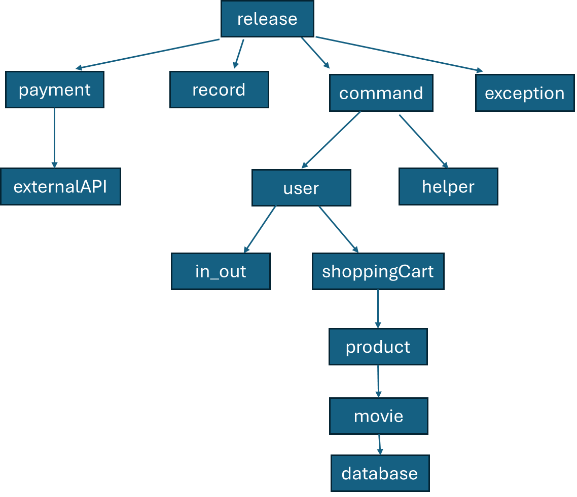

Our testing methodology adopts the bottom-up approach, starting from the lower-level modules towards the higher-level modules. It in general aligns with the package module hierarchy as shown in the figure above.

# **2. Testing Plans and Strategies**

## **2.1 White Box Testing: Bottom-up Approach**

White box testing involves testing the internal structures or functionalities of a program, where the testers have knowledge of the internal code, architecture, and logic. Our test cases are designed based on an understanding of the code and often involve examining the flow of inputs and outputs through the system, testing specific paths, conditions, loops, and statements. Typical techniques include unit testing, which tests individual components or functions for correctness; integration testing, which tests the interaction between integrated units or components; code coverage analysis, which assesses which parts of the code were executed during testing.

For white-box testing, our team have adopted the bottom-up testing approach. Basically, bottom-up testing is an integration testing strategy that starts testing from the lowest level modules, and when these lower-level test cases are passed, we move upwards to gradually test other higher-level functions that depend on these lower-level modules. Lower-level functions are integrated with the higher-level functions throughout the testing process.

There are several reasons for our team to adopt the bottom-up test strategy:

1. We ensure defects can be detected early. Since our design is quite complex that involves various modules such as User, Movie, Payment, etc., with each having many low-level methods. By performing unit testing on these lower-level components at an early stage, we can identify possible issues early and ease our debugging process.

2. With early test on lower-level modules and once they have passed the unit tests, we can affirm they are working properly. This encourages the development and reuse of these lower-level components in subsequent integration. Also, with each level being tested and working correctly, we build a solid foundation ready for smooth integration and subsequent testings.

3. In our design, certain algorithms may be quite complex such as the algorithms for scheduling movies. Thus, they benefit from bottom-up testing as it allows for the verification of individual algorithms and functions before they are integrated into higher-level processes.

4. As we have adopted the agile development approach, which is iterative and incremental, it aligns well with bottom-up testing strategy for it allows for the gradual assembly and verification of the system, making it easier to isolate and address issues early in the development cycle.

In fact, there are many other testing strategies which our team have discussed and considered during the early planning phase. However, due to their drawbacks and incompatibility with our development and testing methodologies, we have eventually given up these other options. For example, the top-down test strategy would require test stubs, which, for the limited time allowed for our project, we have decided it is not the most optimal testing solution. Moreover, as mentioned, we have quite a lot of modules having many low-level methods. These methods should be tested as soon as possible to ensure correctness. The top-down approach will usually test these low-level methods at a very late stage, which may make issues only to be discovered at the very end.

Another common and less organized approach is the big bang test, which involves integrating all components or modules simultaneously. Similarly, we also deem it not suitable for our project as debugging could prove difficult due to the simultaneous integration of multiple modules at once. Considering the fact that we have quite a number of modules and classes, integrating them in an incremental and step-by-step fashion looks more appropriate. Moreover, it is not too agile as it lacks incremental test progress.

## **2.2 Black-box Testing: System Test**

Contrary to white box testing, black box testing focuses on testing the functionality of an application without any knowledge of its internal code structure. Testers evaluate the system solely based on the inputs and expected outputs, disregarding the internal workings. This approach tests the software from an end-user perspective.

In our program, we are using black-box testing to test the command module and main function rather than the white box testing. This is because the command and main modules are primarily concerned with I/O operations (e.g., printing to the console or handling user input). Testing these modules using system tests focuses on whether they meet the functional requirements from an external perspective, which aligns well with black-box testing principles. On the contrary, designing JUnit tests for I/O-heavy functions can be cumbersome and less effective because the tests would involve mocking or capturing console output extensively, which might not add value.

When we conduct black-box testing to the command and main modules, we would execute each use case scenario, and the observed output is compared against the expected results. The system test ensures that the modules meet the specified use cases and behave correctly under normal and edge conditions.

# **3. Test Coverage**

We are focusing on statement coverage strategy, and there are 324 test cases employed in total. The test coverage screenshot below:

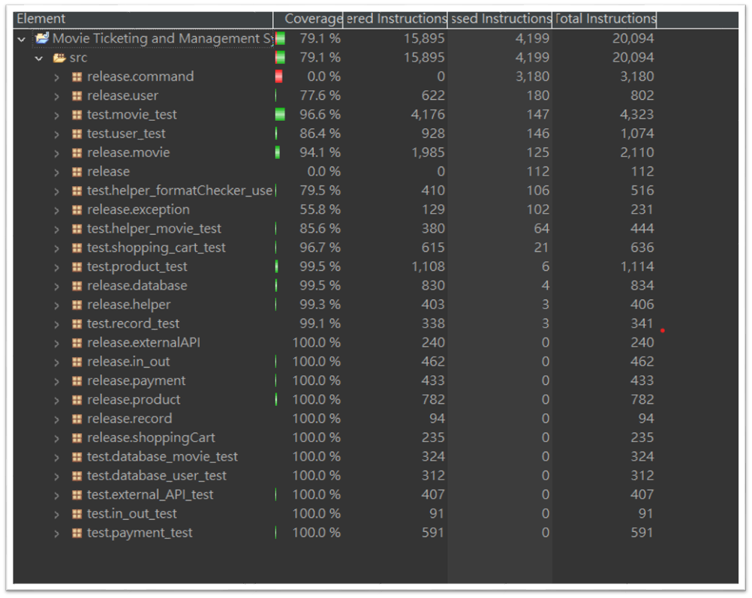

Here, we are attaining almost 80 % coverage, and the reason why the command module and main function (release module) got 0 % coverage are already mentioned in the previous testing plans and strategy section.

# **4. Test Cases**

**DatabaseUserTest.java (Package database_user_test)**

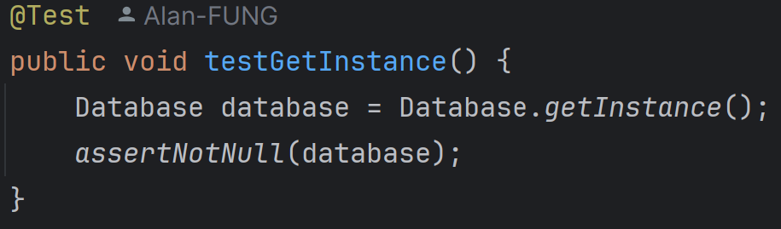

1. testGetInstance:

It verifies that the getInstance method returns a non-null instance of the Database class.

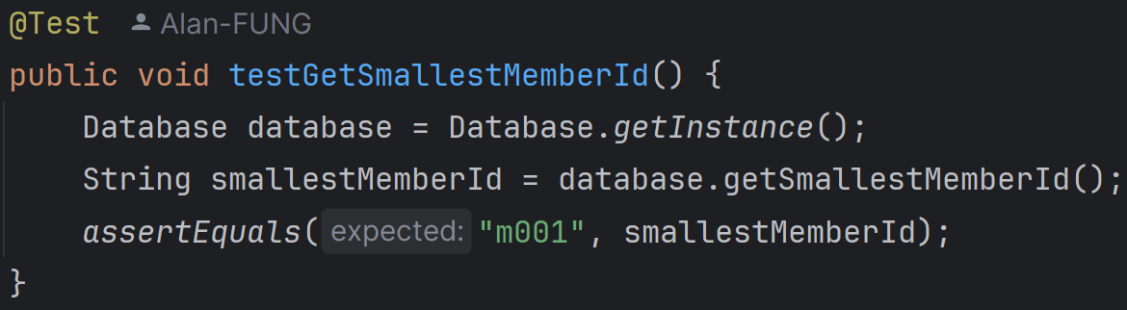

2. testGetSmallestMemberId:

It checks that the smallest available member ID is correctly formatted as "m001".

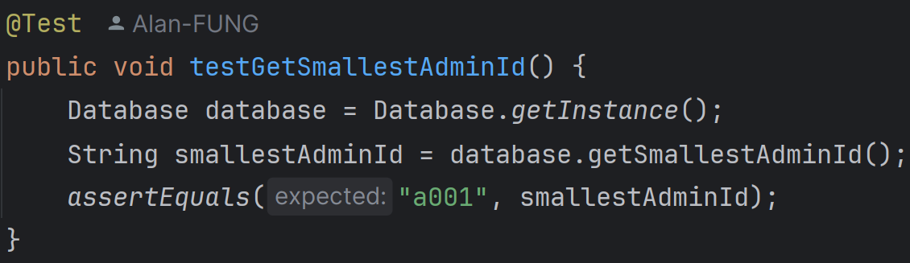

3. testGetSmallestAdminId:

It checks that the smallest available admin ID is correctly formatted as "a001".

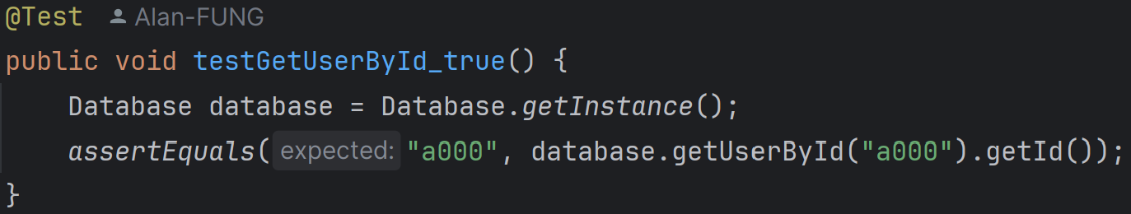

4. testGetUserById_true:

It ensures that the user with ID "a000" (default admin) can be retrieved correctly.

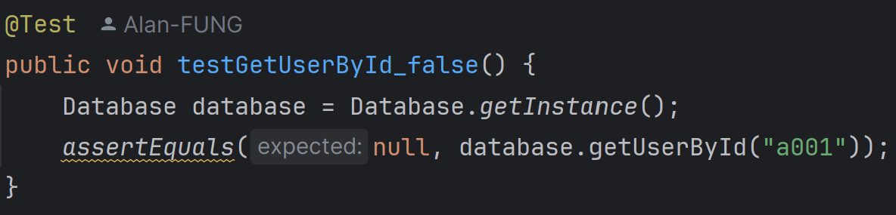

5. testGetUserById_false:

It ensures that attempting to retrieve a non-existent user (ID "a001") returns null.

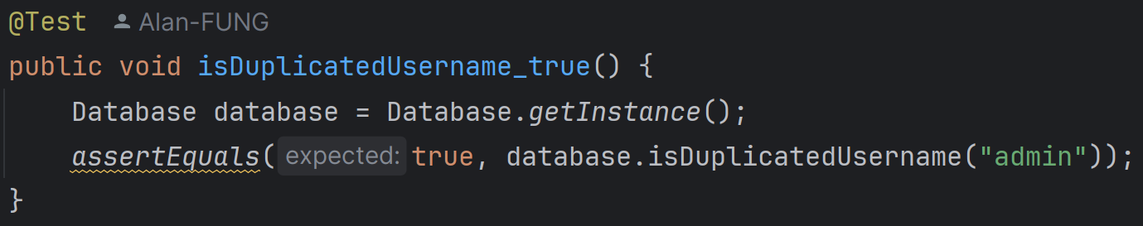

6. isDuplicatedUsername_true:

It verifies that the username "admin" is recognized as a duplicate.

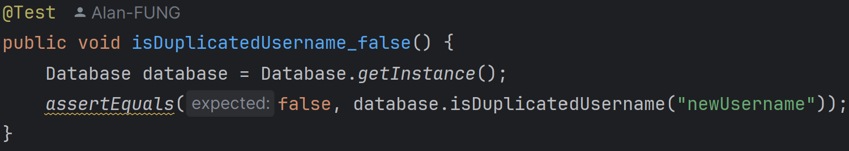

7. isDuplicatedUsername_false:

It verifies that a new username "newUsername" is not recognized as a duplicate.

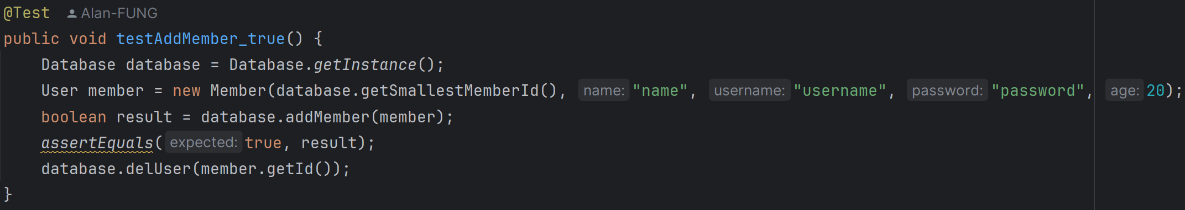

8. testAddMember_true:

It checks that a new member can be added successfully and then deletes the member.

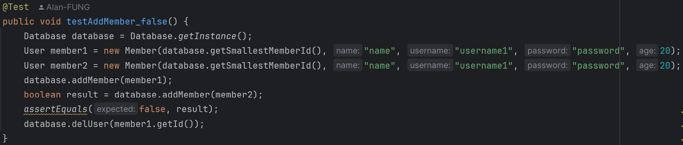

9. testAddMember_false:

It ensures that adding a member with a duplicate username fails.

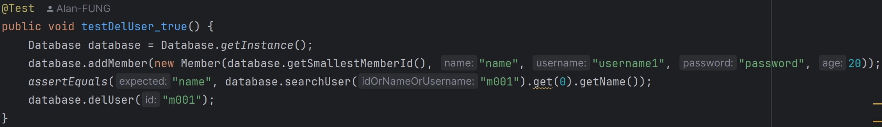

10. testDelUser_true:

It verifies that a user can be deleted successfully and checks the user's name before deletion.

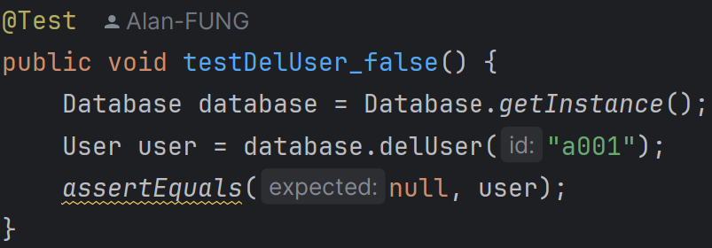

11. testDelUser_false:

It ensures that attempting to delete a non-existent user (ID "a001") returns null.

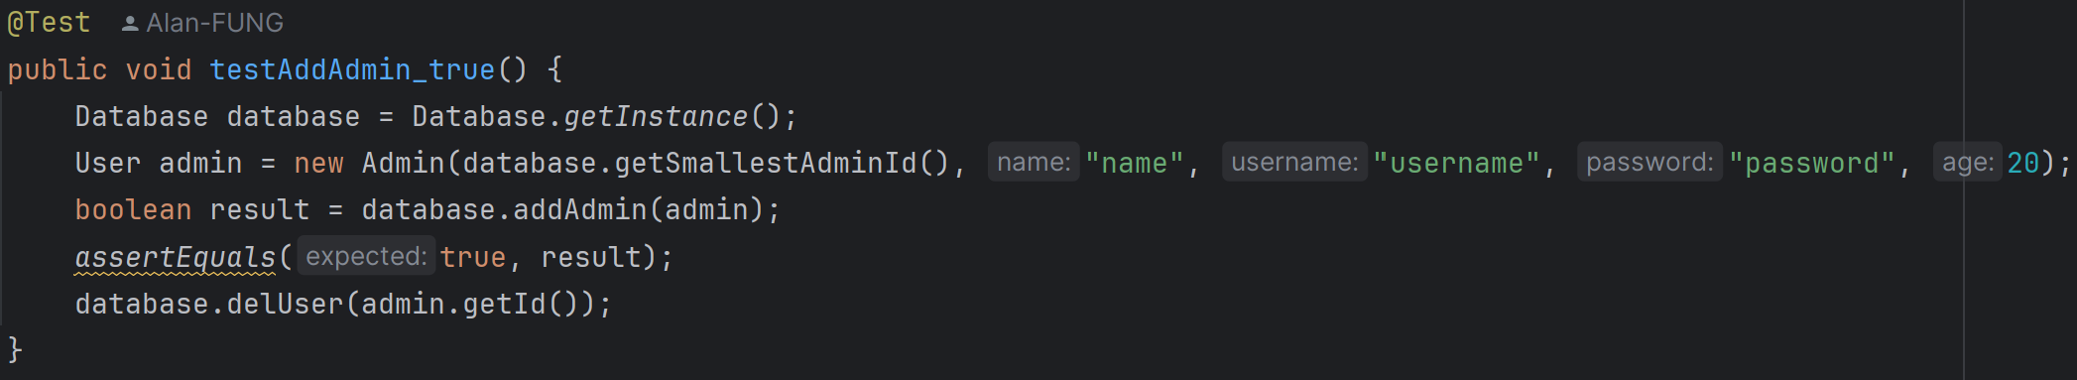

12. testAddAdmin_true:

It checks that a new admin can be added successfully and then deletes the admin.

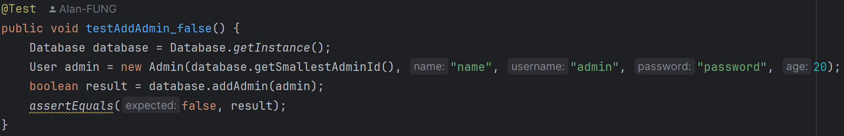

13. testAddAdmin_false:

It ensures that adding an admin with a duplicate username fails.

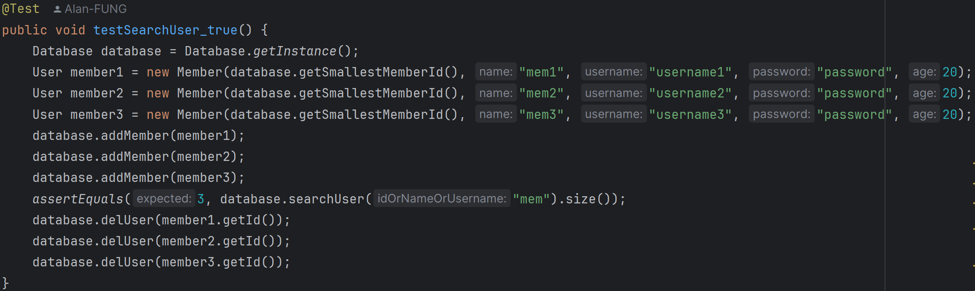

14. testSearchUser_true:

It verifies that searching for users by a partial name returns the correct number of users.

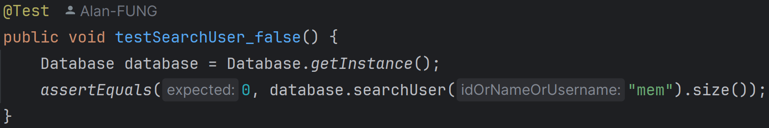

15. testSearchUser_false:

It ensures that searching for a non-existent user returns an empty list.

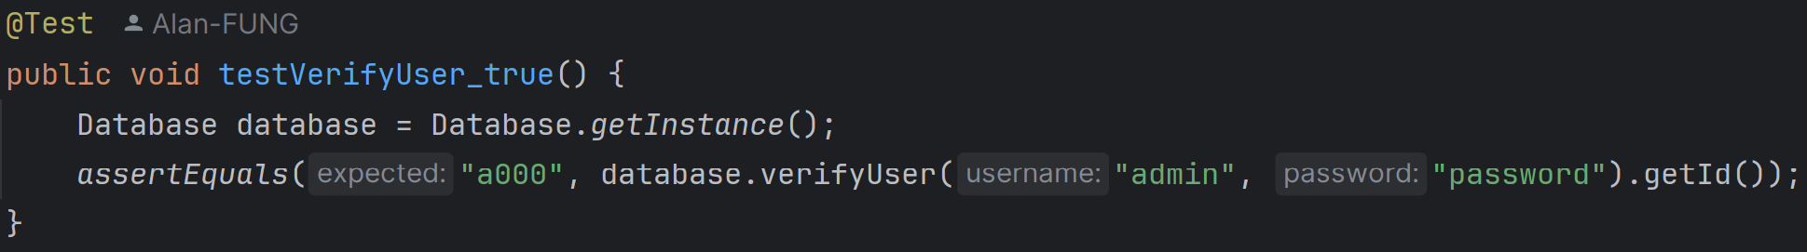

16. testVerifyUser_true:

It verifies that the default admin user can be authenticated with the correct username and password.

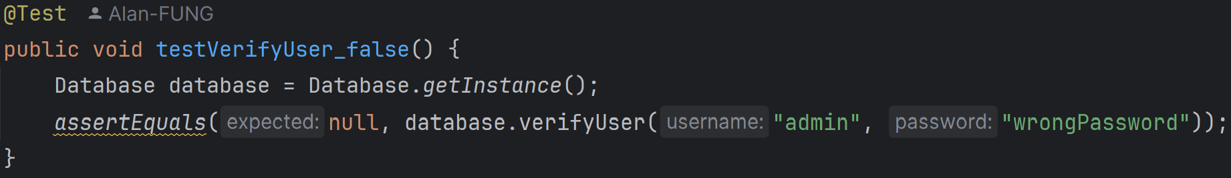

17. testVerifyUser_false:

It ensures that authentication fails with an incorrect password for the default admin user.

**DatabaseTest.java (Package database_movie_test)**

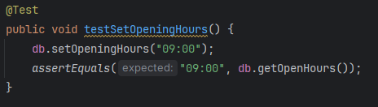

1. testSetOpeningHours:

It sets the opening hours of the database to "09:00" and asserts that the opening hours are correctly set.

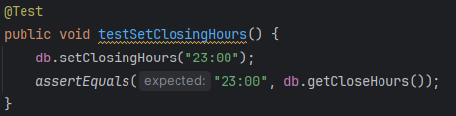

1. testSetClosingHours:

It sets the closing hours of the database to "23:00" and asserts that the closing hours are correctly set.

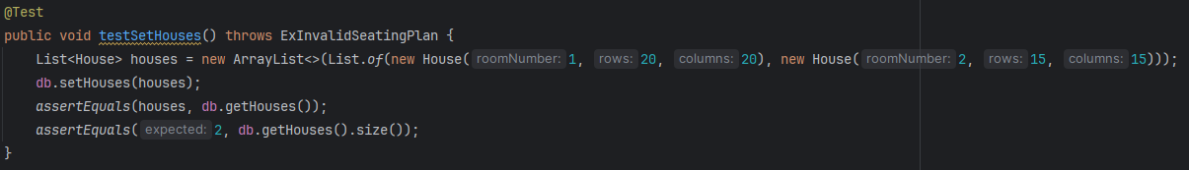

1. testSetHouses:

It creates a list of House objects and sets it in the database and asserts that the houses are correctly set and the size of the list is as expected.

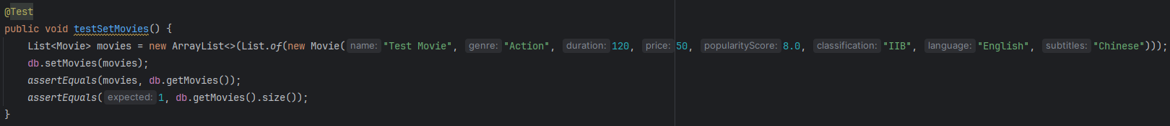

1. testSetMovies:

It creates a list of Movie objects and sets it in the database and asserts that the movies are correctly set and the size of the list is as expected.

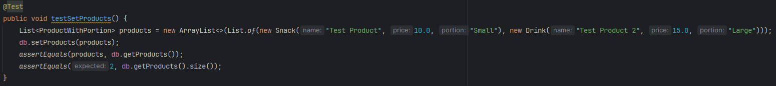

1. testSetProducts:

It creates a list of ProductWithPortion objects (snacks and drinks) and sets it in the database. It asserts that the products are correctly set and the size of the list is as expected.

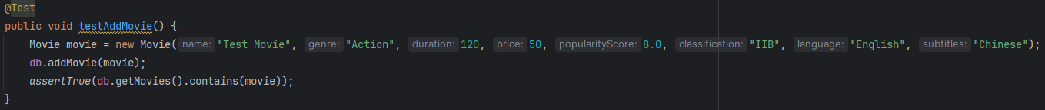

1. testAddMovie:

It adds a Movie object to the database and asserts that the movie is successfully added to the list of movies in the database.

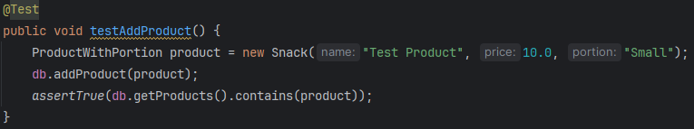

1. testAddProduct:

It adds a ProductWithPortion object (snack) to the database and asserts that the product is successfully added to the list of products in the database.

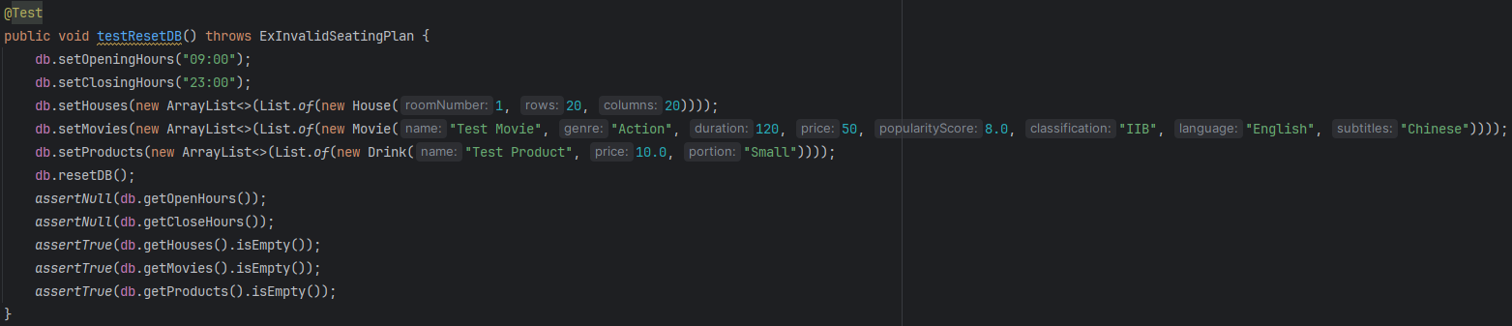

1. testResetDB:

It sets various properties of the database (opening hours, closing hours, houses, movies, products), then resets the database. It asserts that all properties are reset to their initial state (null or empty).

**DefaultDataTest.java (Package database_movie_test)**

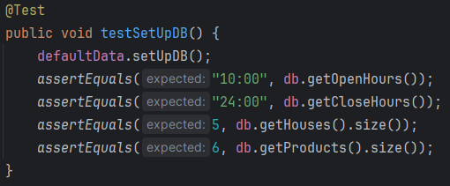

1. testSetUpDB:

This test verifies that the setUpDB method correctly initializes the database with the default opening hours, closing hours, houses, and products.

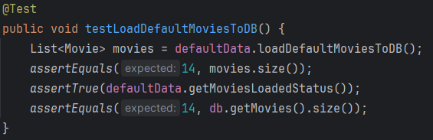

1. testLoadDefaultMoviesToDB:

This test verifies that the loadDefaultMoviesToDB method correctly loads the default movies into the database.

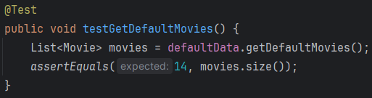

1. testGetDefaultMovies:

This test verifies that the getDefaultMovies method returns the correct list of default movies.

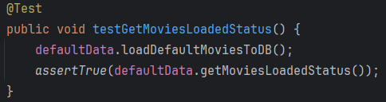

1. testGetMoviesLoadedStatus:

This test verifies that the getMoviesLoadedStatus method correctly returns the status of whether the movies have been loaded into the database.

**AlipayAPITest.java (Package external_API_test)**

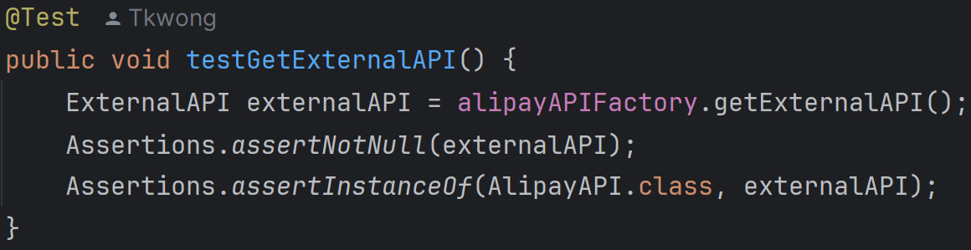

1. testGetExternalAPI:

This test checks if the AlipayAPIFactory can create an instance of AlipayAPI. It asserts that the created instance is not null and is of type AlipayAPI.

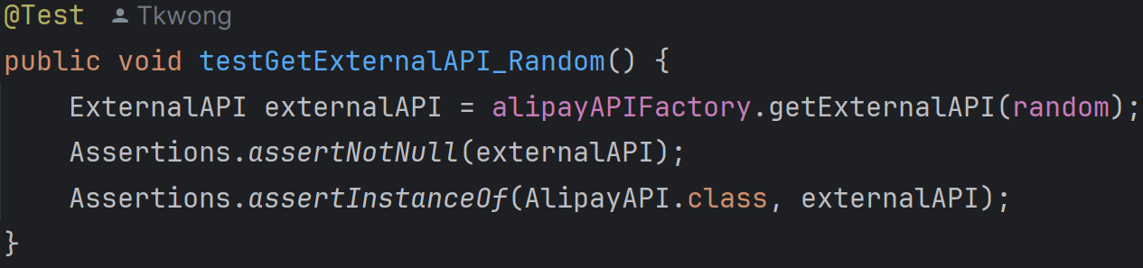

2. testGetExternalAPI_Random:

This test checks if the AlipayAPIFactory can create an instance of AlipayAPI using a provided Random object. It asserts that the created instance is not null and is of type AlipayAPI.

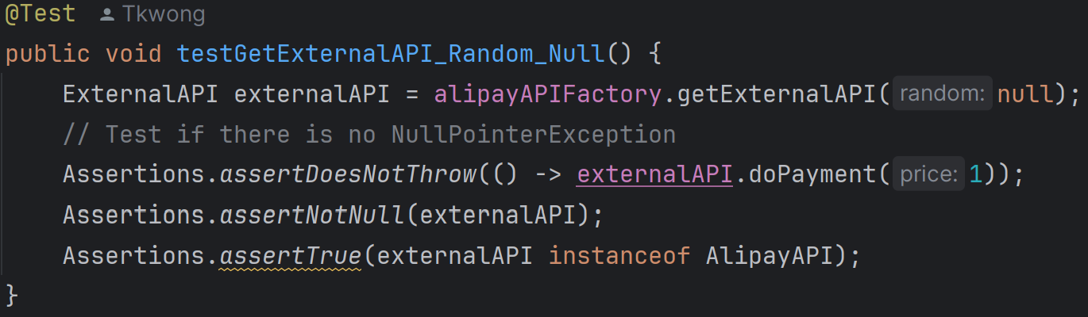

3. testGetExternalAPI_Random_Null:

This test checks if the AlipayAPIFactory can handle a null Random object. It asserts that no NullPointerException is thrown when calling doPayment and that the created instance is not null and is of type AlipayAPI.

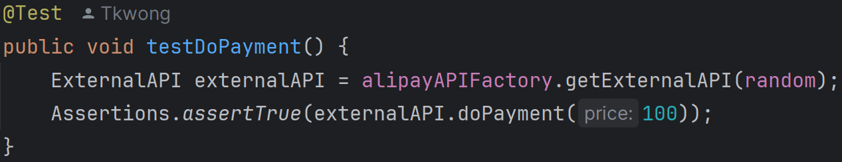

4. testDoPayment:

This test checks if the AlipayAPI can successfully process a payment. It asserts that the payment is successful when the price is 100, as the random number generated should be greater than or equal to the price.

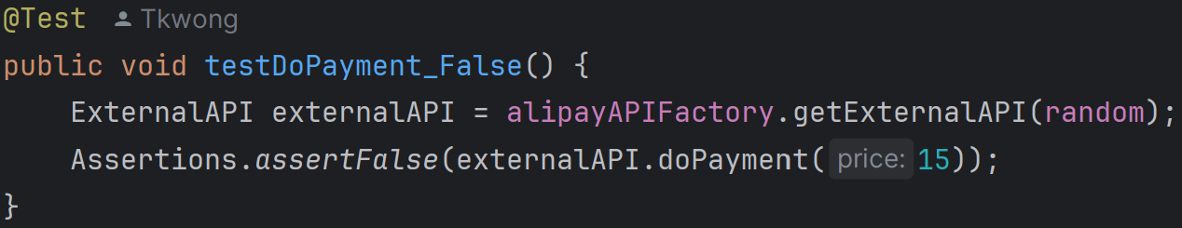

5. testDoPayment_False:

This test checks if the AlipayAPI can handle an unsuccessful payment. It asserts that the payment is not successful when the price is 15, as the random number generated should be less than the price.

**CreditCardAPITest.java (Package external_API_test)**

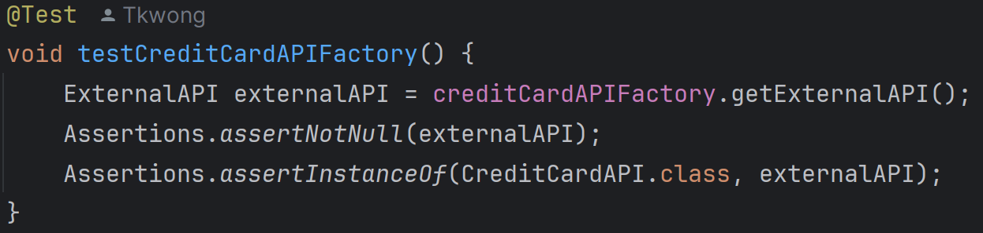

1. testCreditCardAPIFactory:

It tests if the CreditCardAPIFactory can create an instance of CreditCardAPI. It ensures that the factory returns a non-null instance and that the instance is of type CreditCardAPI.

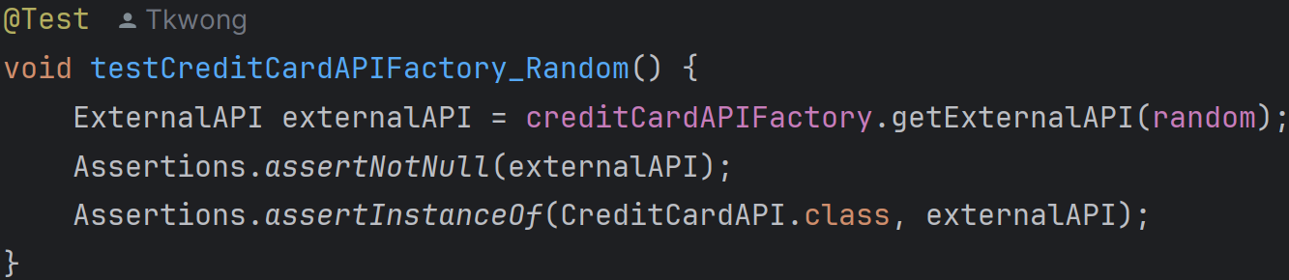

2. testCreditCardAPIFactory_Random:

It tests if the CreditCardAPIFactory can create an instance of CreditCardAPI with a provided Random object. It ensures that the factory returns a non-null instance and that the instance is of type CreditCardAPI.

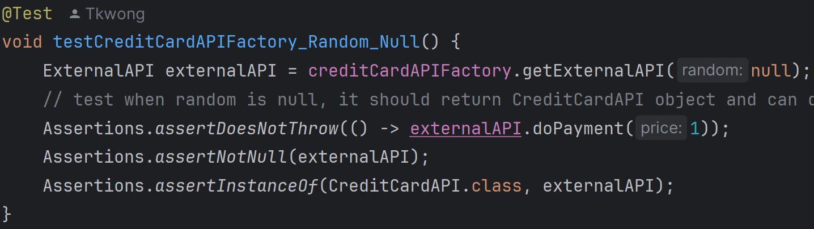

3. testCreditCardAPIFactory_Random_Null:

It tests if the CreditCardAPIFactory can create an instance of CreditCardAPI with a null Random object. It ensures that the method does not throw a NullPointerException, the factory returns a non-null instance, and the instance is of type CreditCardAPI.

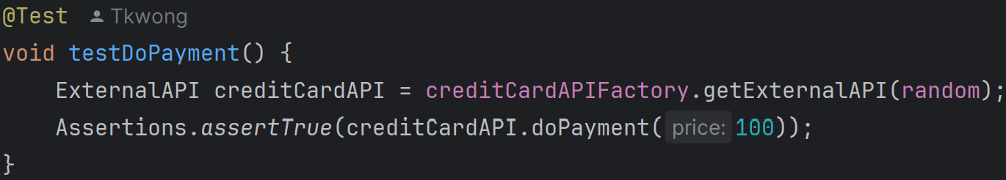

4. testDoPayment:

It tests if the CreditCardAPI can successfully process a payment. It ensures that the payment is successful when the price is 100.

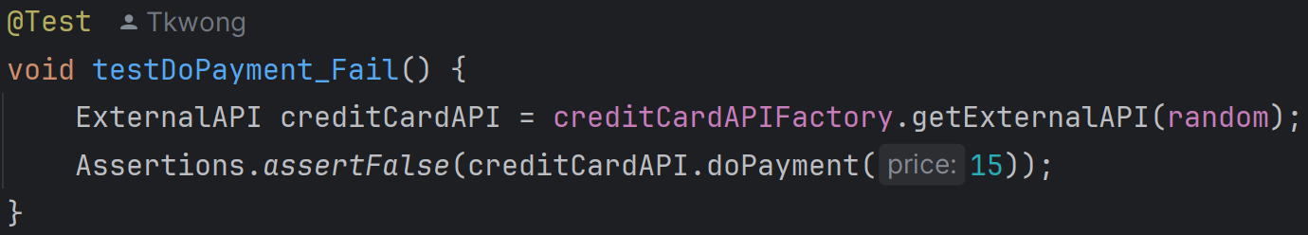

5. testDoPayment_Fail:

It tests if the CreditCardAPI can fail to process a payment. It ensures that the payment fails when the price is 15.

**OctopusAPITest.java (Package external_API_test)**

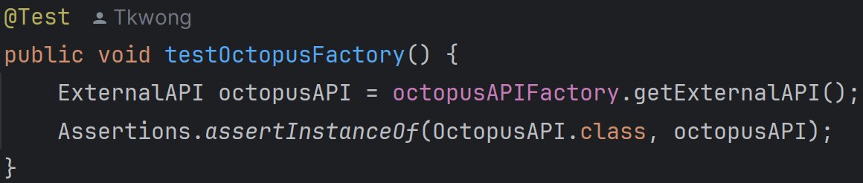

1. testOctopusFactory:

This test verifies that the OctopusAPIFactory can create an instance of OctopusAPI. It calls octopusAPIFactory.getExternalAPI() and asserts that the returned object is an instance of OctopusAPI.

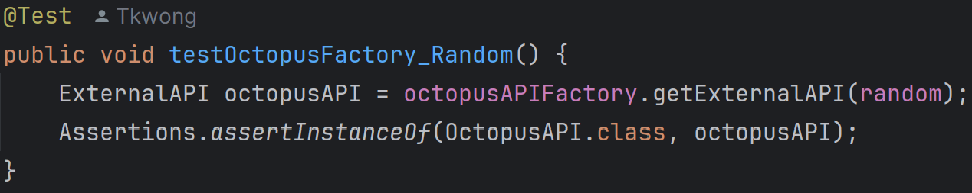

2. testOctopusFactory_Random:

This test checks if the OctopusAPIFactory can create an instance of OctopusAPI using a provided Random object. It calls octopusAPIFactory.getExternalAPI(random) and asserts that the returned object is an instance of OctopusAPI.

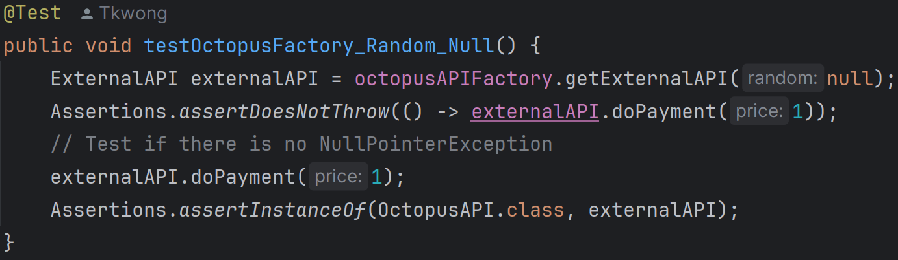

3. testOctopusFactory_Random_Null:

This test ensures that the OctopusAPIFactory can handle a null Random object without throwing a NullPointerException. It calls octopusAPIFactory.getExternalAPI(null), performs a payment operation to check for exceptions, and asserts that the returned object is an instance of OctopusAPI.

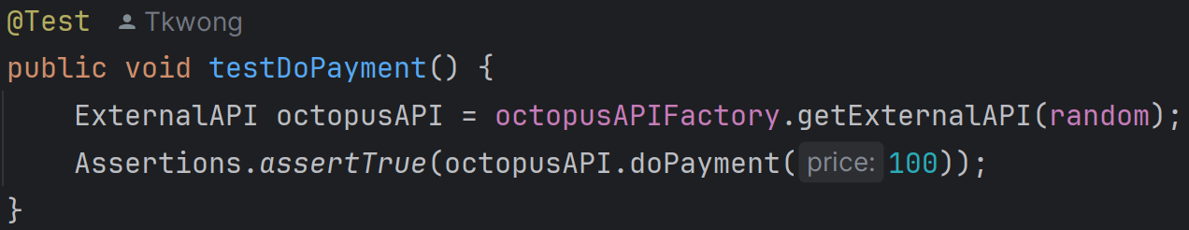

4. testDoPayment:

This test verifies the doPayment method of OctopusAPI for a successful payment scenario. It creates an OctopusAPI instance using the factory and a Random object, then asserts that doPayment(100) returns true.

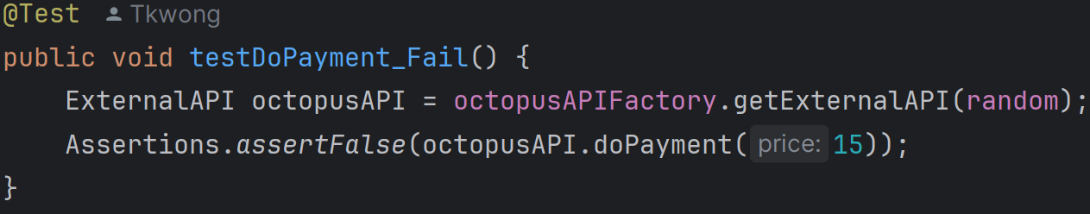

5. testDoPayment_Fail:

This test checks the doPayment method of OctopusAPI for an unsuccessful payment scenario. It creates an OctopusAPI instance using the factory and a Random object, then asserts that doPayment(15) returns false.

**PayMeAPITest.java (Package external_API_test)**

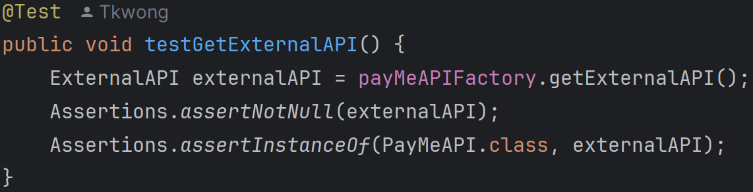

1. testGetExternalAPI:

This test verifies that the PayMeAPIFactory can create an instance of PayMeAPI without any parameters. It checks that the created instance is not null and is of type PayMeAPI.

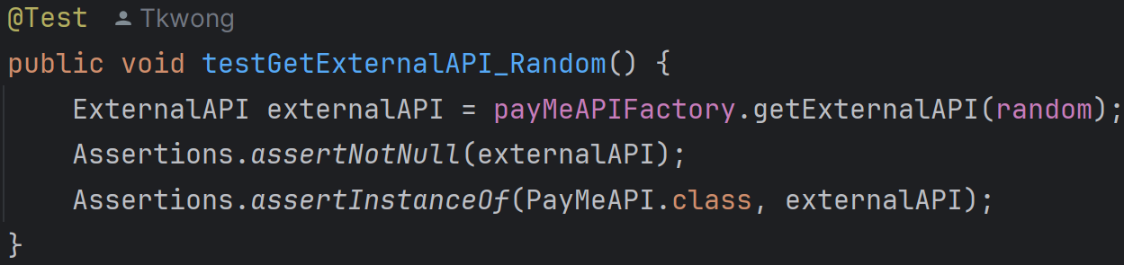

2. testGetExternalAPI_Random:

This test verifies that the PayMeAPIFactory can create an instance of PayMeAPI when provided with a Random object. It checks that the created instance is not null and is of type PayMeAPI.

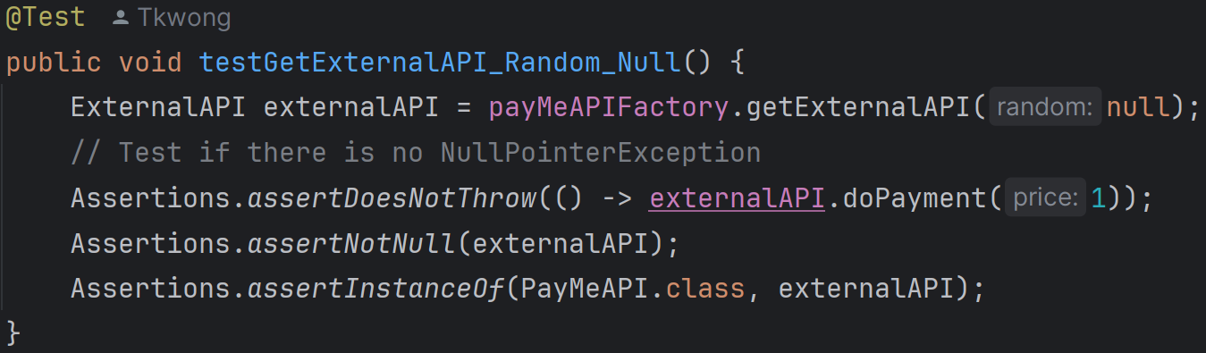

3. testGetExternalAPI_Random_Null:

This test verifies that the PayMeAPIFactory can create an instance of PayMeAPI when provided with a null Random object. It ensures that the method does not throw a NullPointerException and that the created instance is not null and is of type PayMeAPI.

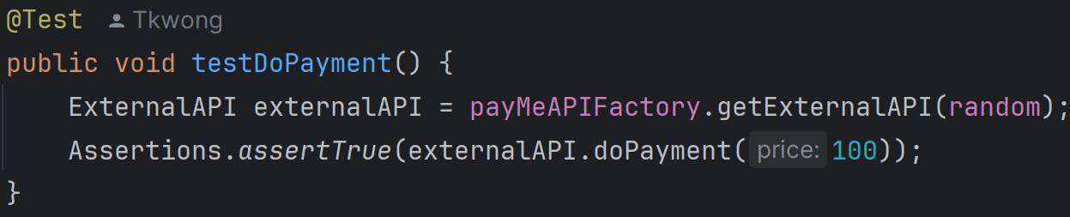

4. testDoPayment:

This test verifies the doPayment method of PayMeAPI. It checks that the payment is successful (returns true) when the price is 100, assuming the random number generated is greater than or equal to 100.

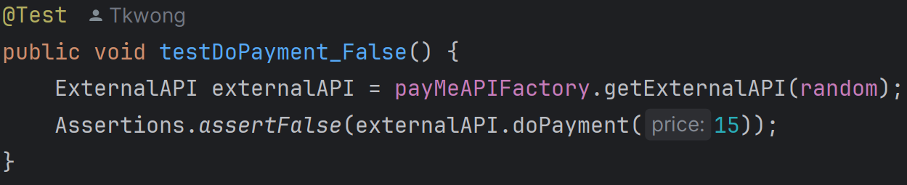

5. testDoPayment_False:

This test verifies the doPayment method of PayMeAPI. It checks that the payment is unsuccessful (returns false) when the price is 15, assuming the random number generated is less than 15.

**WeChatPayAPITest.java (Package external_API_test)**

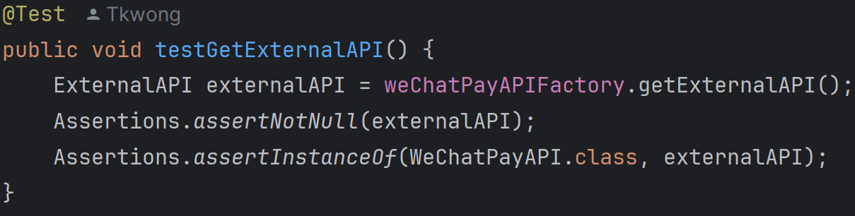

1. testGetExternalAPI:

This test verifies that the WeChatPayAPIFactory can create an instance of WeChatPayAPI without any parameters. It checks that the created object is not null and is an instance of WeChatPayAPI.

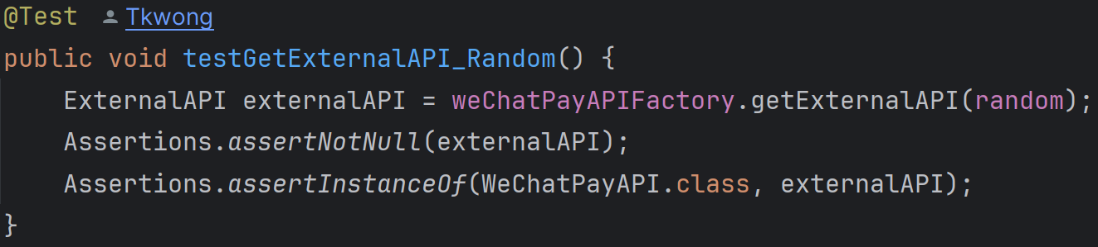

2. testGetExternalAPI_Random:

This test verifies that the WeChatPayAPIFactory can create an instance of WeChatPayAPI using a provided Random object. It checks that the created object is not null and is an instance of WeChatPayAPI.

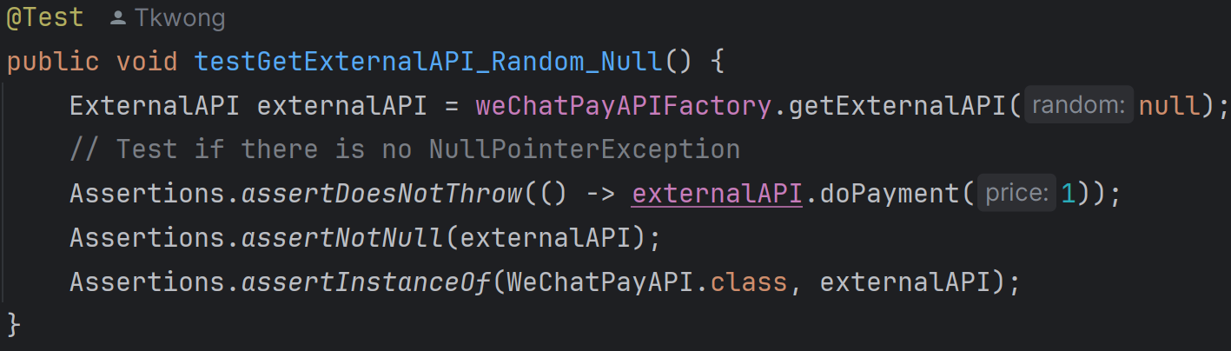

3. testGetExternalAPI_Random_Null:

This test verifies that the WeChatPayAPIFactory can create an instance of WeChatPayAPI even when a null Random object is provided. It ensures that the method does not throw a NullPointerException and that the created object is not null and is an instance of WeChatPayAPI.

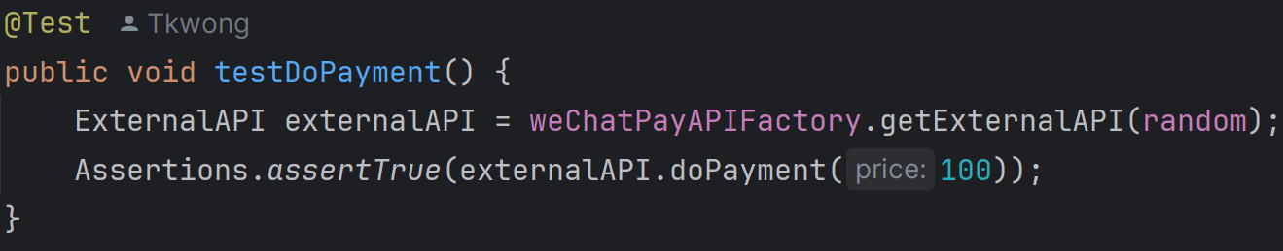

4. testDoPayment:

This test verifies the doPayment method of WeChatPayAPI when the price is 100. It checks that the payment is successful (returns true), assuming the random number generated is greater than or equal to the price.

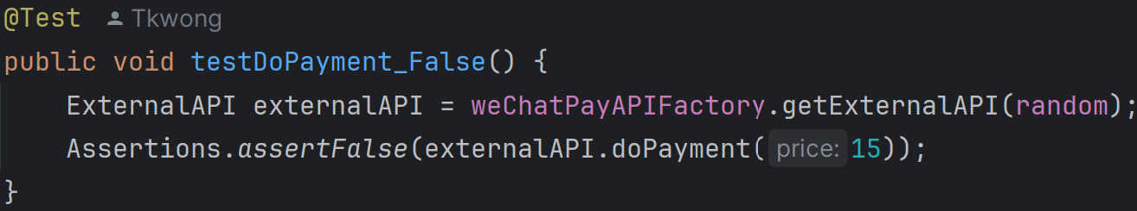

5. testDoPayment_False:

This test verifies the doPayment method of WeChatPayAPI when the price is 15. It checks that the payment fails (returns false), assuming the random number generated is less than the price.

**FormatCheckerUserTest.java (Package helper_formatChecker_user_test)**

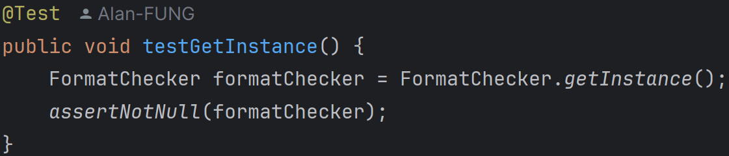

1. testGetInstance:

It ensures that the getInstance method returns a non-null FormatChecker instance.

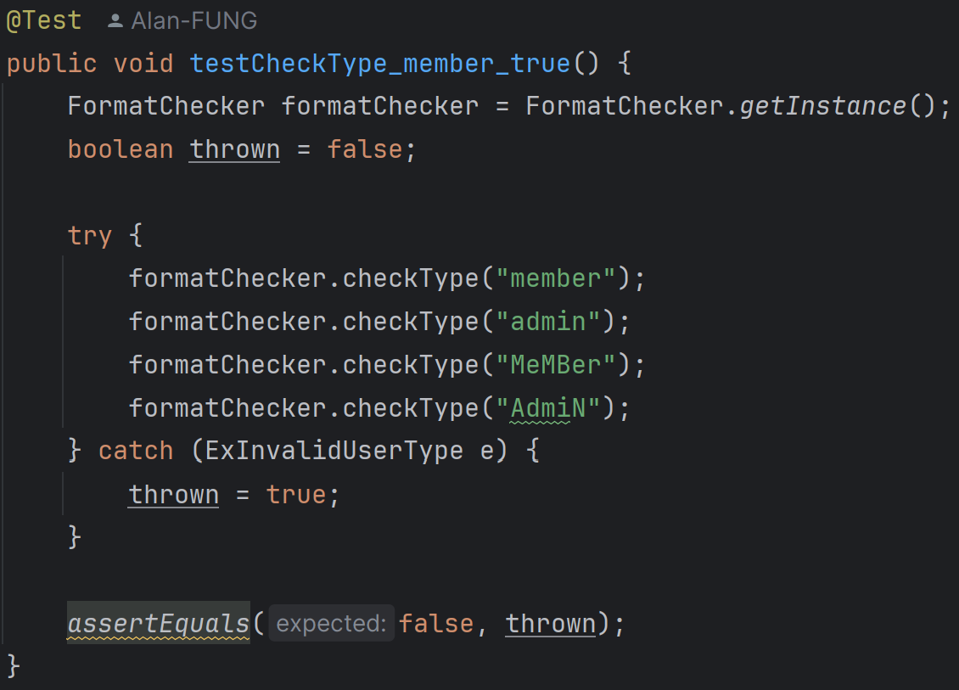

2. testCheckType_member_true:

It verifies that valid user types ("member", "admin", and their case-insensitive variations) do not throw an ExInvalidUserType exception.

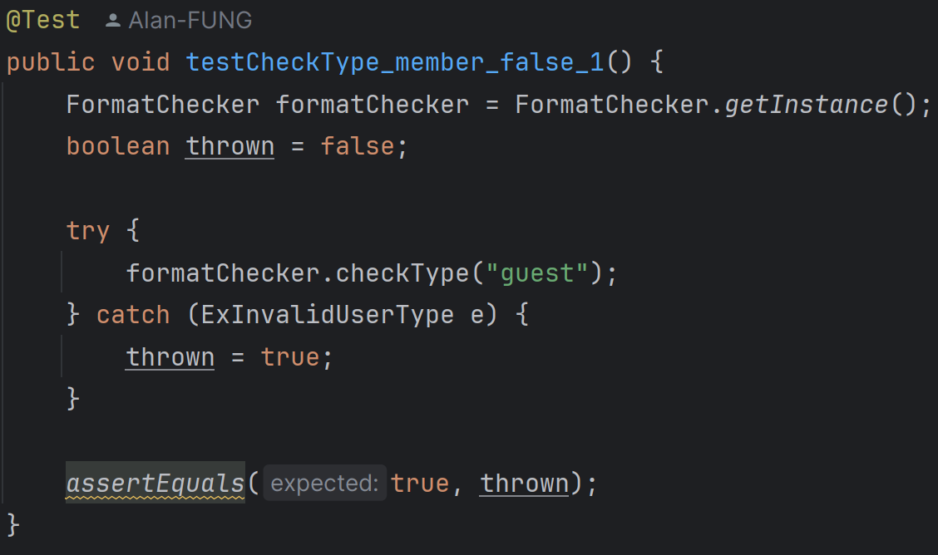

3. testCheckType_member_false_1:

It ensures that an invalid user type ("guest") throws an ExInvalidUserType exception.

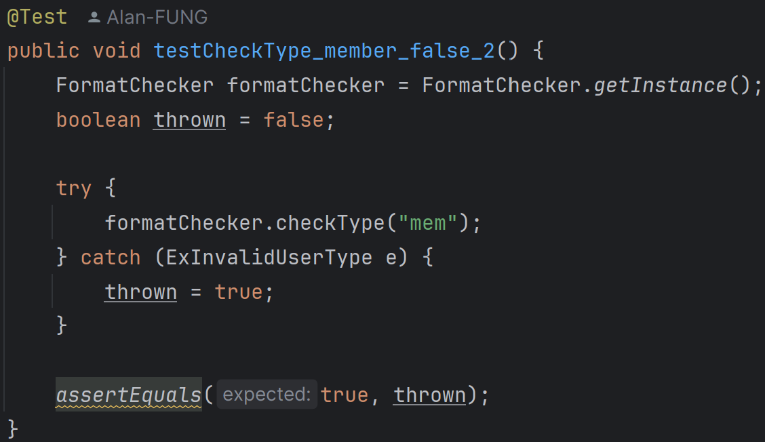

4. testCheckType_member_false_2:

It ensures that an invalid user type ("mem") throws an ExInvalidUserType exception.

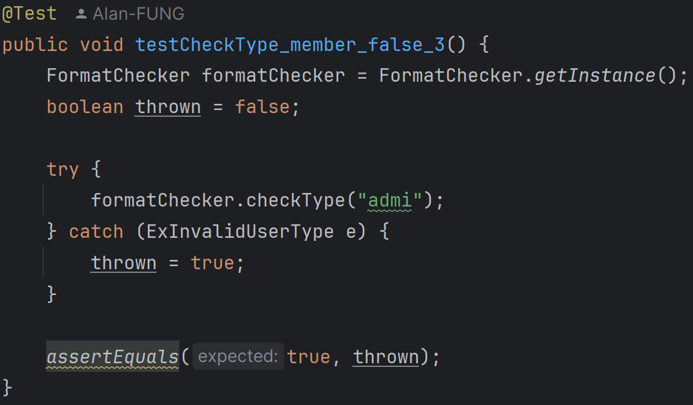

5. testCheckType_member_false_3:

It ensures that an invalid user type ("admi") throws an ExInvalidUserType exception.

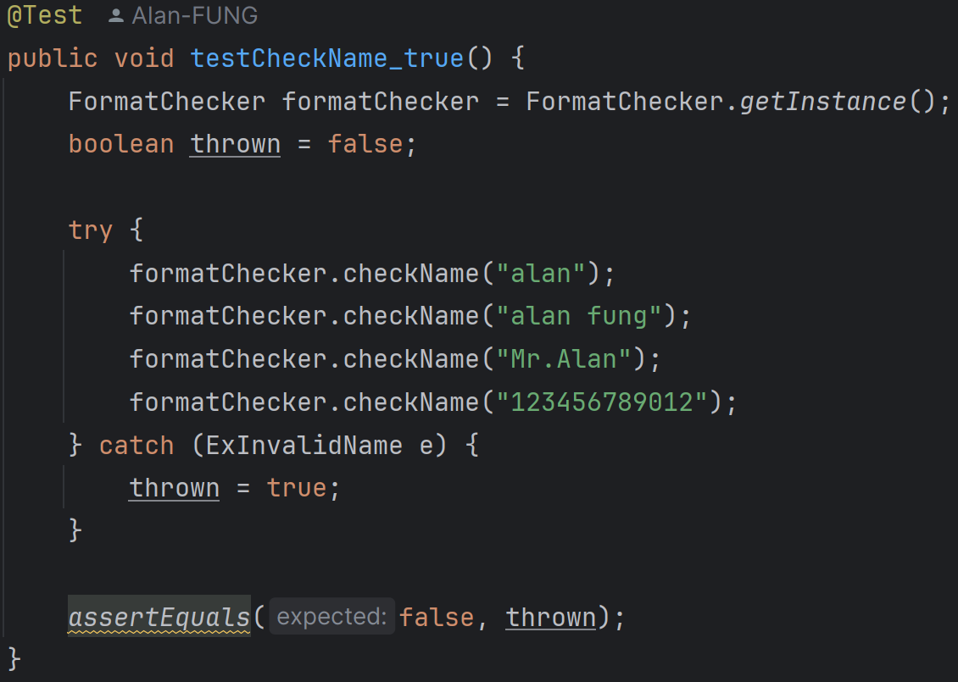

6. testCheckName_true:

It verifies that valid names (non-empty and up to 12 characters) do not throw an ExInvalidName exception.

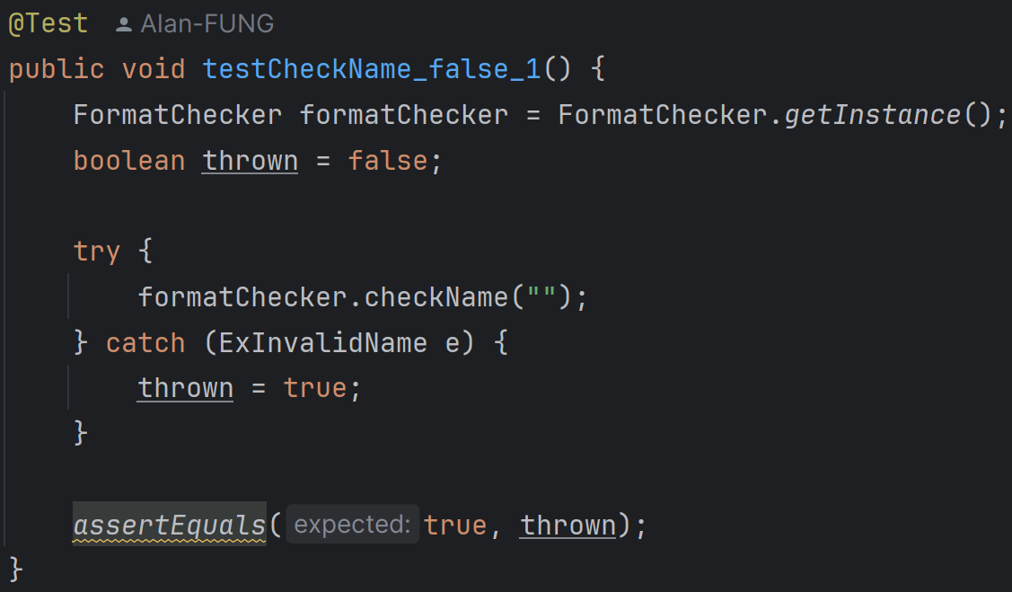

7. testCheckName_false_1:

It ensures that an empty name throws an ExInvalidName exception.

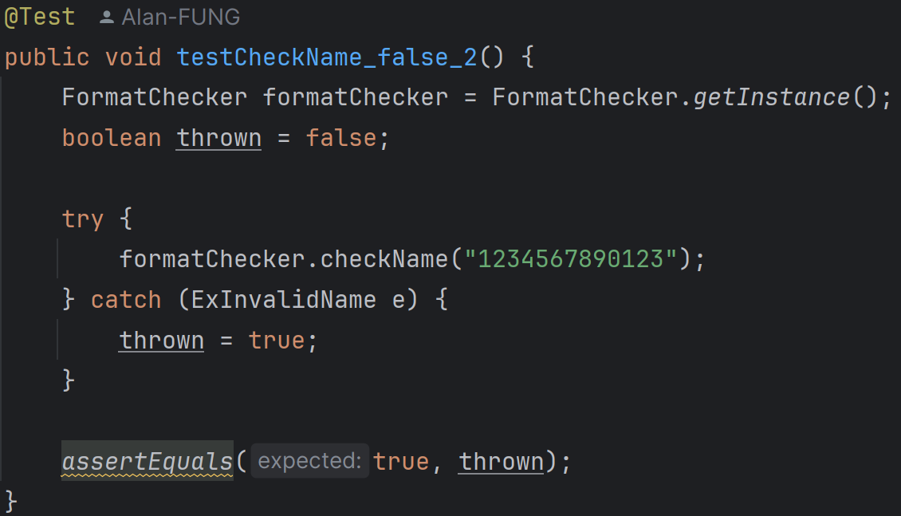

8. testCheckName_false_2:

It ensures that a name longer than 12 characters throws an ExInvalidName exception.

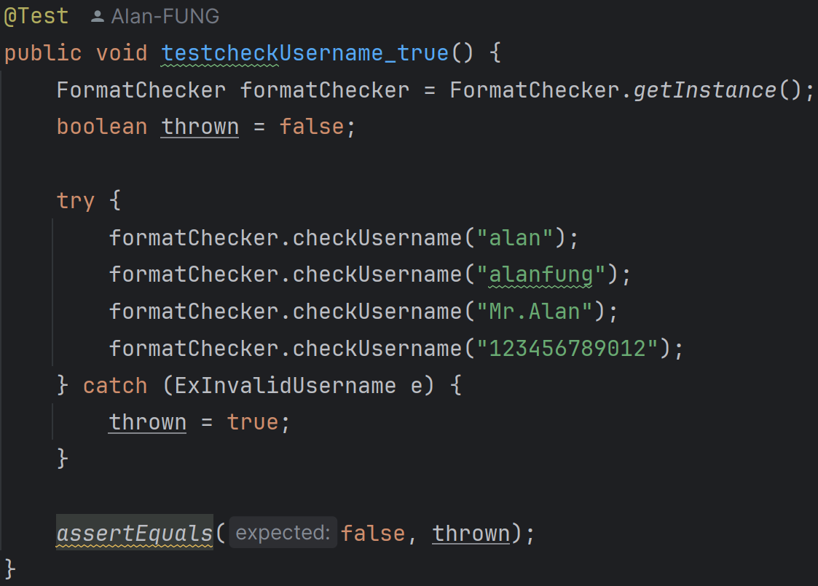

9. testcheckUsername_true:

It verifies that valid usernames (non-empty, no spaces, and up to 12 characters) do not throw an ExInvalidUsername exception.

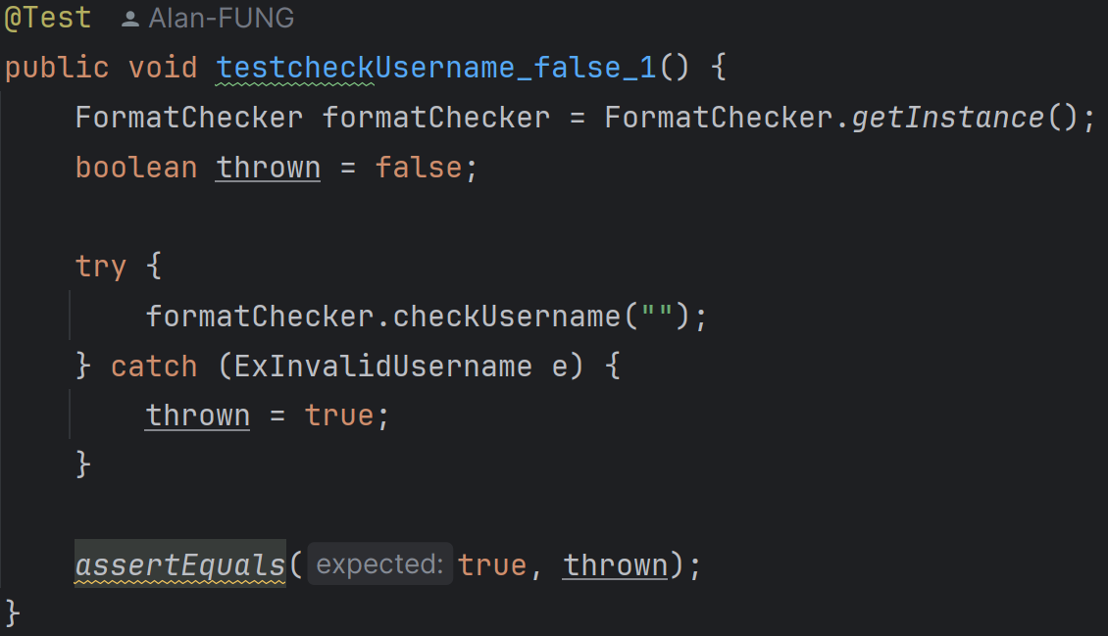

10. testcheckUsername_false_1:

It ensures that an empty username throws an ExInvalidUsername exception.

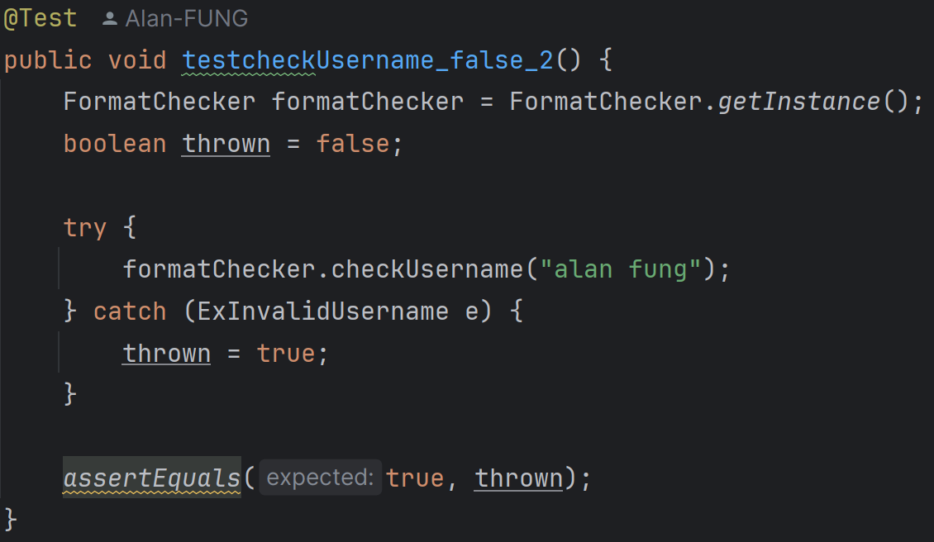

11. testcheckUsername_false_2:

It ensures that a username containing spaces throws an ExInvalidUsername exception.

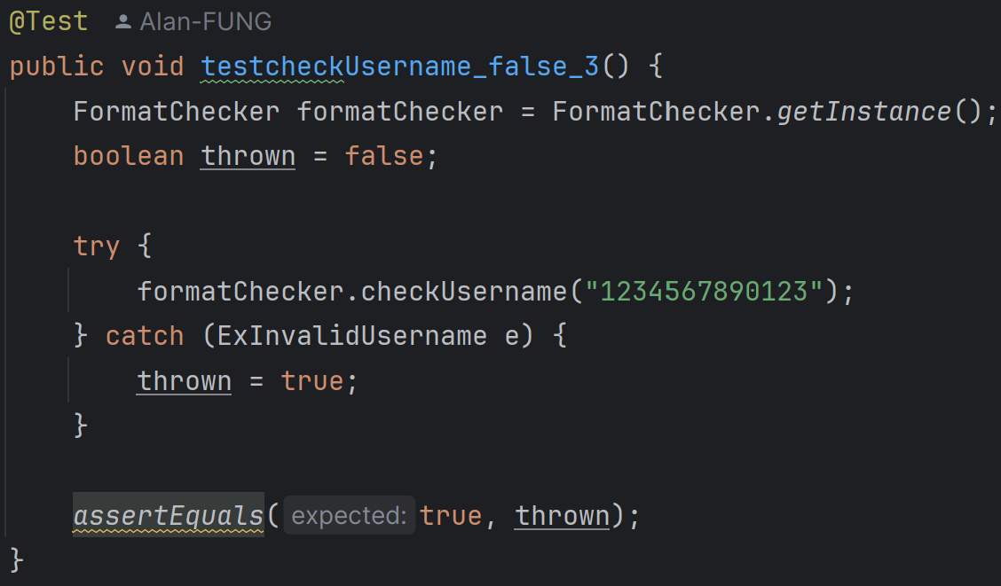

12. testcheckUsername_false_3:

It ensures that a username longer than 12 characters throws an ExInvalidUsername exception.

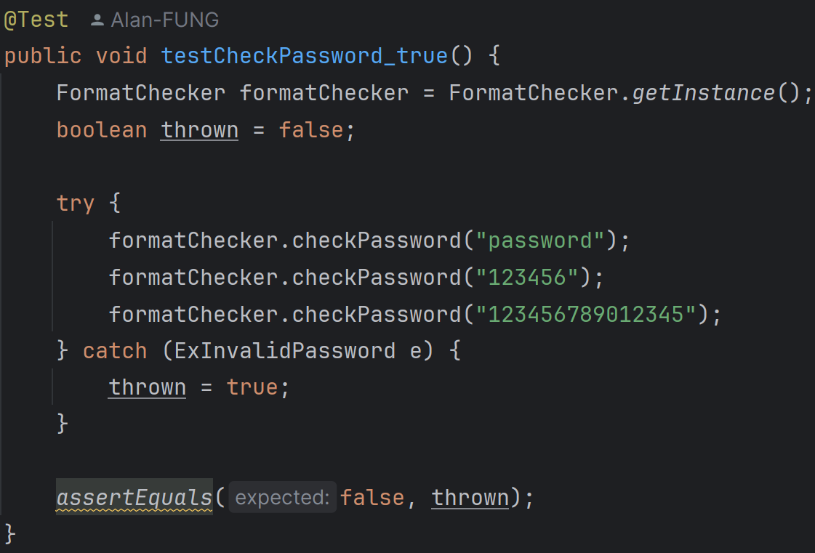

13. testCheckPassword_true:

It verifies that valid passwords (non-empty, no spaces, and up to 15 characters) do not throw an ExInvalidPassword exception.

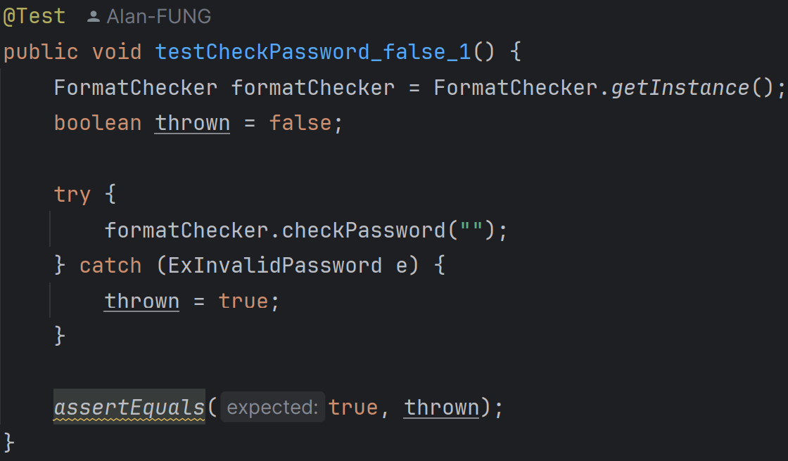

14. testCheckPassword_false_1:

It ensures that an empty password throws an ExInvalidPassword exception.

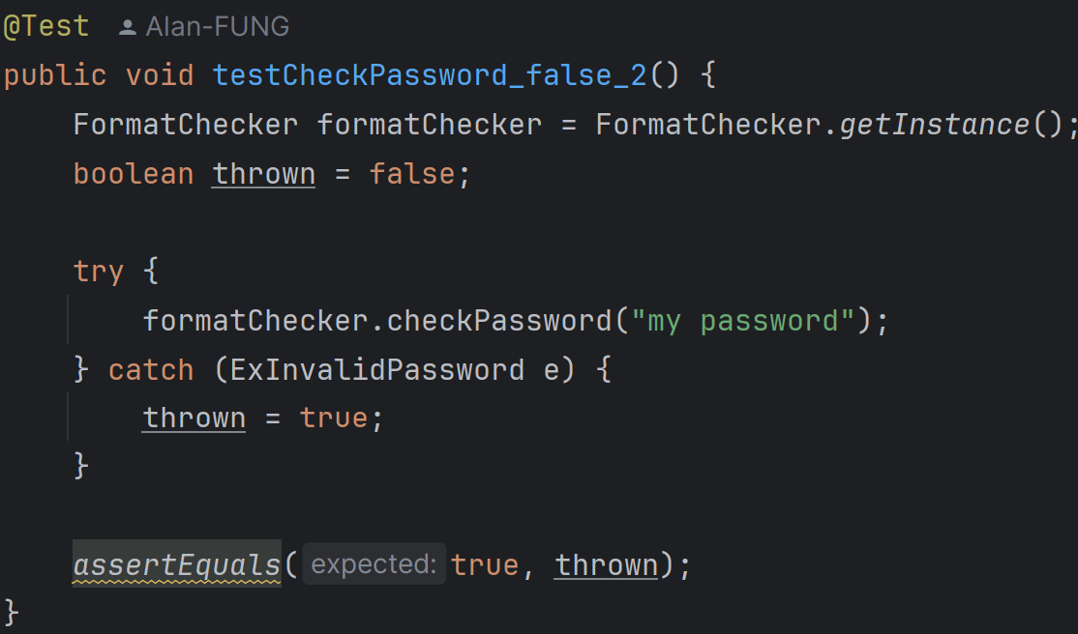

15. testCheckPassword_false_2:

It ensures that a password containing spaces throws an ExInvalidPassword exception.

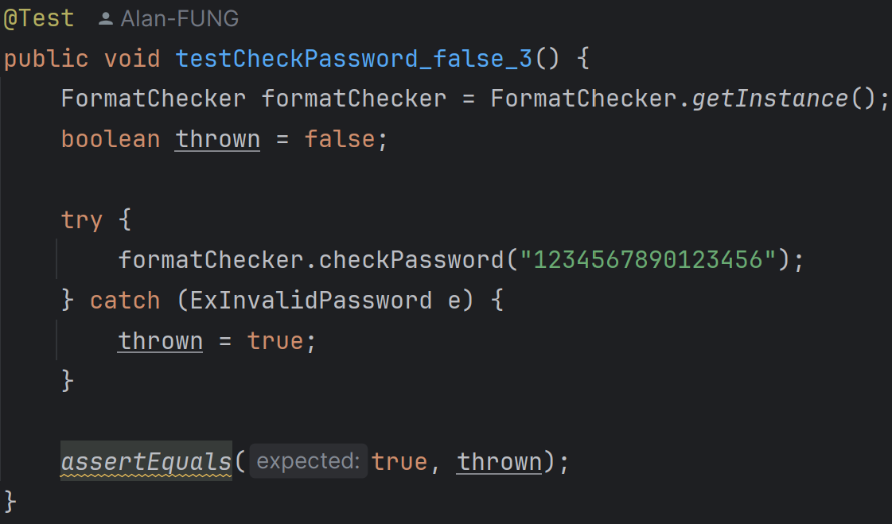

16. testCheckPassword_false_3:

It ensures that a password longer than 15 characters throws an ExInvalidPassword exception.

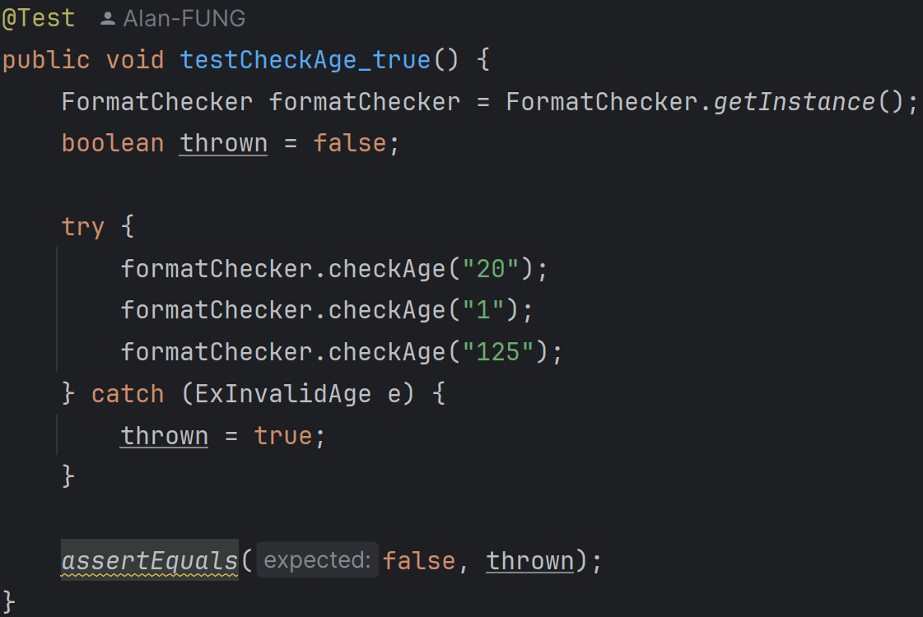

17. testCheckAge_true:

It verifies that valid ages (between 1 and 125) do not throw an ExInvalidAge exception.

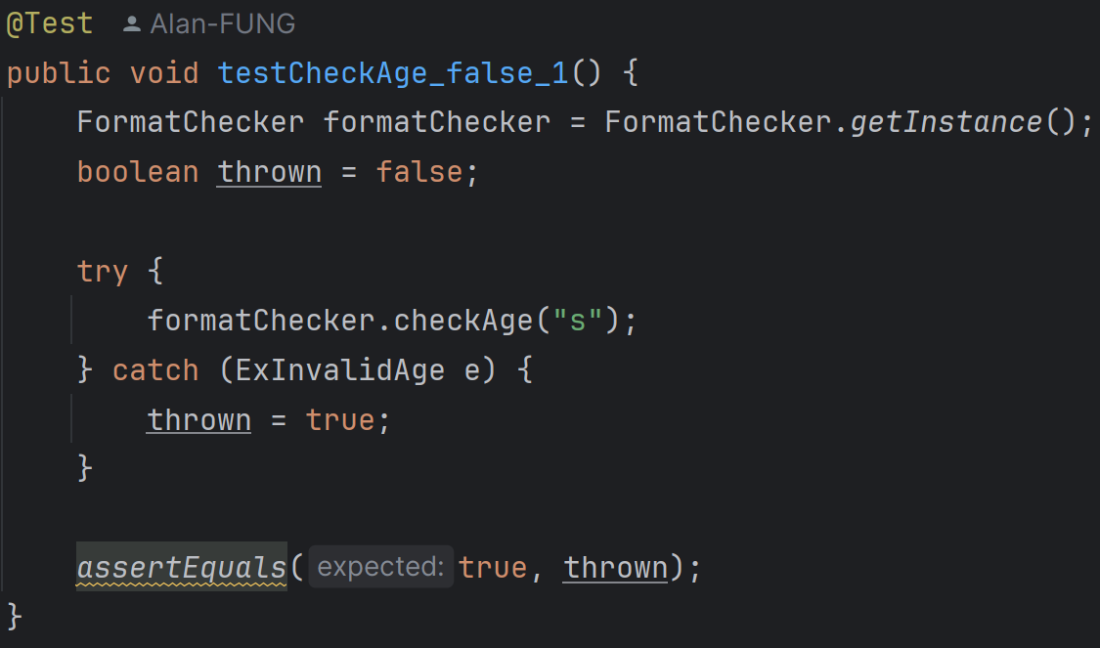

18. testCheckAge_false_1:

It ensures that a non-numeric age throws an ExInvalidAge exception.

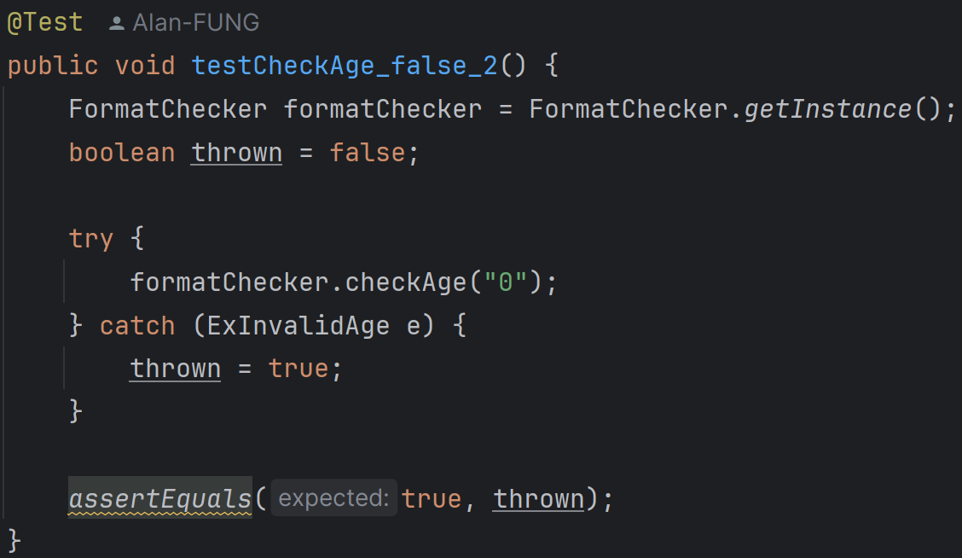

19. testCheckAge_false_2:

It ensures that an age less than 1 throws an ExInvalidAge exception.

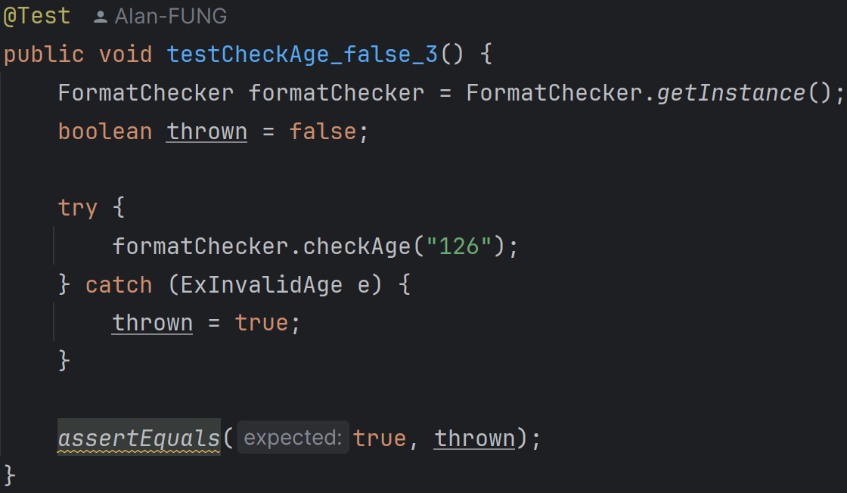

20. testCheckAge_false_3:

It ensures that an age greater than 125 throws an ExInvalidAge exception.

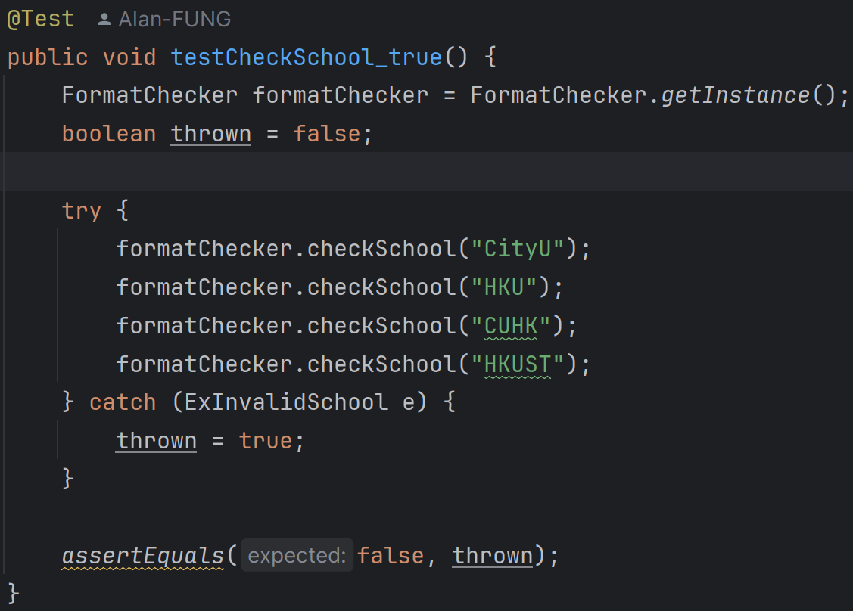

21 testCheckSchool_true:

It verifies that valid school names (non-empty) do not throw an ExInvalidSchool exception.

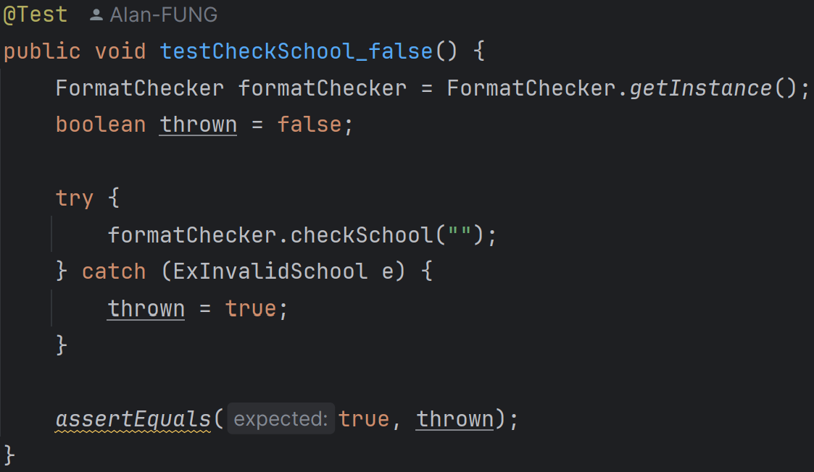

22. testCheckSchool_false:

It ensures that an empty school name throws an ExInvalidSchool exception.

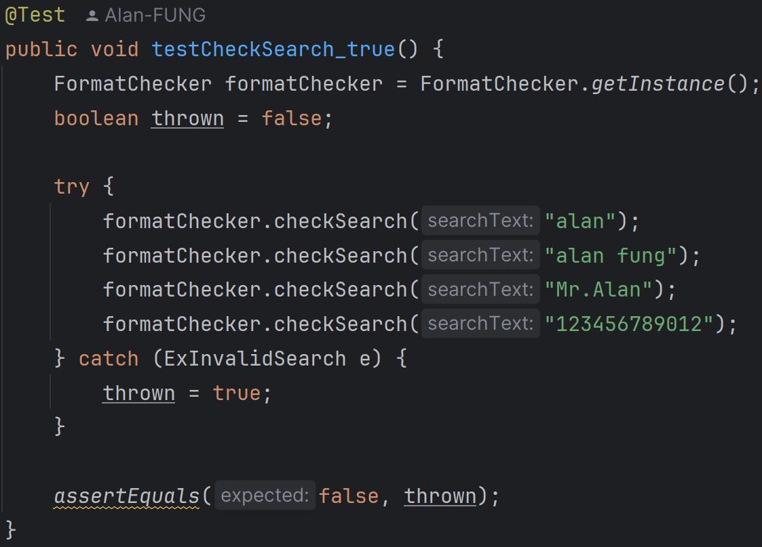

23. testCheckSearch_true:

It verifies that valid search texts (non-empty and up to 12 characters) do not throw an ExInvalidSearch exception.

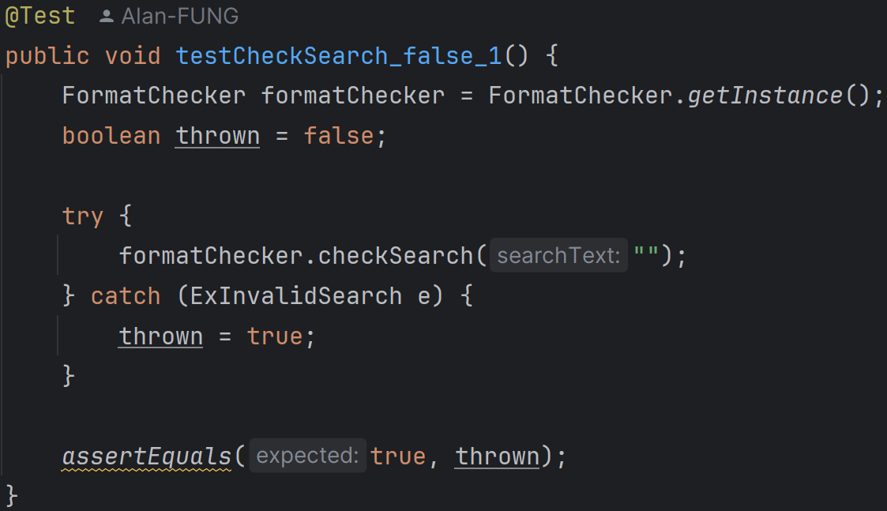

24. testCheckSearch_false_1:

It ensures that an empty search text throws an ExInvalidSearch exception.

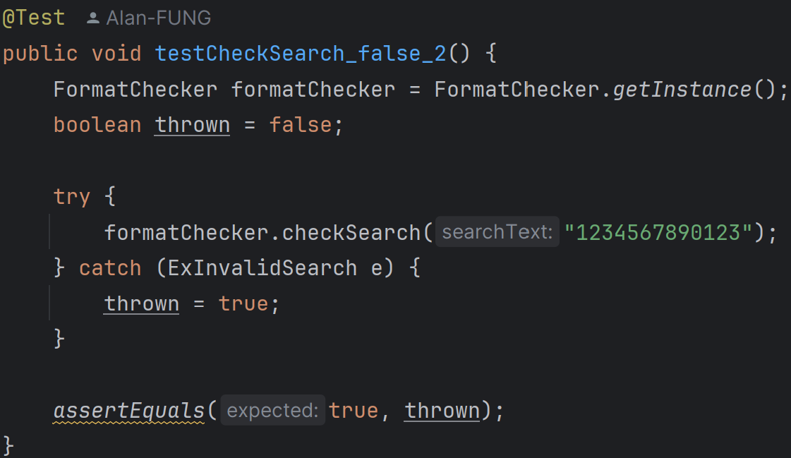

25. testCheckSearch_false_2:

It ensures that a search text longer than 12 characters throws an ExInvalidSearch exception.

**FormatCheckerTest.java (Package helper_movie_test)**

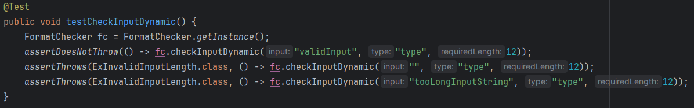

1. testCheckInputDynamic:

It tests the checkInputDynamic method. It verifies that a valid input does not throw an exception. It verifies that an empty input and an overly long input throw ExInvalidInputLength exception.

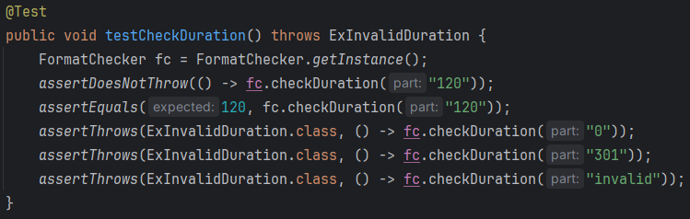

2. testCheckDuration:

It tests the checkDuration method. It verifies that a valid duration does not throw an exception and returns the correct value. It verifies that invalid durations (0, 301, non-numeric) throw ExInvalidDuration exception.

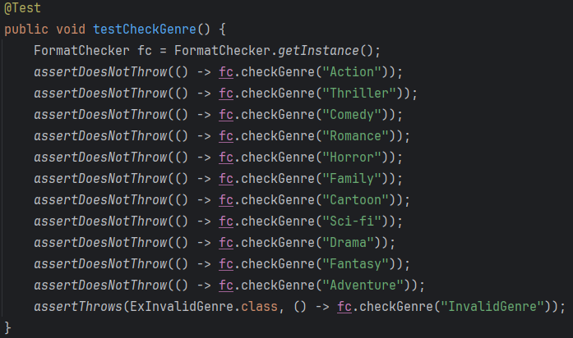

3. testCheckGenre:

It tests the checkGenre method. It verifies that valid genres do not throw an exception. It verifies that an invalid genre throws ExInvalidGenre exception.

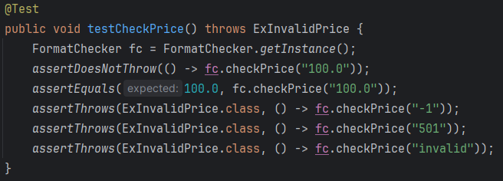

4. testCheckPrice:

It tests the checkPrice method. It verifies that a valid price does not throw an exception and returns the correct value. It verifies that invalid prices (negative, too high, non-numeric) throw ExInvalidPrice exception.

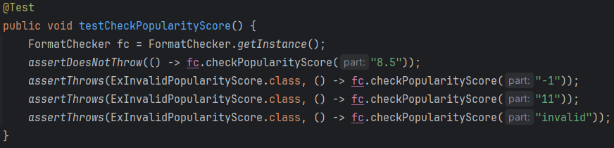

5. testCheckPopularityScore:

It tests the checkPopularityScore method. It verifies that a valid popularity score does not throw an exception. It verifies that invalid scores (negative, too high, non-numeric) throw ExInvalidPopularityScore exception.

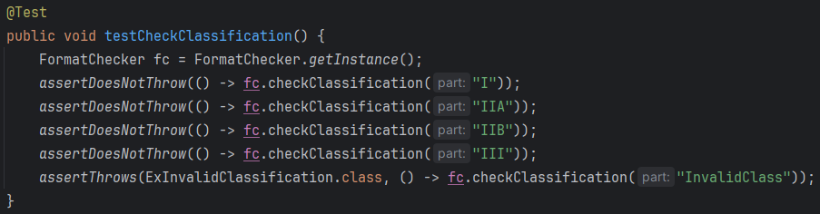

6. testCheckClassification:

It tests the checkClassification method. It verifies that valid classifications do not throw an exception. It verifies that an invalid classification throws ExInvalidClassification exception.

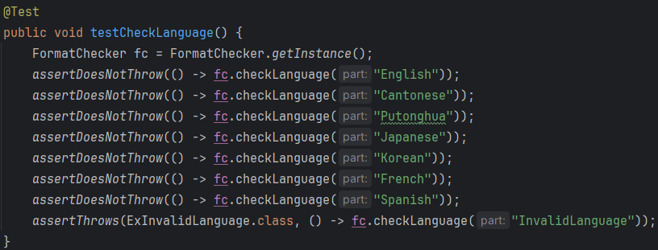

7. testCheckLanguage:

It tests the checkLanguage method. It verifies that valid languages do not throw an exception. It verifies that an invalid language throws ExInvalidLanguage exception.

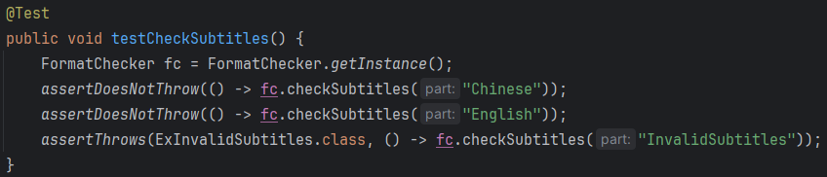

8. testCheckSubtitles:

It tests the checkSubtitles method. It verifies that valid subtitles do not throw an exception. It verifies that invalid subtitles throw ExInvalidSubtitles exception.

**TimeTest.java (Package helper_movie_test)**

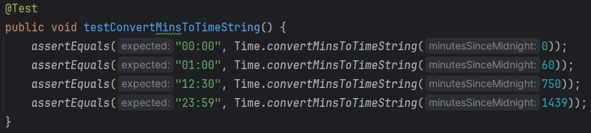

1. testConvertMinsToTimeString:

It tests the convertMinsToTimeString method which converts minutes since midnight to a time string in "HH:mm" format. For the test cases, 0 minutes should return "00:00"; 60 minutes should return "01:00"; 750 minutes should return "12:30"; 1439 minutes should return "23:59".

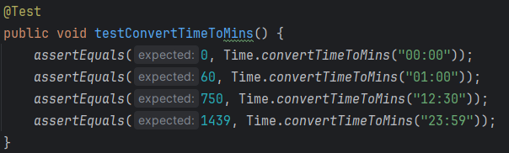

1. testConvertTimeToMins:

It tests the convertTimeToMins method which converts a time string in "HH:mm" format to minutes since midnight. For the test cases, "00:00" should return 0 minutes; "01:00" should return 60 minutes; "12:30" should return 750 minutes; "23:59" should return 1439 minutes.

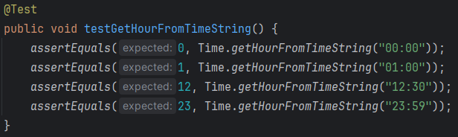

1. testGetHourFromTimeString:

It tests the getHourFromTimeString method which extracts the hour part from a time string in "HH:mm" format.

For the test cases, "00:00" should return 0 hours; "01:00" should return 1 hour; "12:30" should return 12 hours; "23:59" should return 23 hours.

**OptionCenterTest.java (Package in_out_test)**

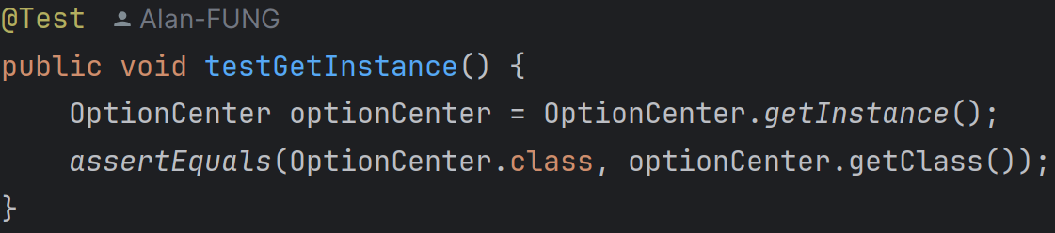

1. testGetInstance:

This test checks if the getInstance method of OptionCenter returns an instance of the OptionCenter class. It asserts that the class of the returned instance is OptionCenter.

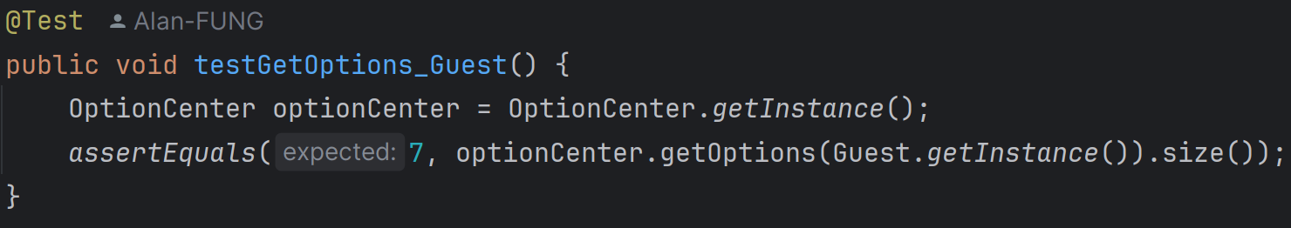

2. testGetOptions_Guest:

This test verifies that the getOptions method returns the correct number of options for a Guest user. It asserts that the size of the options list for a Guest is 7.

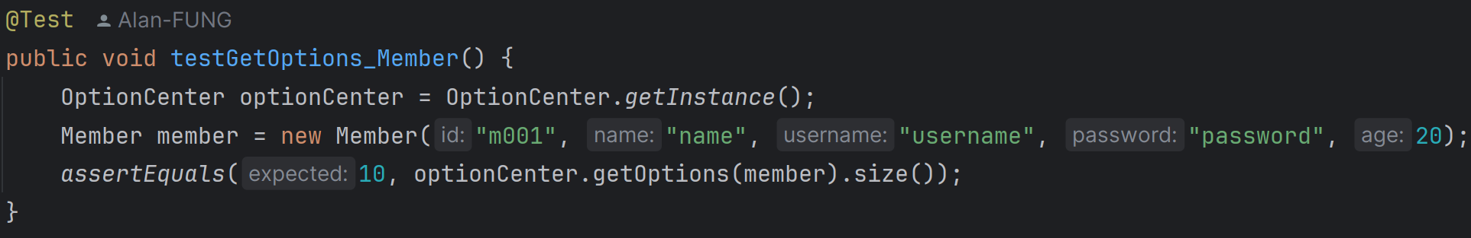

3. testGetOptions_Member:

This test checks that the getOptions method returns the correct number of options for a Member user. It creates a new Member instance and asserts that the size of the options list for a Member is 10.

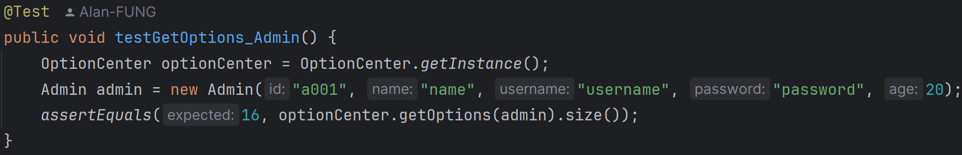

4. testGetOptions_Admin:

This test verifies that the getOptions method returns the correct number of options for an Admin user. It creates a new Admin instance and asserts that the size of the options list for an Admin is 16.

**OptionTest (Package in_out_test)**

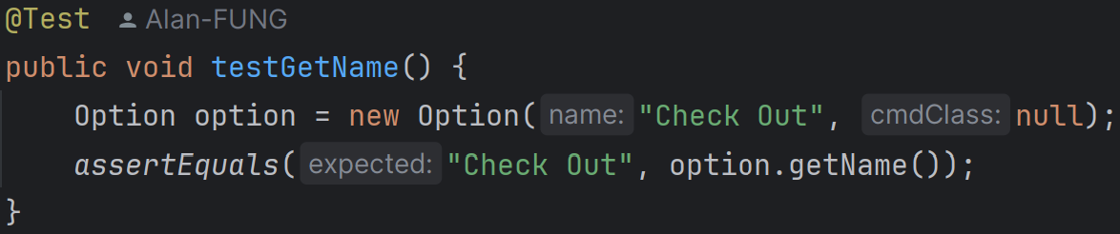

1. testGetName:

This test case creates an Option object with the name "Check Out" and a null command class. It then asserts that the getName method returns the correct name "Check Out".

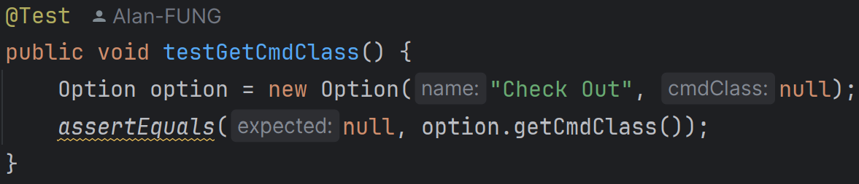

2. testGetCmdClass:

This test case creates an Option object with the name "Check Out" and a null command class. It then asserts that the getCmdClass method returns null, as expected.

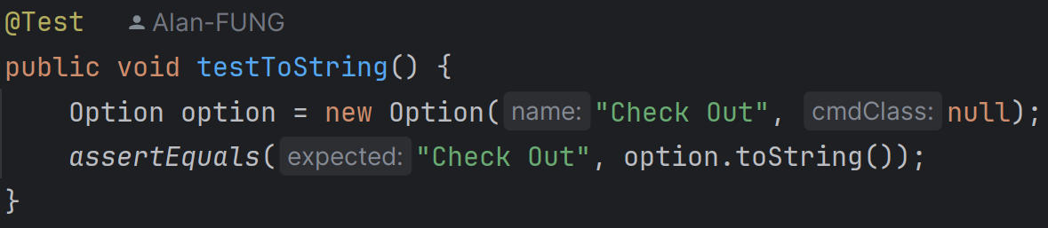

3. testToString:

This test case creates an Option object with the name "Check Out" and a null command class. It then asserts that the toString method returns the correct string representation "Check Out".

**MovieTest.java (Package movie_test)**

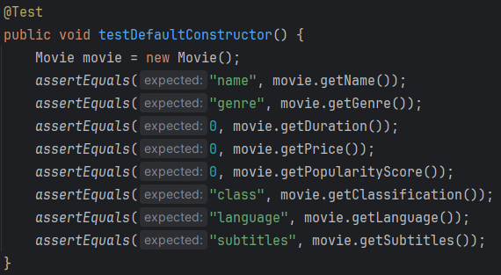

1. testDefaultConstructor:

It tests the default constructor of the Movie class. It asserts that the default values are correctly set.

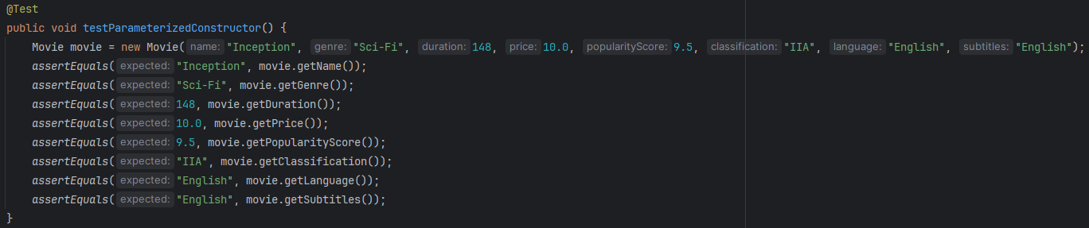

1. testParameterizedConstructor:

It tests the parameterized constructor of the Movie class. It asserts that the values passed to the constructor are correctly assigned to the movie's attributes.

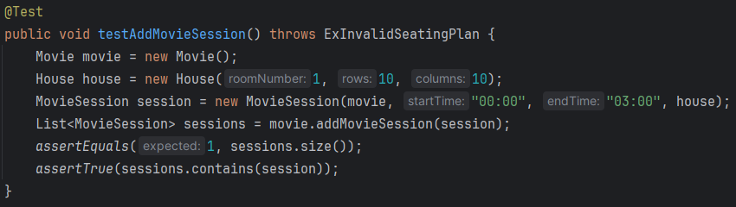

1. testAddMovieSession:

It tests the addMovieSession method. It creates a Movie and a MovieSession, adds the session to the movie, and asserts that the session list contains the added session.

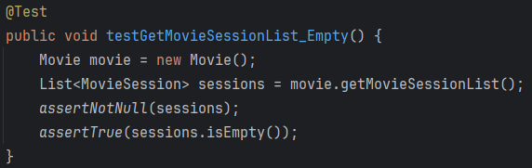

1. testGetMovieSessionList_Empty:

It tests the getMovieSessionList method when no sessions have been added. It asserts that the session list is not null and is empty.

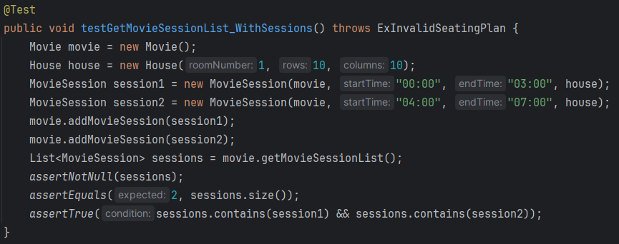

1. testGetMovieSessionList_WithSessions:

It tests the getMovieSessionList method when sessions have been added. It adds two sessions to the movie and asserts that the session list contains both sessions.

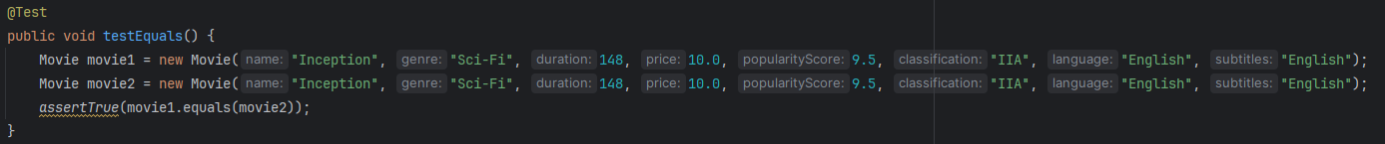

1. testEquals:

It tests the equals method. It creates two identical Movie objects and asserts that they are considered equal.

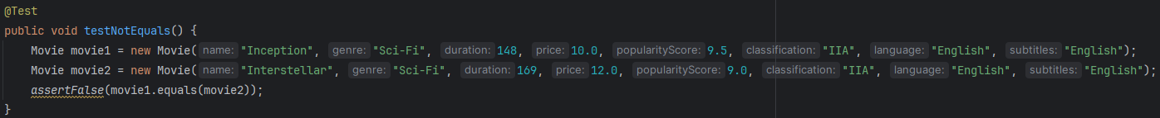

1. testNotEquals:

It tests the equals method. It creates two different Movie objects and asserts that they are not considered equal.

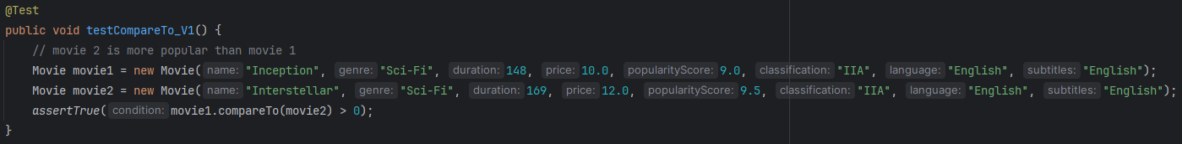

1. testCompareTo_V1:

It tests the compareTo method. It asserts that a less popular movie is considered greater than a more popular movie, as the comparison is based on descending order of popularity score multiplied by price.

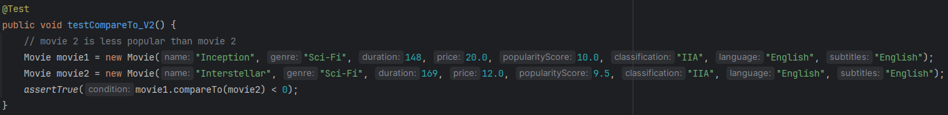

1. testCompareTo_V2:

It tests the compareTo method. It asserts that a more popular movie is considered less than a less popular movie.

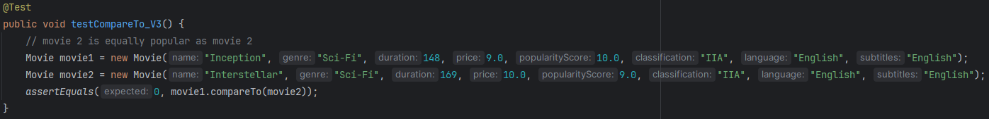

1. testCompareTo_V3:

It tests the compareTo method. It asserts that two movies with equal popularity scores and prices are considered equal.

**MovieSessionTest.java (Package movie_test)**

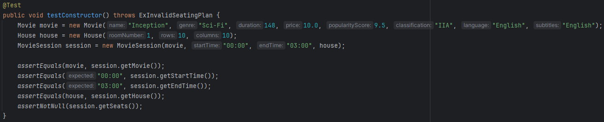

1. testConstructor:

This test verifies the constructor of the MovieSession class. It creates a Movie and a House object. It then creates a MovieSession object using these objects and specific start and end times. The test asserts that the MovieSession object correctly initializes its fields (movie, startTime, endTime, house, and seats).

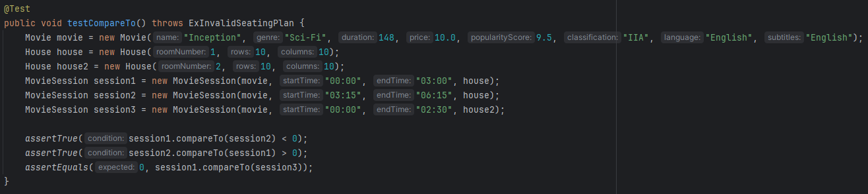

1. testCompareTo:

This test verifies the compareTo method of the MovieSession class. It creates three MovieSession objects with different start times and houses. The test asserts that the compareTo method correctly compares the start times of the sessions, where session1 should be less than session2 (earlier start time); session2 should be greater than session1 (later start time); session1 should be equal to session3 (same start time).

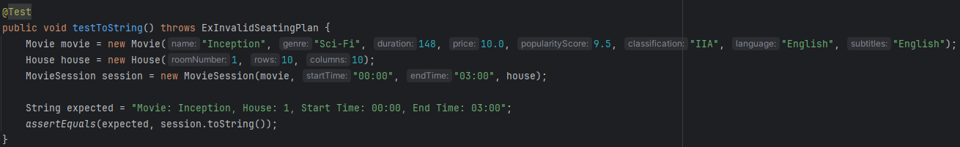

1. testToString:

This test verifies the toString method of the MovieSession class. It creates a MovieSession object. The test asserts that the toString method returns the expected string representation of the MovieSession object.

**SeatingPlanTest.java (Package movie_test)**

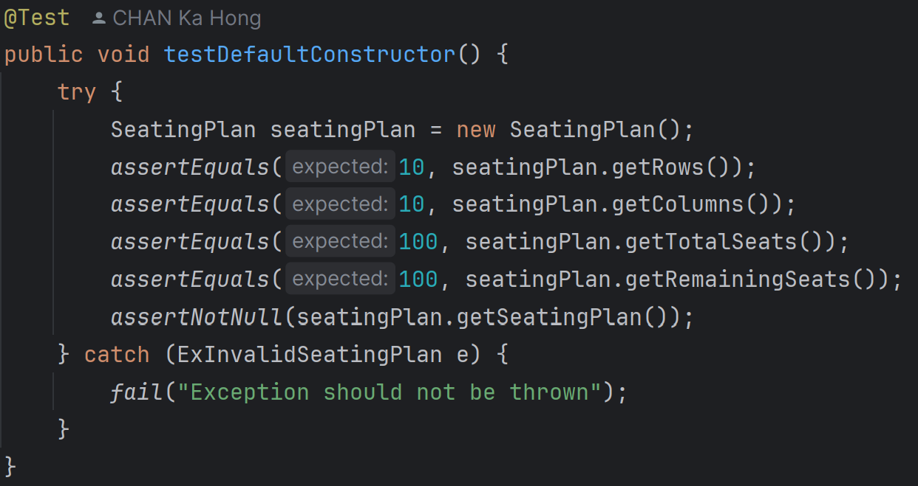

1. testDefaultConstructor:

It tests the default constructor of SeatingPlan. It verifies that the default seating plan has 10 rows and 10 columns. It checks that the total and remaining seats are 100 and ensures that the seating plan is not null.

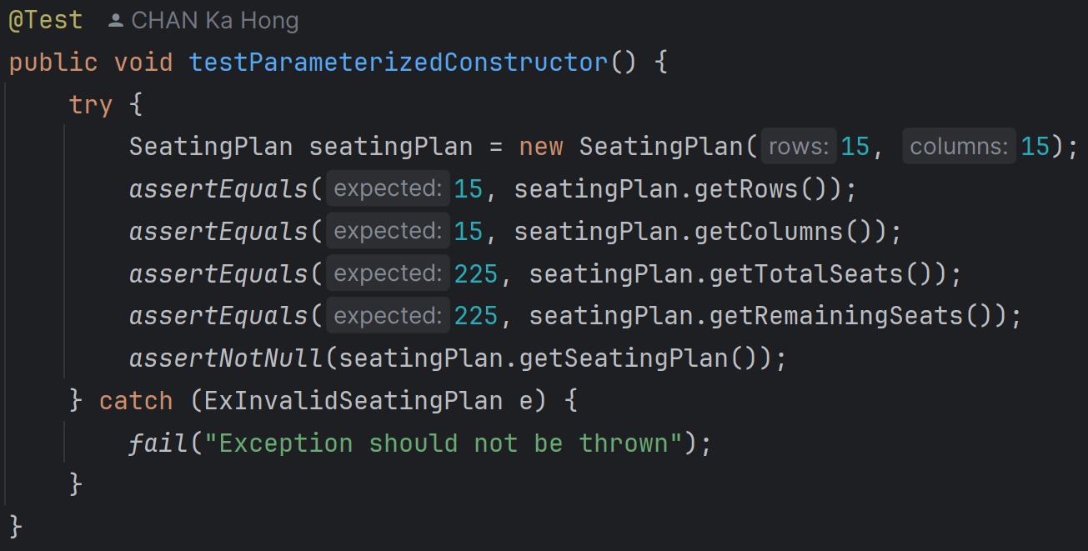

1. testParameterizedConstructor:

It tests the parameterized constructor of SeatingPlan with 15 rows and 15 columns. It verifies that the seating plan has 15 rows and 15 columns. It checks that the total and remaining seats are 225 and ensures that the seating plan is not null.

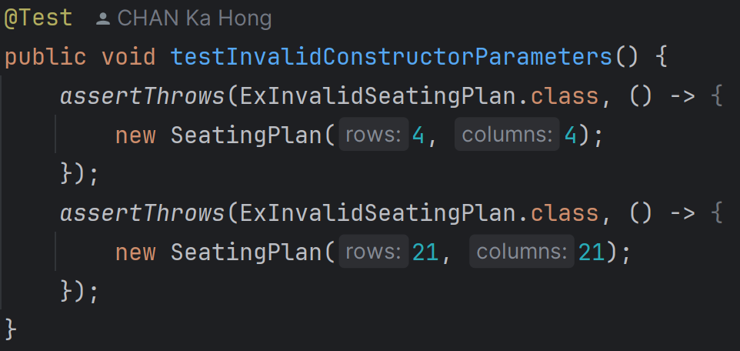

1. testInvalidConstructorParameters:

It tests the constructor with invalid parameters (4x4 and 21x21). It verifies that an ExInvalidSeatingPlan exception is thrown for invalid seating plan sizes.

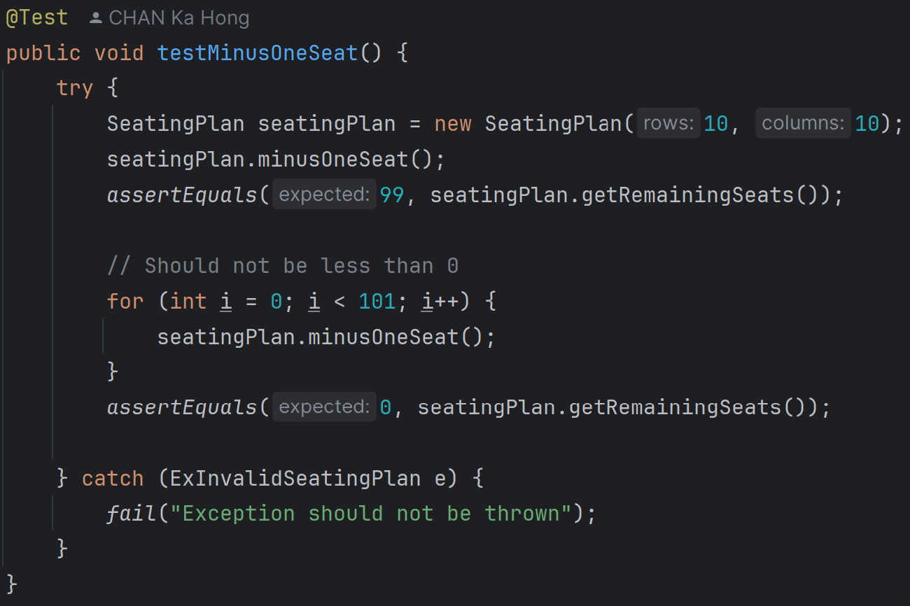

1. testMinusOneSeat:

It tests the minusOneSeat method. It verifies that the remaining seats decrease by one. It ensures that the remaining seats do not go below 0, even after multiple calls.

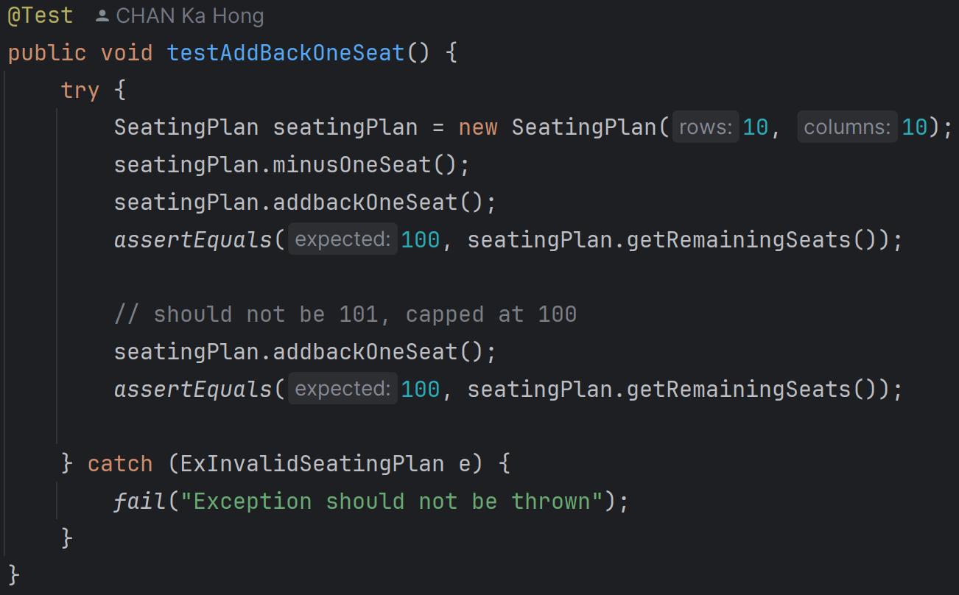

1. testAddBackOneSeat:

It tests the addbackOneSeat method. It verifies that the remaining seats increase by one. It ensures that the remaining seats do not exceed the total seats, even after multiple calls.

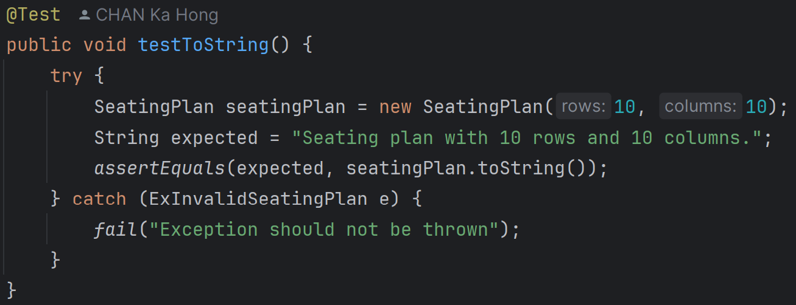

1. testToString:

It tests the toString method. It verifies that the string representation of the seating plan is correct for a 10x10 seating plan.

**HouseTest.java (Package movie_test)**

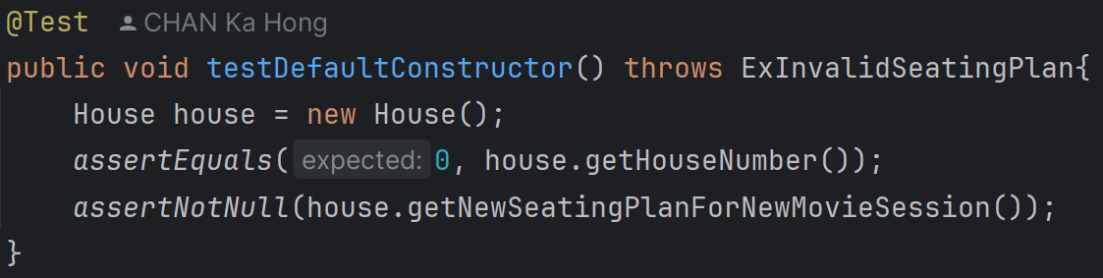

1. testDefaultConstructor:

It tests the default constructor of the House class. It asserts that the houseNumber is 0 and asserts that a new seating plan for a new movie session is not null.

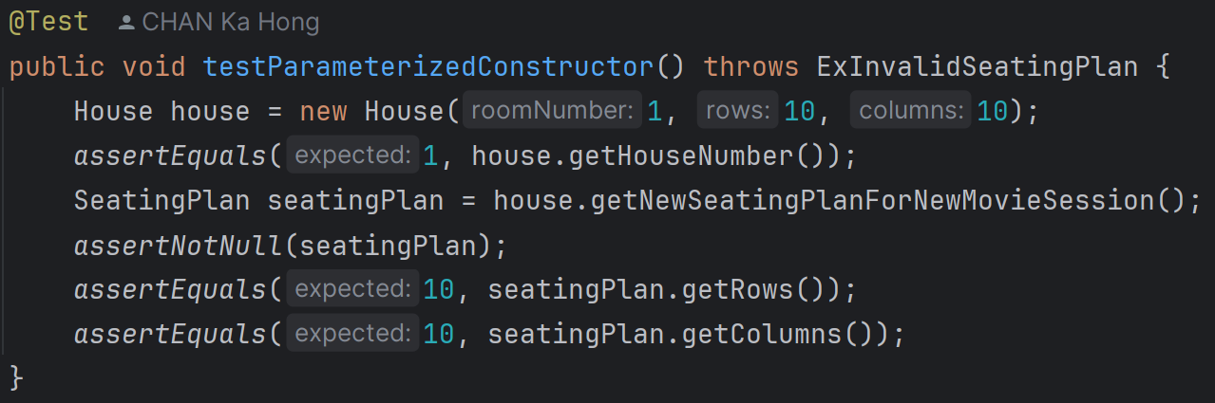

2. testParameterizedConstructor:

It tests the parameterized constructor of the House class. It asserts that the houseNumber is set correctly and asserts that the seating plan created for a new movie session has the correct number of rows and columns.

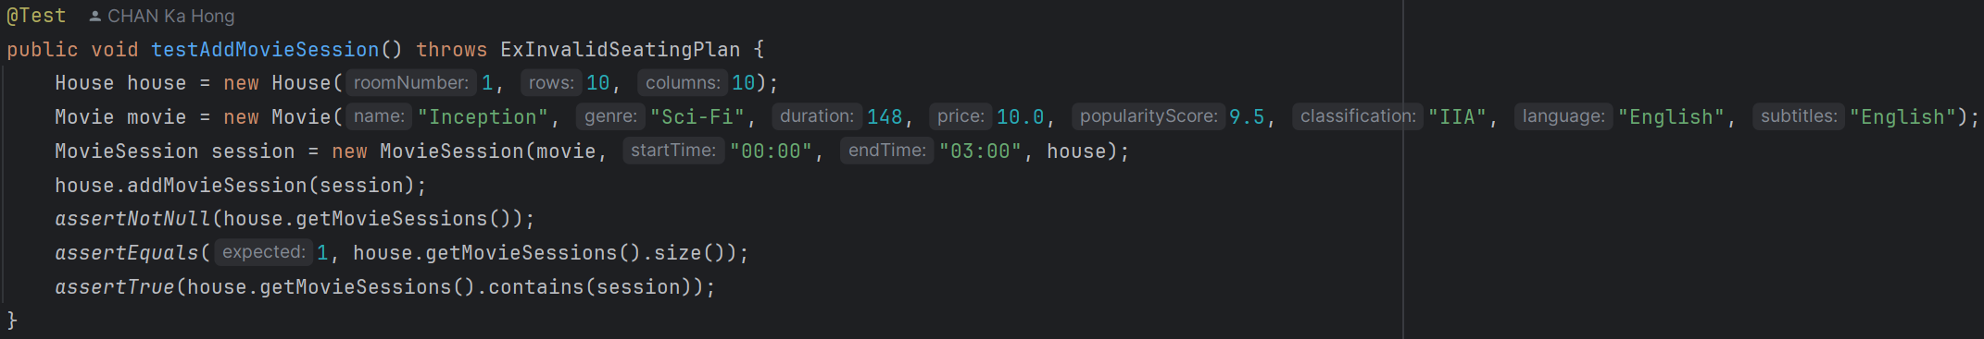

3. testAddMovieSession:

It tests the addMovieSession method. It creates a House and a MovieSession and adds the MovieSession to the House. It asserts that the movieSessions list is not null, asserts that the movieSessions list contains exactly one session, and asserts that the added session is in the movieSessions list.

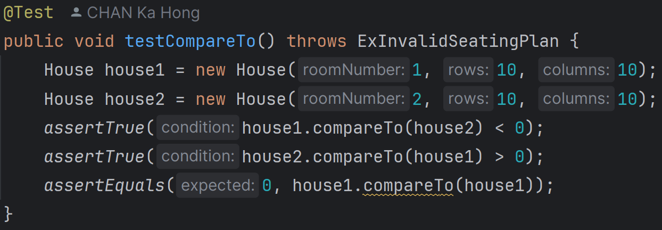

4. testCompareTo:

It tests the compareTo method. It creates two House objects with different houseNumber values and asserts that the comparison between the two houses is correct (less than, greater than, and equal).

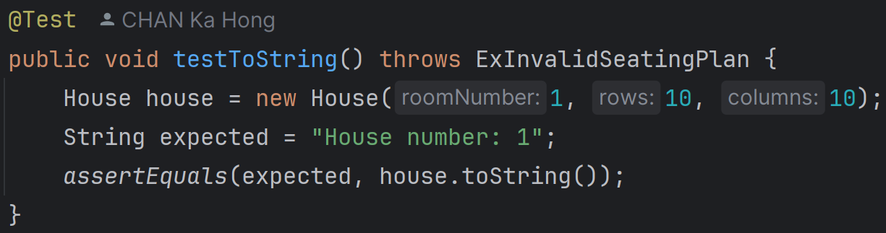

5. testToString:

It tests the toString method. It creates a House object and asserts that the toString method returns the expected string representation of the House.

**MovieServiceTest.java (Package movie_test)**

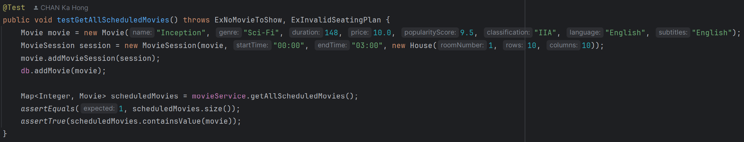

1. testGetAllScheduledMovies:

It verifies that the method getAllScheduledMovies returns all scheduled movies. It adds a movie with a session to the database and checks that the returned map contains the added movie.

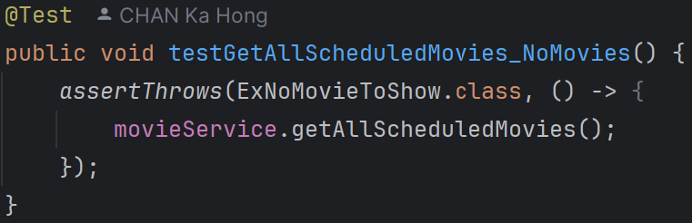

2. testGetAllScheduledMovies_NoMovies:

It verifies that the method getAllScheduledMovies throws an ExNoMovieToShow exception when there are no scheduled movies. It expects an ExNoMovieToShow exception to be thrown.

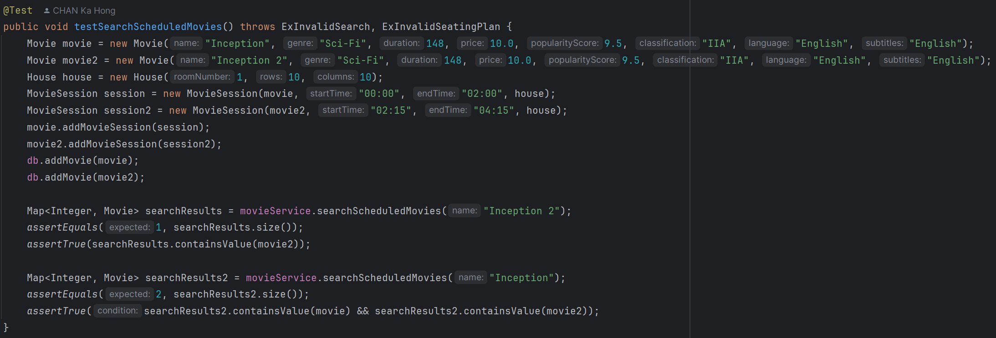

3. testSearchScheduledMovies:

It verifies that the method searchScheduledMovies returns the correct movies based on the search keyword. It adds two movies with sessions to the database and checks that the search results match the expected movies.

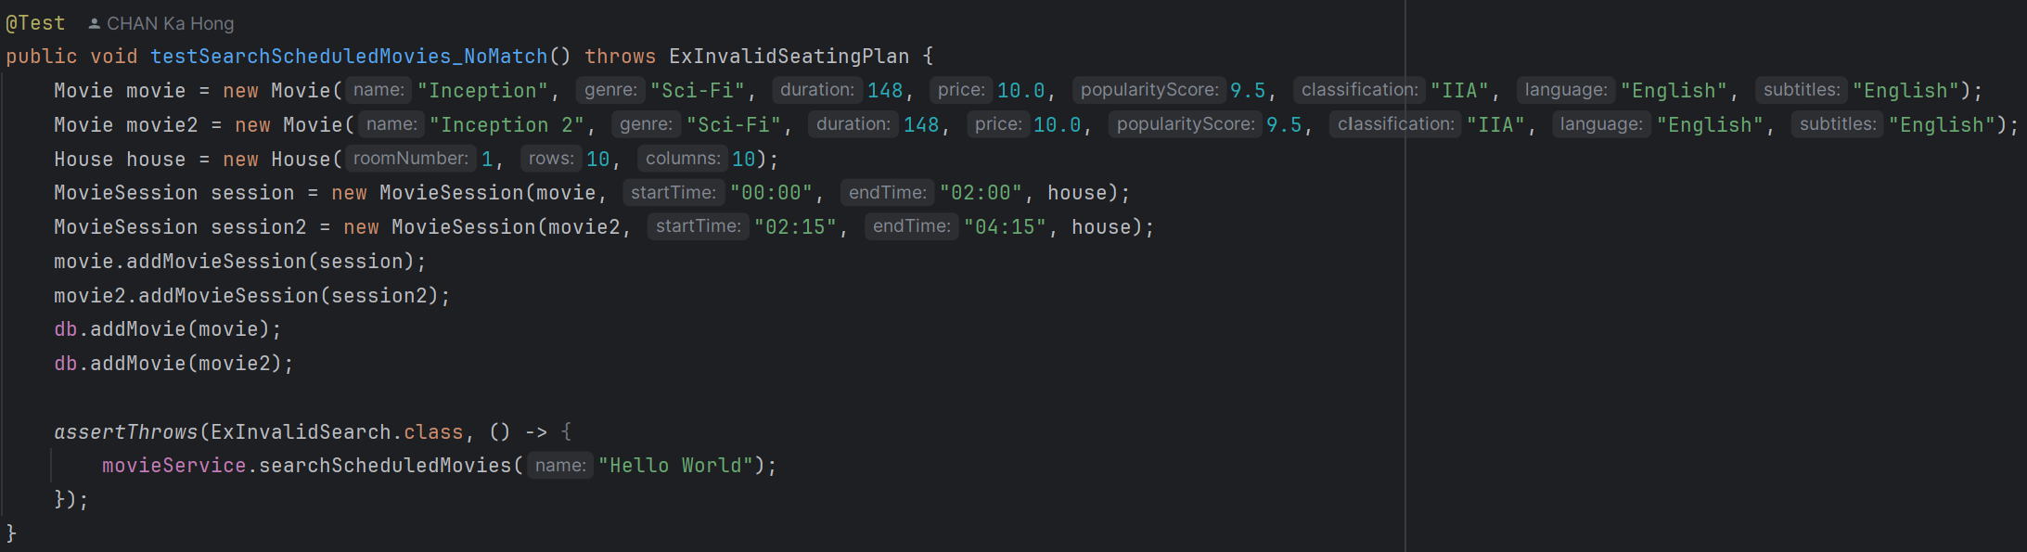

4. testSearchScheduledMovies_NoMatch:

It verifies that the method searchScheduledMovies throws an ExInvalidSearch exception when no movies match the search keyword. It expects an ExInvalidSearch exception to be thrown.

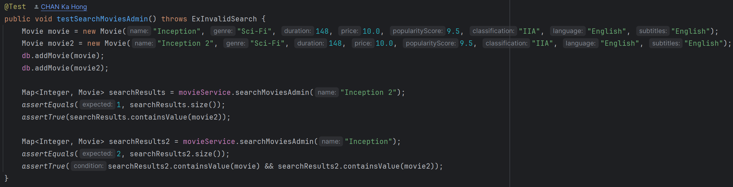

5. testSearchMoviesAdmin:

It verifies that the method searchMoviesAdmin returns the correct movies based on the search keyword. It adds two movies to the database and checks that the search results match the expected movies.

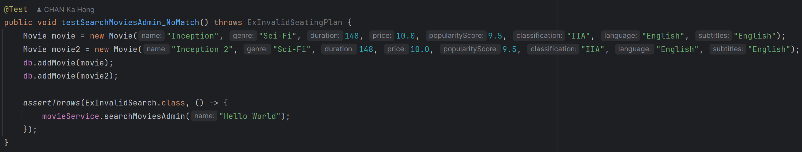

6. testSearchMoviesAdmin_NoMatch:

It verifies that the method searchMoviesAdmin throws an ExInvalidSearch exception when no movies match the search keyword. It expects an ExInvalidSearch exception to be thrown.

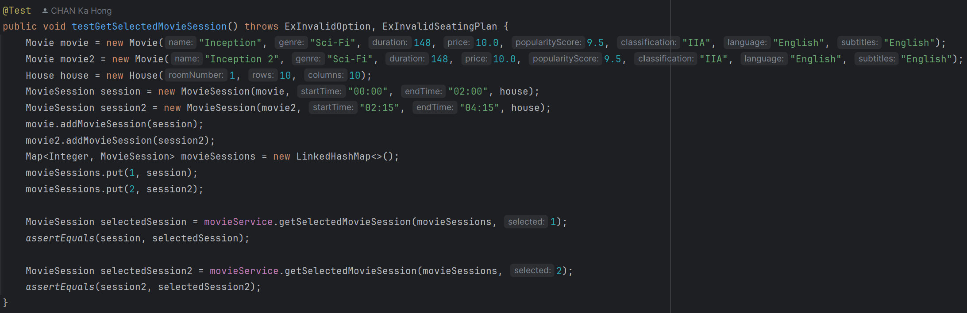

7. testGetSelectedMovieSession:

It verifies that the method getSelectedMovieSession returns the correct movie session based on the selected key. It adds two movie sessions to a map and checks that the returned movie session matches the expected session.

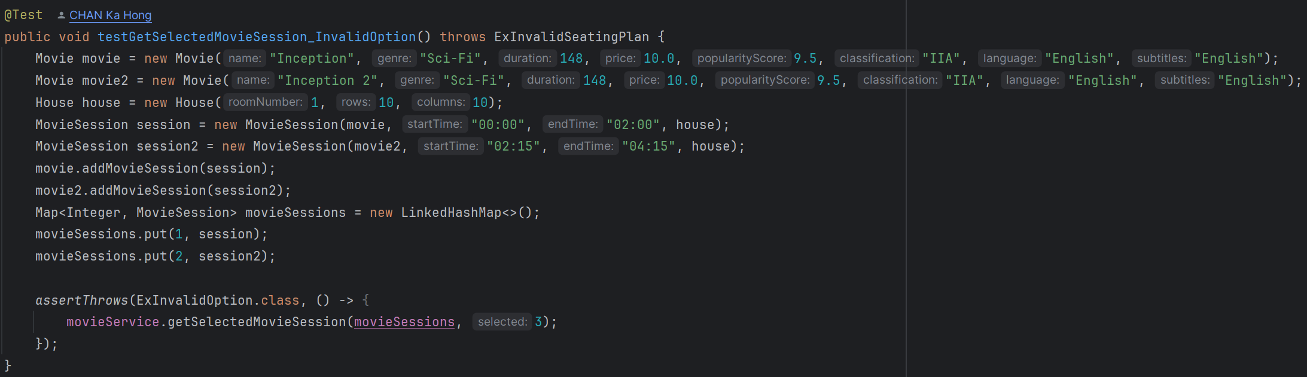

8. testGetSelectedMovieSession_InvalidOption:

It verifies that the method getSelectedMovieSession throws an ExInvalidOption exception when an invalid key is selected. It expects an ExInvalidOption exception to be thrown.

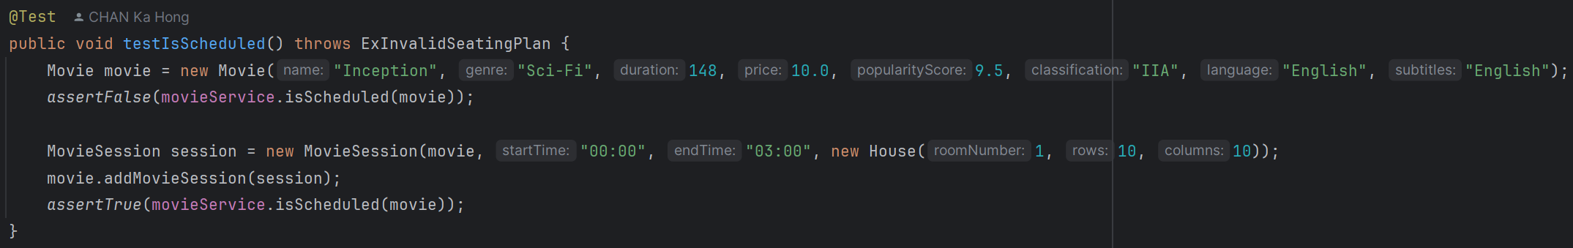

9. testIsScheduled:

It verifies that the method isScheduled correctly identifies if a movie is scheduled. It creates a movie, optionally adds a session to it and checks that the method returns true if the movie has sessions and false otherwise.

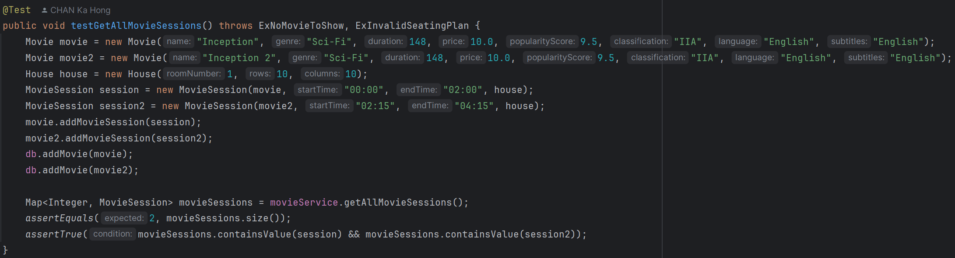

10. testGetAllMovieSessions:

It verifies that the method getAllMovieSessions returns all movie sessions. It adds two movies with sessions to the database and checks that the returned map contains all the added sessions.

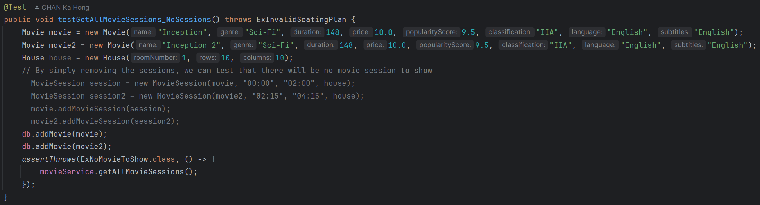

11. testGetAllMovieSessions_NoSessions:

It verifies that the method getAllMovieSessions throws an ExNoMovieToShow exception when there are no movie sessions. It expects an ExNoMovieToShow exception to be thrown.

**BookSeatServiceTest.java (Package movie_test)**

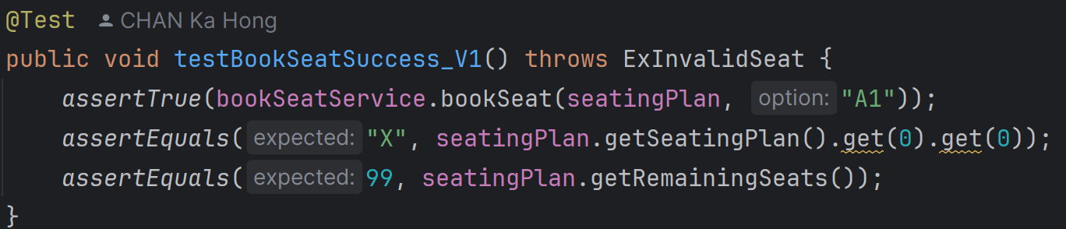

1. testBookSeatSuccess_V1:

It books seat "A1" and checks if the booking is successful. It verifies that the seat is marked as booked ("X") and the remaining seats count is updated correctly.

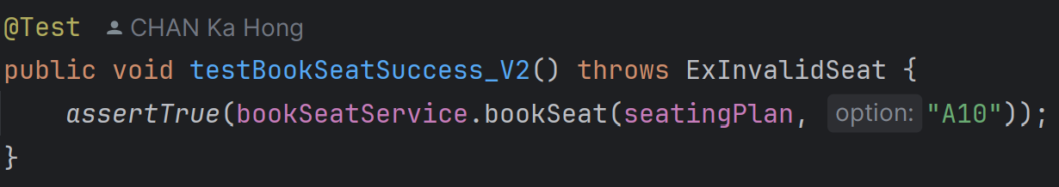

2. testBookSeatSuccess_V2:

It books seat "A10" and checks if the booking is successful.

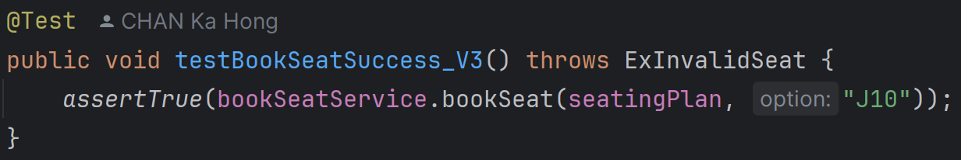

3. testBookSeatSuccess_V3:

It books seat "J10" and checks if the booking is successful.

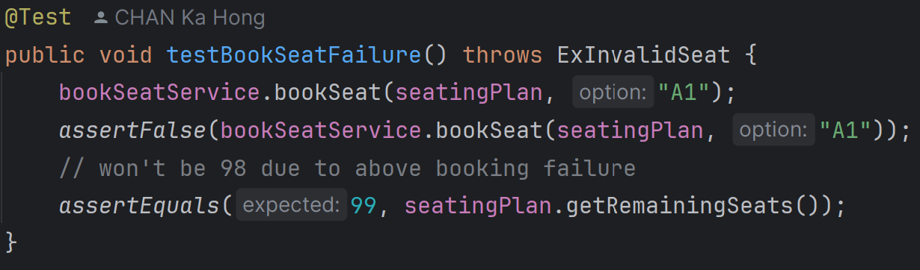

4. testBookSeatFailure:

It books seat "A1" and then attempts to book the same seat again. It verifies that the second booking attempt fails and the remaining seats count is not decremented further.

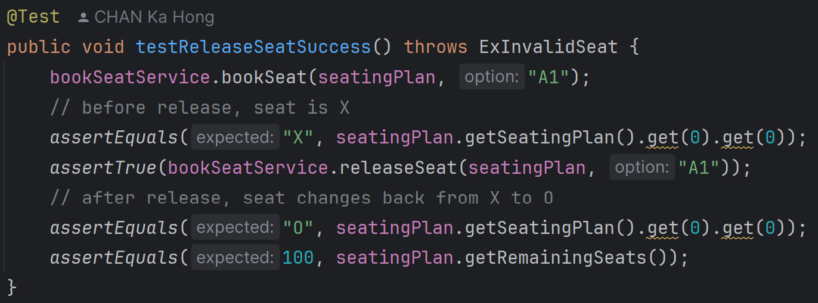

5. testReleaseSeatSuccess:

It books seat "A1" and then releases it. It verifies that the seat is marked as available ("O") after release and the remaining seats count is updated correctly.

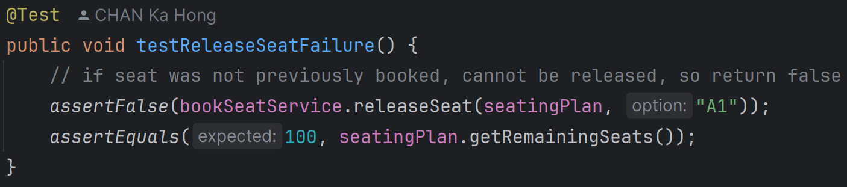

6. testReleaseSeatFailure:

It attempts to release seat "A1" without booking it first. It verifies that the release attempt fails and the remaining seats count remains unchanged.

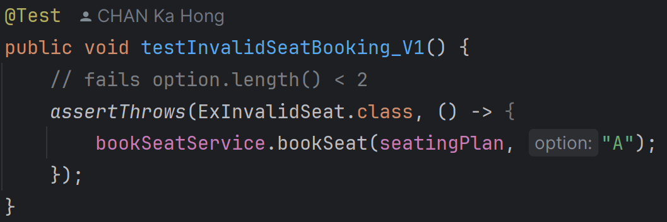

7. testInvalidSeatBooking_V1:

It attempts to book an invalid seat option "A", which fails due to option length < 2. It expects an ExInvalidSeat exception.

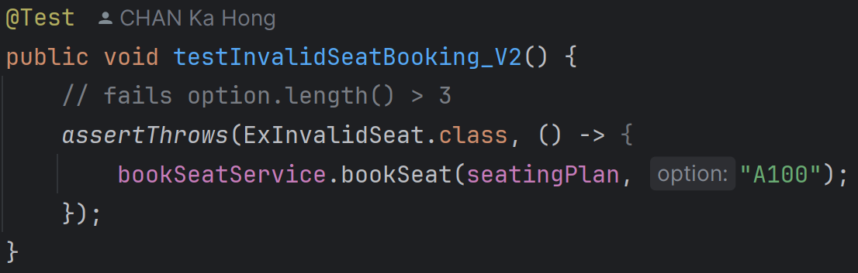

8. testInvalidSeatBooking_V2:

It attempts to book an invalid seat option "A100", which fails due to option length > 3. It expects an ExInvalidSeat exception.

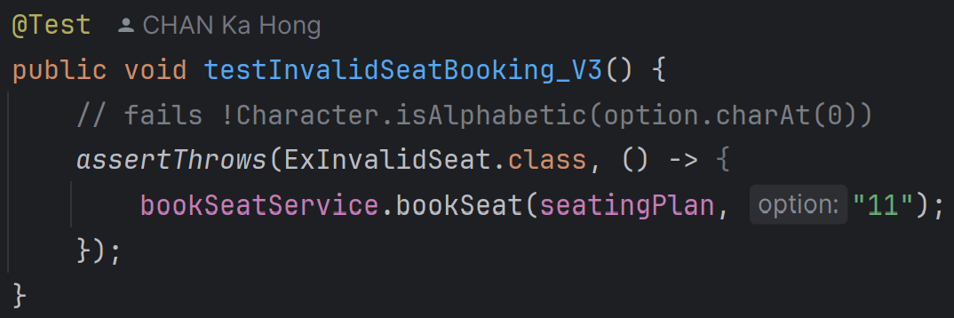

9. testInvalidSeatBooking_V3:

It attempts to book an invalid seat option "11", which fails due to non-alphabetic first character. It expects an ExInvalidSeat exception.

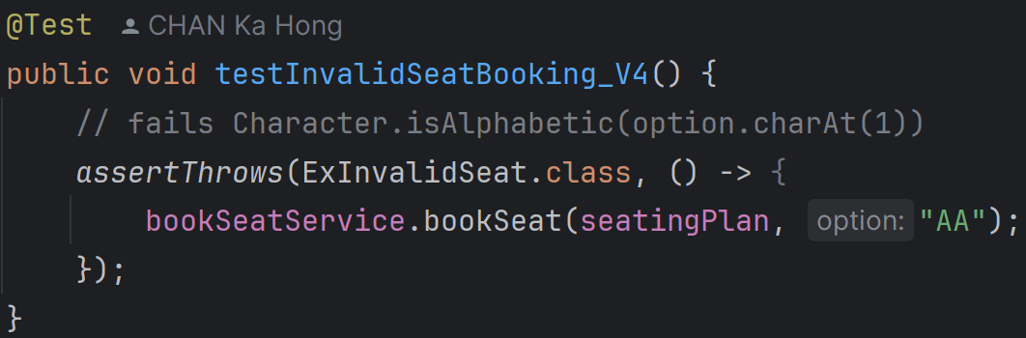

10. testInvalidSeatBooking_V4:

It attempts to book an invalid seat option "AA", which fails due to alphabetic second character. It expects an ExInvalidSeat exception.

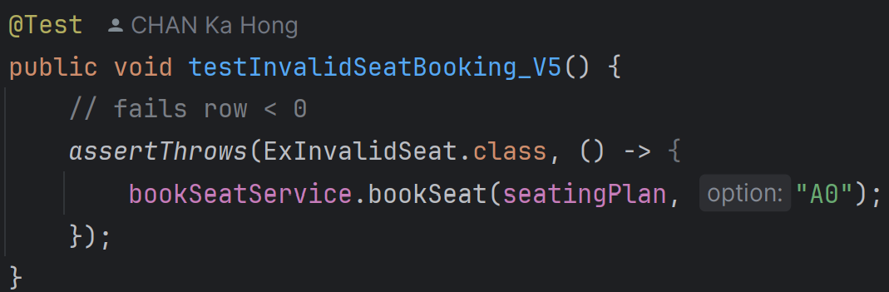

11. testInvalidSeatBooking_V5:

It attempts to book an invalid seat option "A0", which fails due to row < 0. It expects an ExInvalidSeat exception.

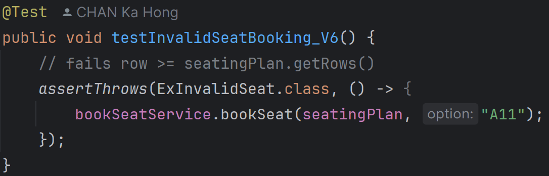

12. testInvalidSeatBooking_V6:

It attempts to book an invalid seat option "A11", which fails due to row >= seatingPlan.getRows(). It expects an ExInvalidSeat exception.

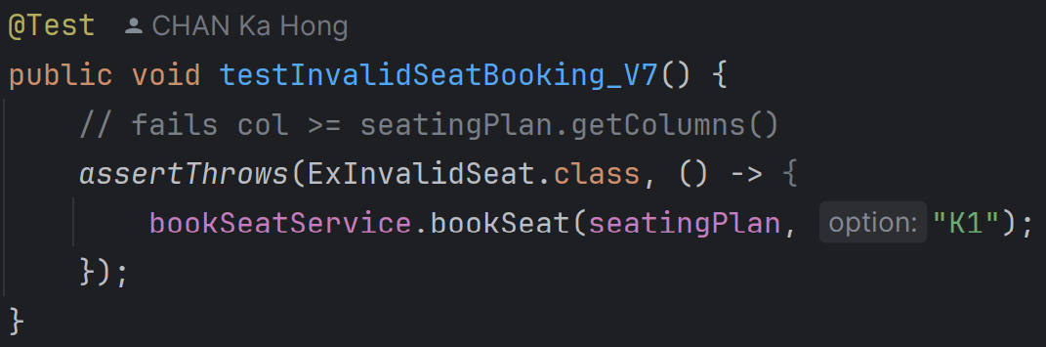

13. testInvalidSeatBooking_V7:

It attempts to book an invalid seat option "K1", which fails due to col >= seatingPlan.getColumns(). It expects an ExInvalidSeat exception.

**MovieInfoToStringTest.java (Package movie_test)**

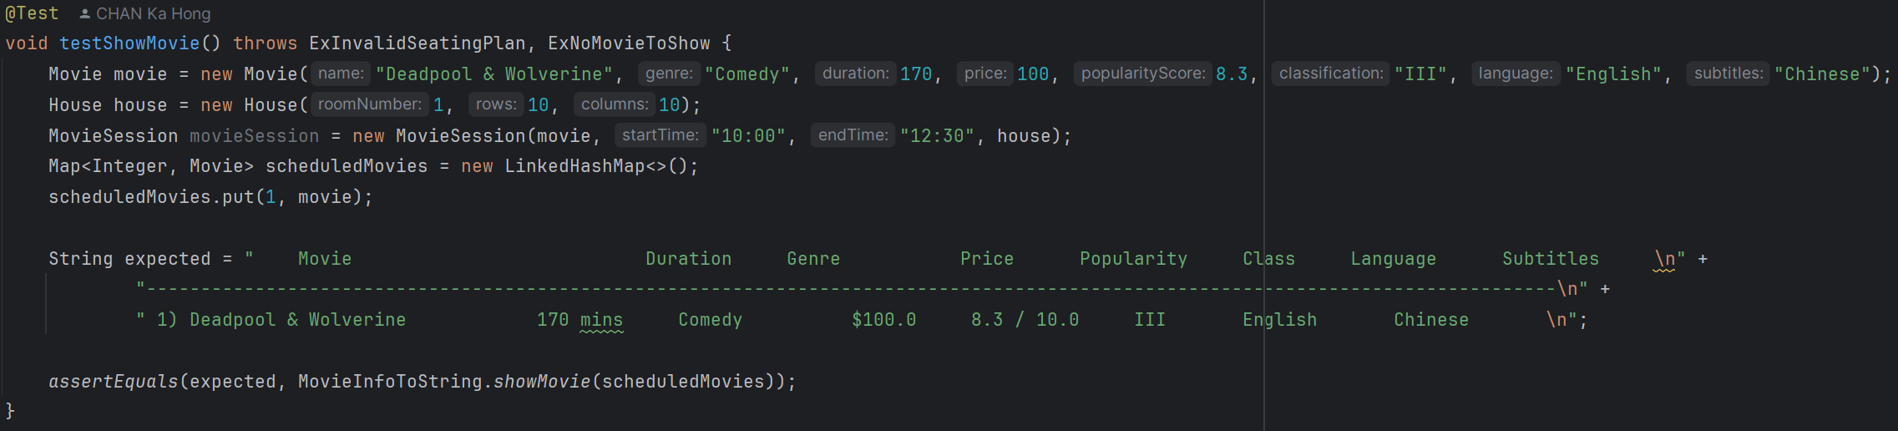

1. testShowMovie:

This test verifies the showMovie method. It creates a Movie object and adds it to a LinkedHashMap of scheduled movies. It then checks if the output of showMovie matches the expected string format.

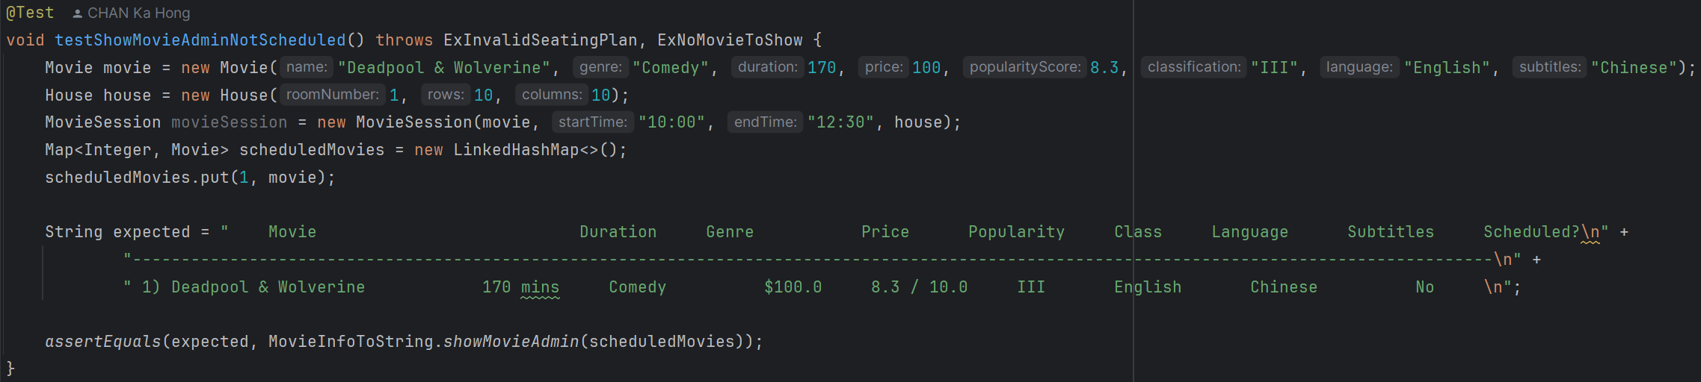2. testShowMovieAdminNotScheduled:

This test verifies the showMovieAdmin method when the movie is not scheduled. It creates a Movie object and adds it to a LinkedHashMap of scheduled movies. It then checks if the output of showMovieAdmin matches the expected string format, indicating the movie is not scheduled.

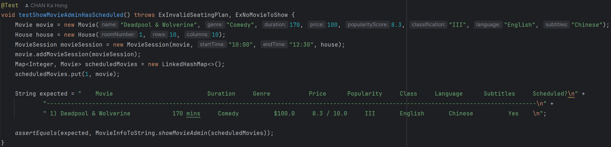

3. testShowMovieAdminHasScheduled:

This test verifies the showMovieAdmin method when the movie is scheduled. It creates a Movie object, adds a MovieSession to it, and adds it to a LinkedHashMap of scheduled movies. It then checks if the output of showMovieAdmin matches the expected string format, indicating the movie is scheduled.

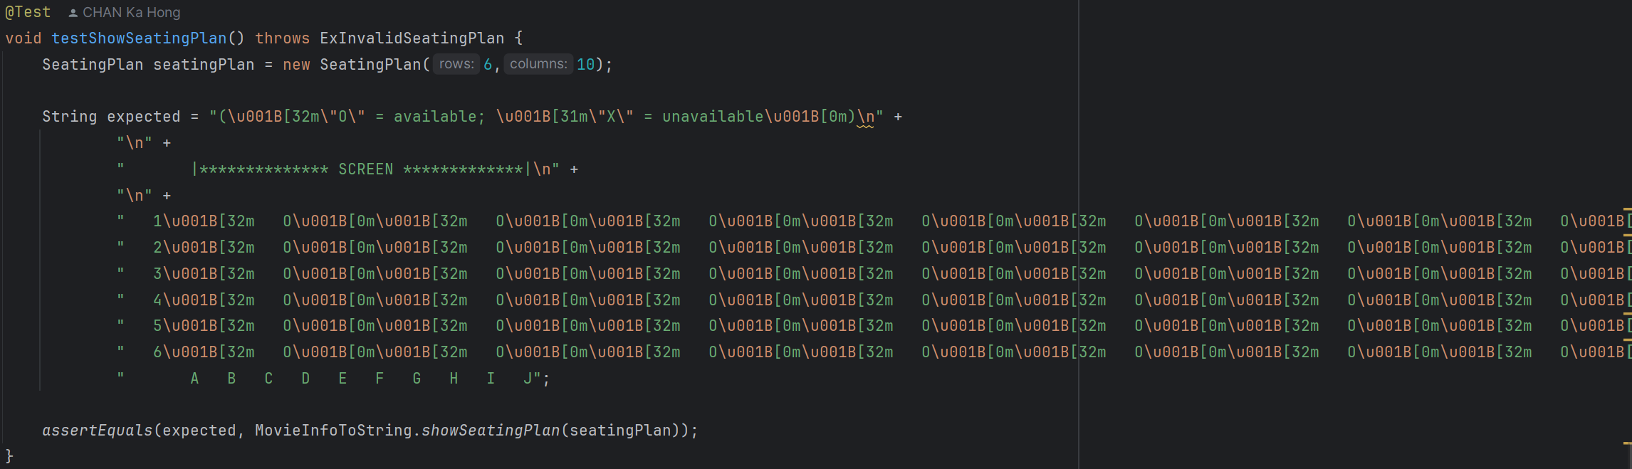

4. testShowSeatingPlan:

This test verifies the showSeatingPlan method. It creates a SeatingPlan object with 6 rows and 10 columns. It then checks if the output of showSeatingPlan matches the expected string format, showing the seating plan with available seats.

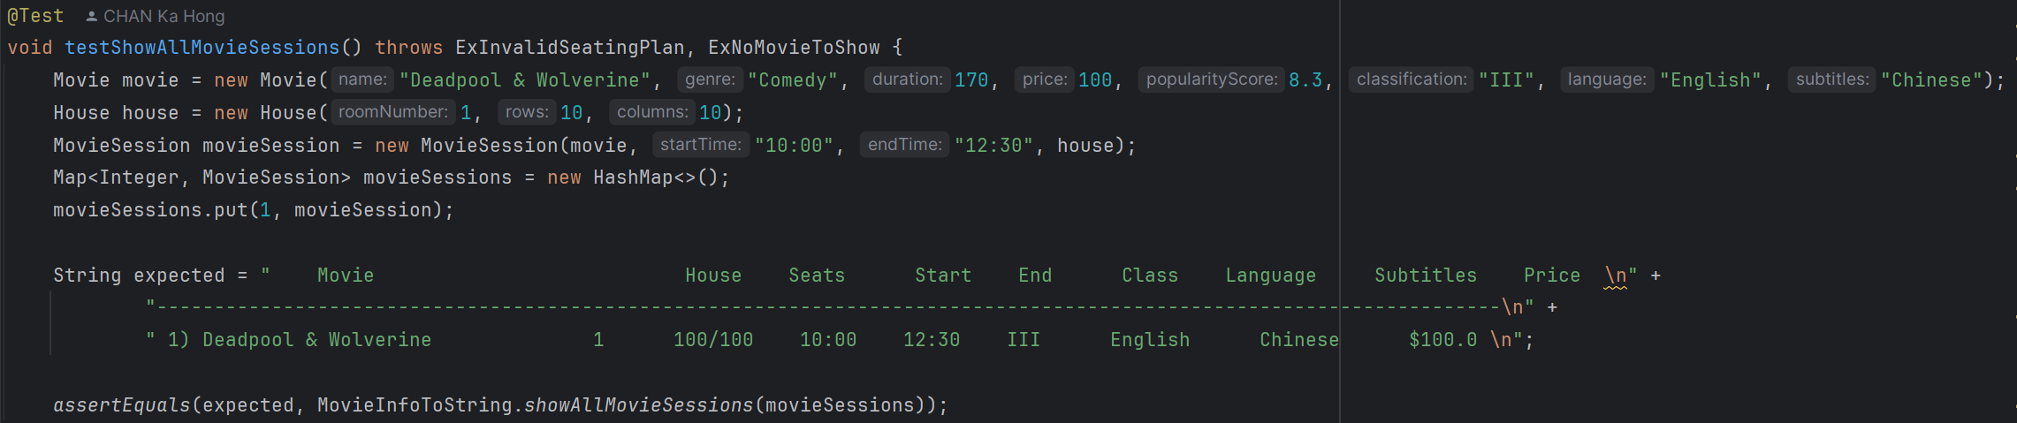

5. testShowAllMovieSessions:

This test verifies the showAllMovieSessions method. It creates a Movie object, a House object, and a MovieSession object, and adds the session to a HashMap of movie sessions. It then checks if the output of showAllMovieSessions matches the expected string format, showing all movie sessions.

**MovieSchedulingTest.java (Package movie_test)**

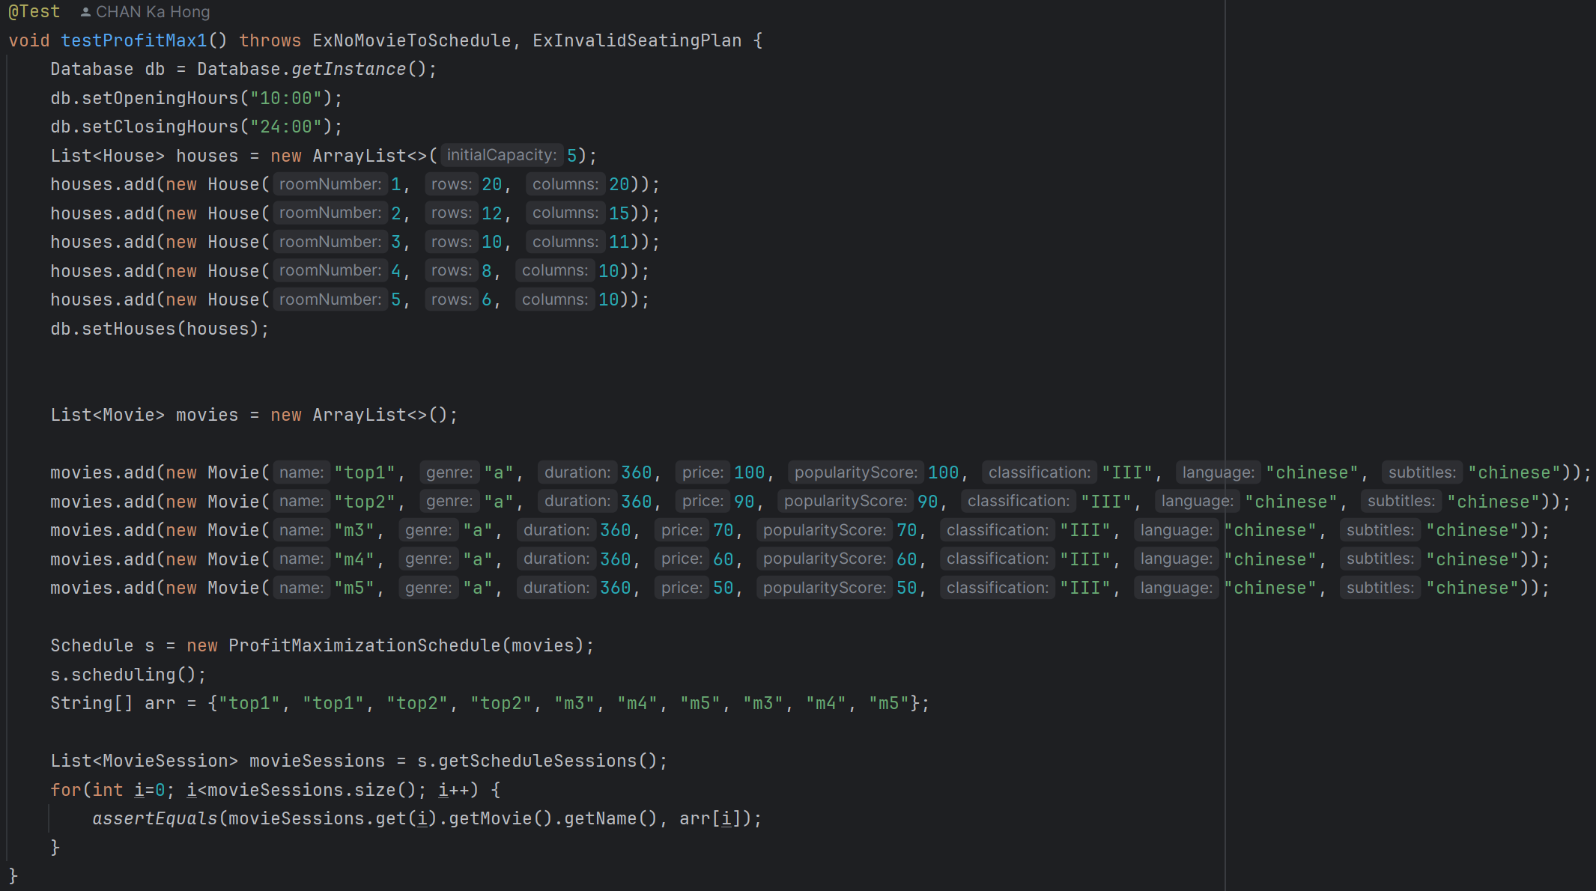

1. testProfitMax1:

It sets up a database with opening and closing hours and a list of houses, creates a list of movies with different popularity scores and prices, and uses the ProfitMaximizationSchedule to schedule the movies. It asserts that the scheduled movie sessions match the expected order based on profit maximization.

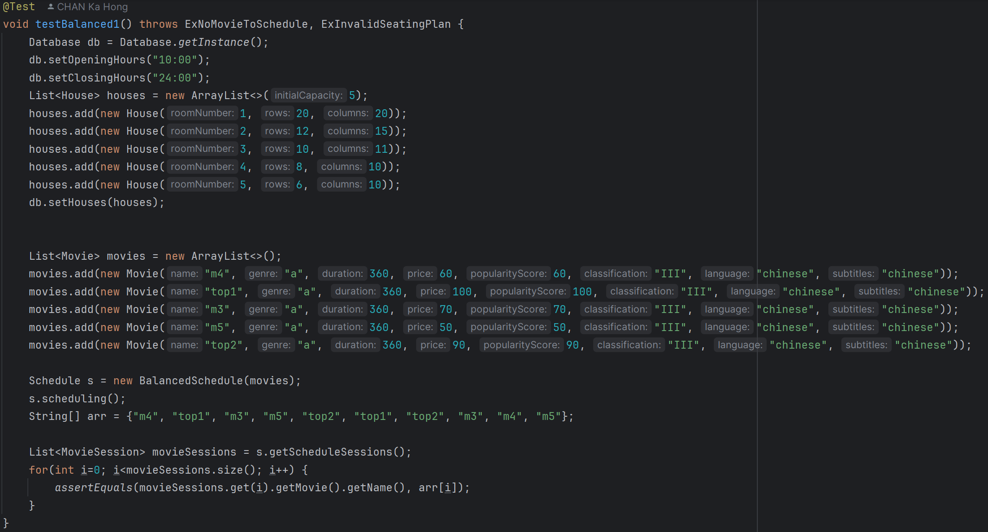

2. testBalanced1:

It uses the BalancedSchedule to schedule the movies and asserts that the scheduled movie sessions match the expected order based on a balanced scheduling approach.

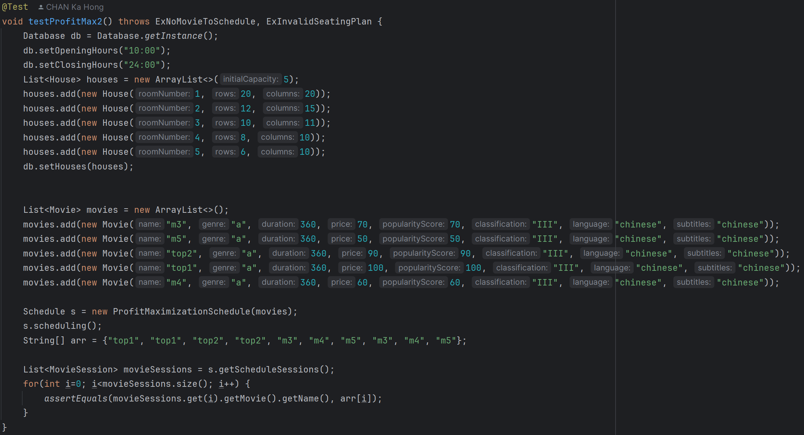

3. testProfitMax2:

It uses the ProfitMaximizationSchedule to schedule a different set of movies and asserts that the scheduled movie sessions match the expected order based on profit maximization.

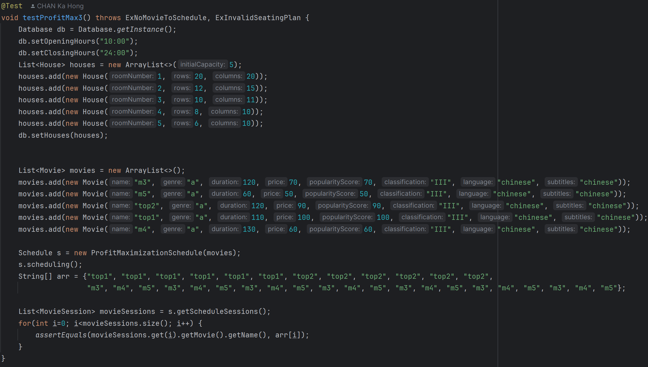

4. testProfitMax3:

It uses the ProfitMaximizationSchedule to schedule movies with different durations and asserts that the scheduled movie sessions match the expected order based on profit maximization.

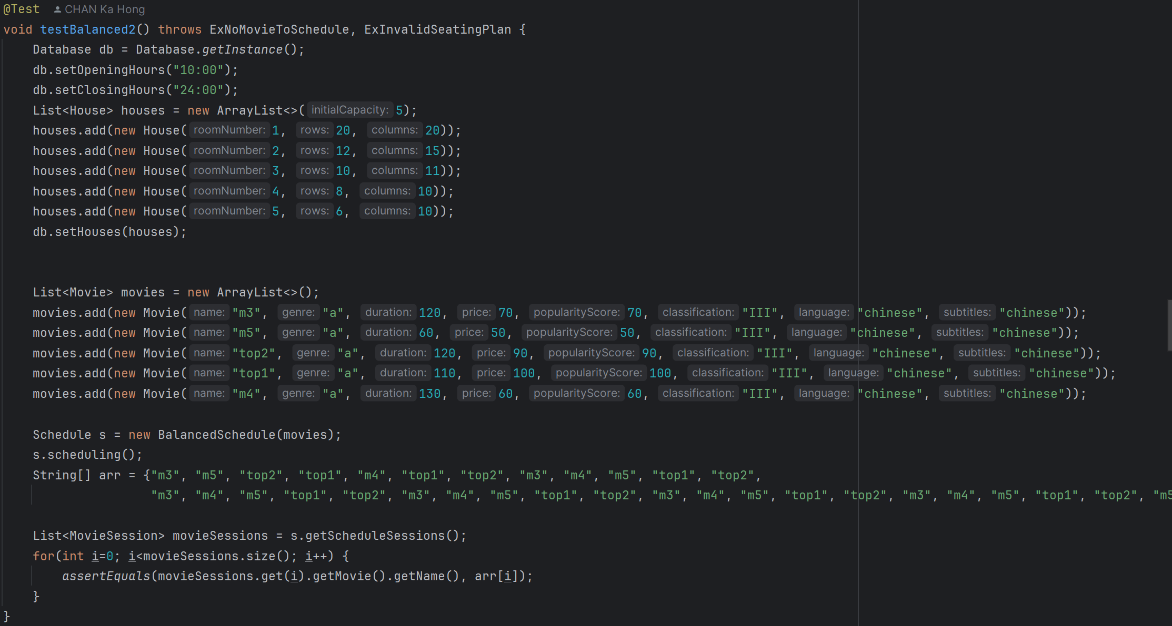

5. testBalanced2:

It uses the BalancedSchedule to schedule a different set of movies. And asserts that the scheduled movie sessions match the expected order based on a balanced scheduling approach.

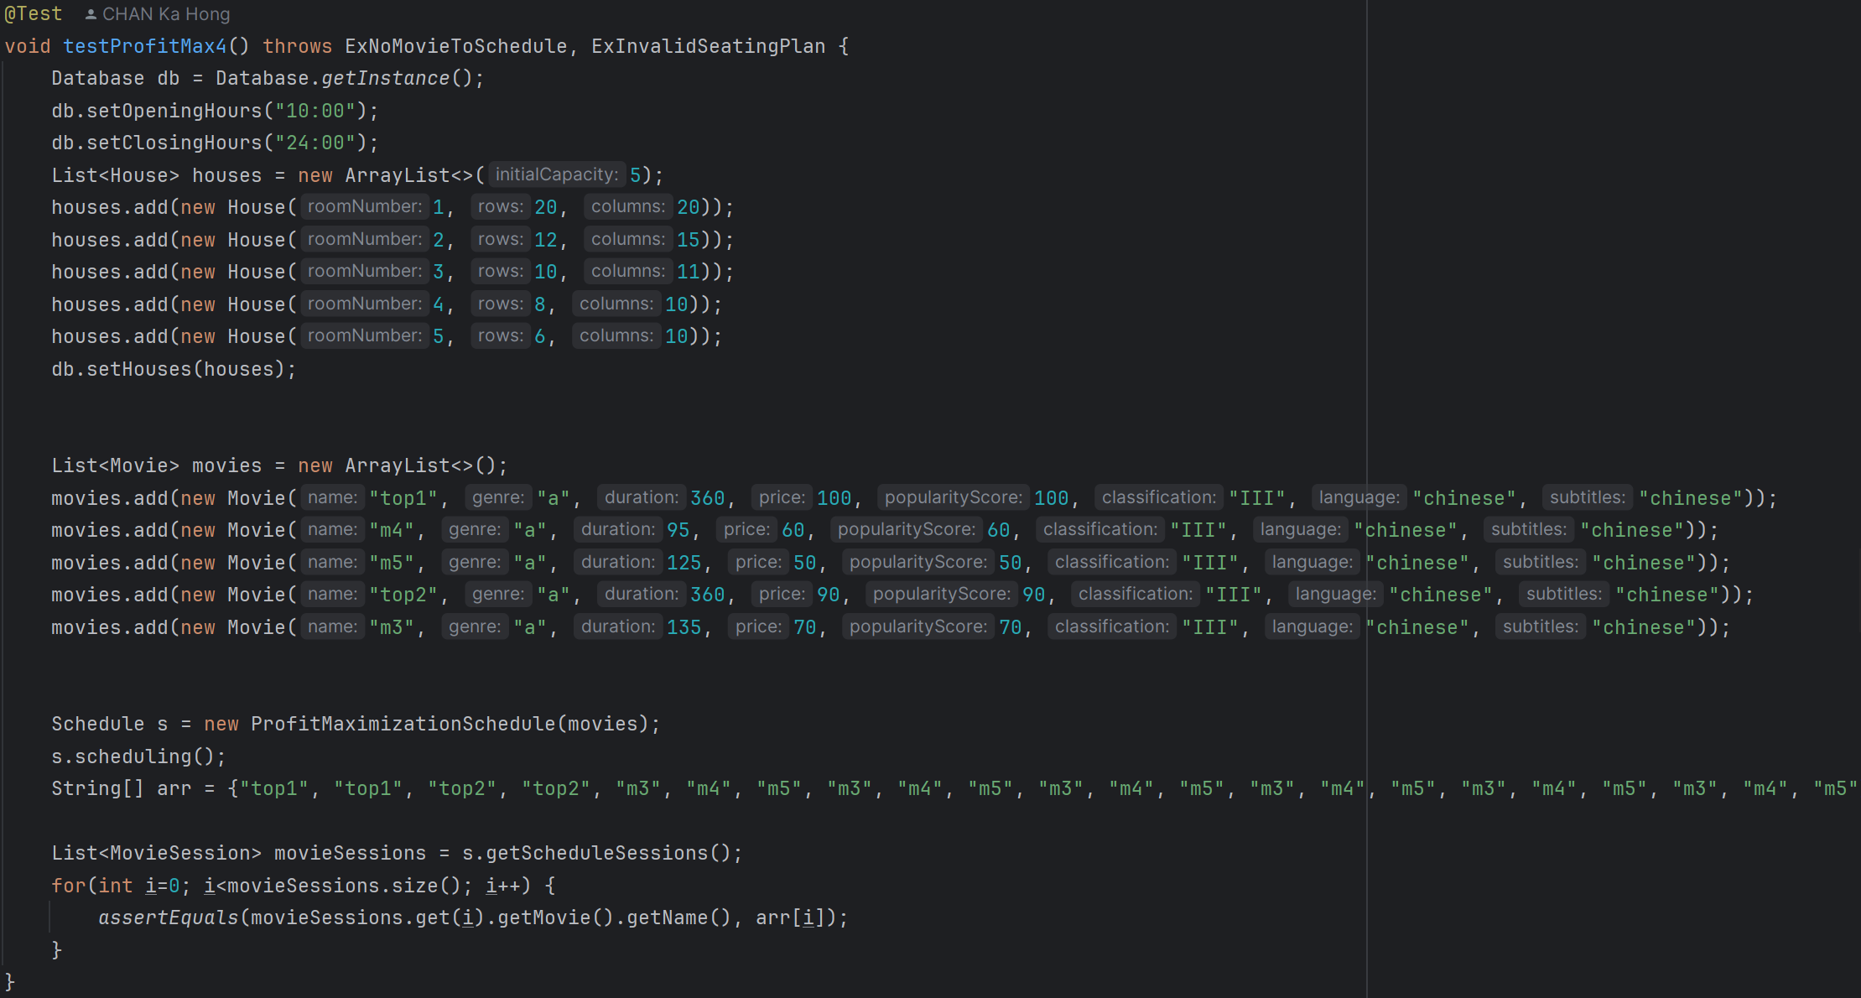

6. testProfitMax4:

It uses the ProfitMaximizationSchedule to schedule another set of movies and asserts that the scheduled movie sessions match the expected order based on profit maximization.

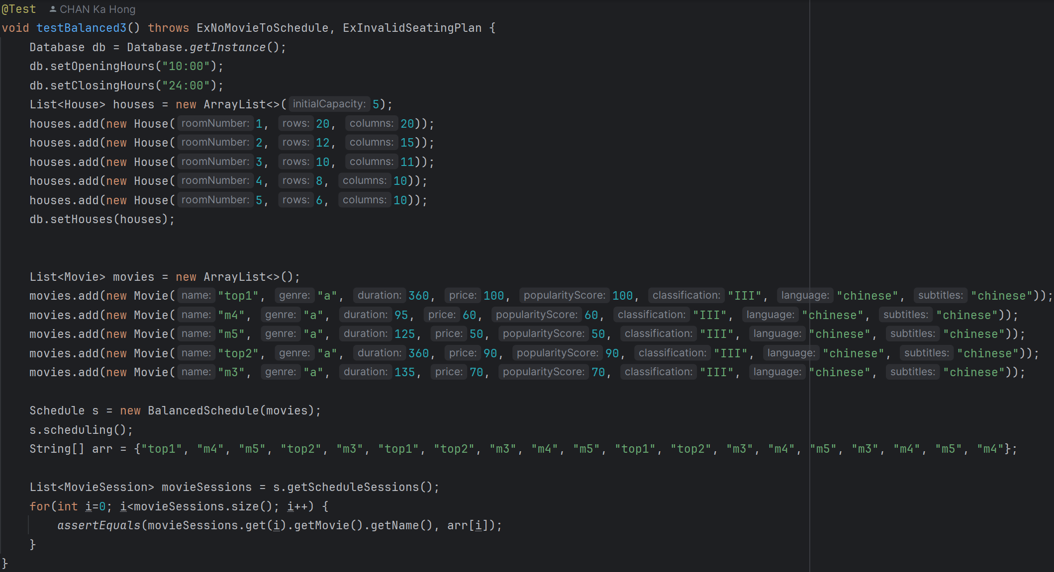

7. testBalanced3:

It uses the BalancedSchedule to schedule another set of movies and asserts that the scheduled movie sessions match the expected order based on a balanced scheduling approach.

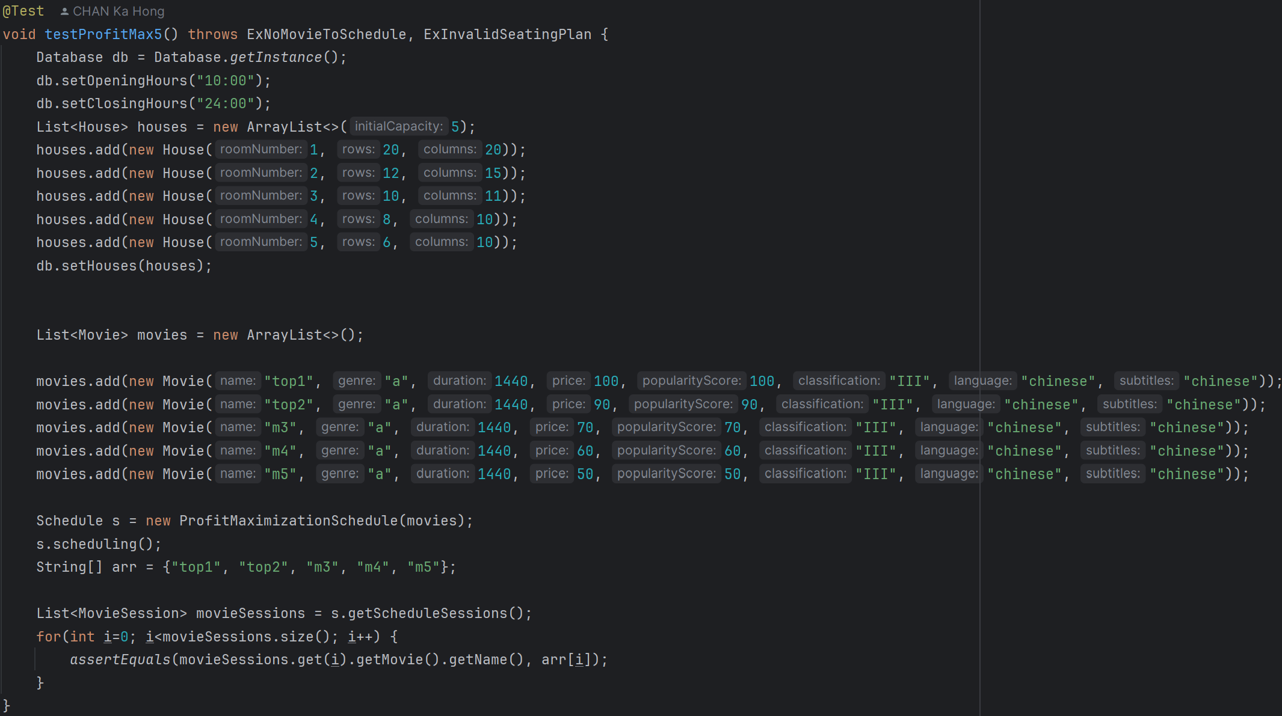

8. testProfitMax5:

It uses the ProfitMaximizationSchedule to schedule movies with very long durations and asserts that the scheduled movie sessions match the expected order based on profit maximization.

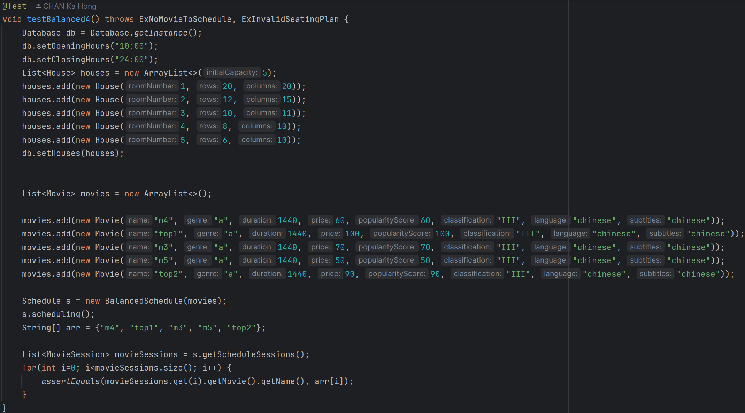

9. testBalanced4:

It uses the BalancedSchedule to schedule movies with very long durations and asserts that the scheduled movie sessions match the expected order based on a balanced scheduling approach.

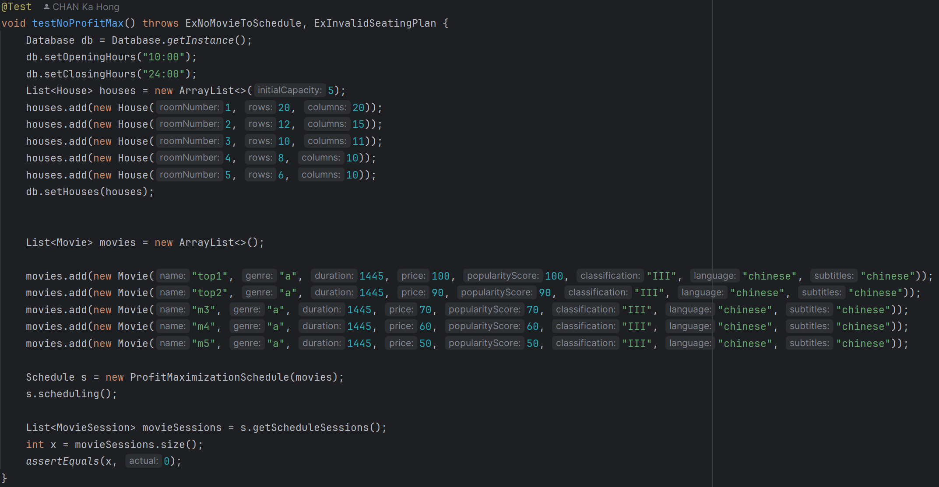

10. testNoProfitMax:

It sets up a database with opening and closing hours and a list of houses, creates a list of movies with durations longer than the available scheduling time, and uses the ProfitMaximizationSchedule to attempt to schedule the movies. It asserts that no movie sessions are scheduled due to the excessive durations.

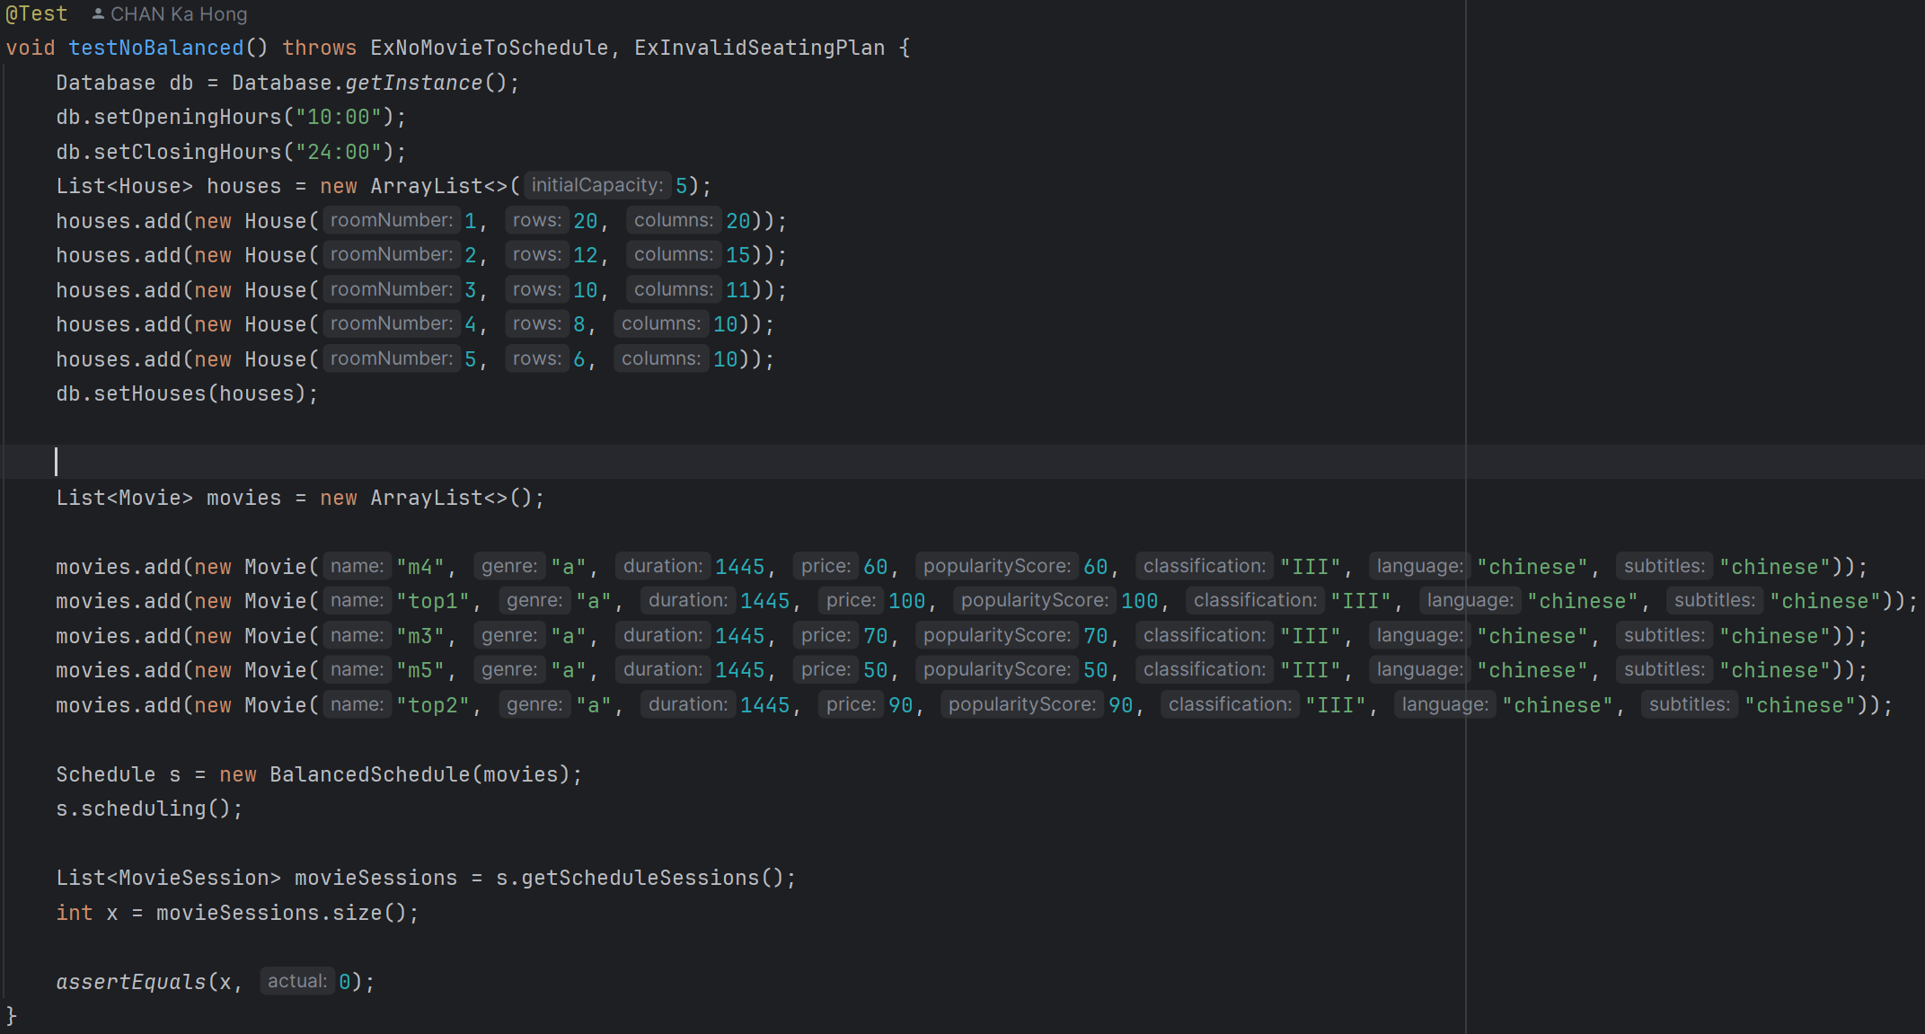

11. testNoBalanced:

It uses the BalancedSchedule to attempt to schedule the movies and asserts that no movie sessions are scheduled due to the excessive durations.

**AlipayPaymentTest.java (Package payment_test)**

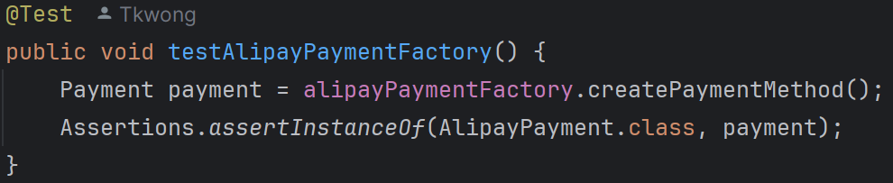

1. testAlipayPaymentFactory:

This test verifies that the AlipayPaymentFactory can create an instance of AlipayPayment. It asserts that the created payment method is an instance of AlipayPayment.

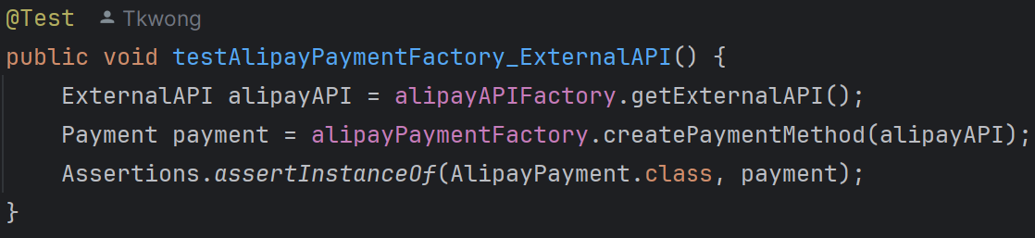

2. testAlipayPaymentFactory_ExternalAPI:

This test checks if the AlipayPaymentFactory can create an instance of AlipayPayment using an ExternalAPI object. It asserts that the created payment method is an instance of AlipayPayment.

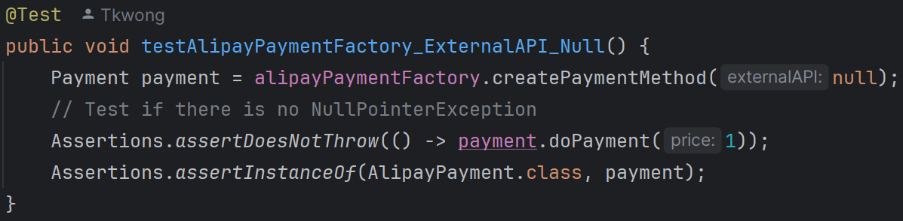

3. testAlipayPaymentFactory_ExternalAPI_Null:

This test ensures that the AlipayPaymentFactory can handle a null ExternalAPI object without throwing a NullPointerException. It asserts that the doPayment method does not throw an exception and that the created payment method is an instance of AlipayPayment.

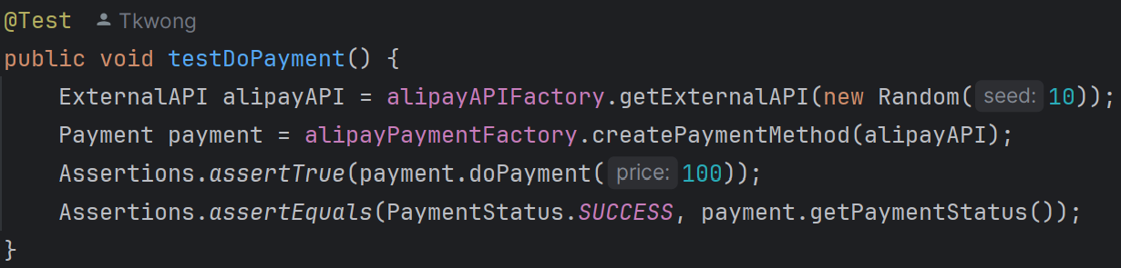

4. testDoPayment:

This test verifies that the AlipayPayment can successfully process a payment. It asserts that the payment is successful and that the payment status is SUCCESS.

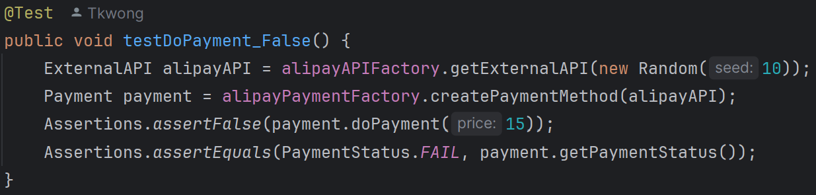

5. testDoPayment_False:

This test checks if the AlipayPayment can handle a failed payment. It asserts that the payment fails and that the payment status is FAIL.

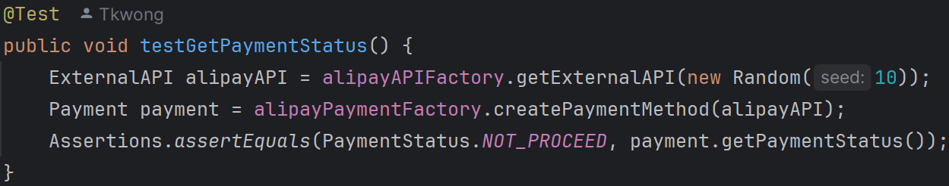

6. testGetPaymentStatus:

This test verifies the initial payment status of AlipayPayment. It asserts that the initial payment status is NOT_PROCEED.

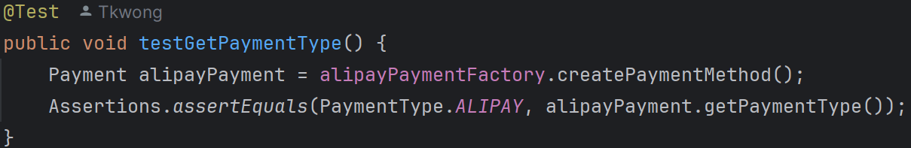

7. testGetPaymentType:

This test checks the payment type of AlipayPayment. It asserts that the payment type is ALIPAY.

**CreditCardPaymentTest.java (Package payment_test)**

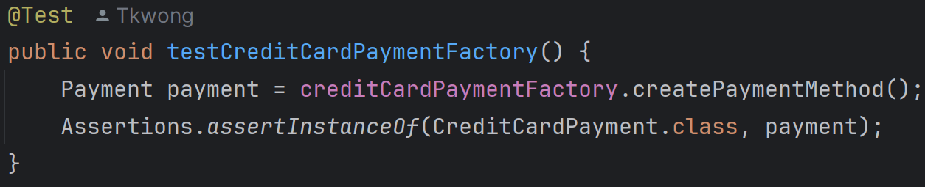

1. testCreditCardPaymentFactory:

It verifies that the CreditCardPaymentFactory can create an instance of CreditCardPayment.

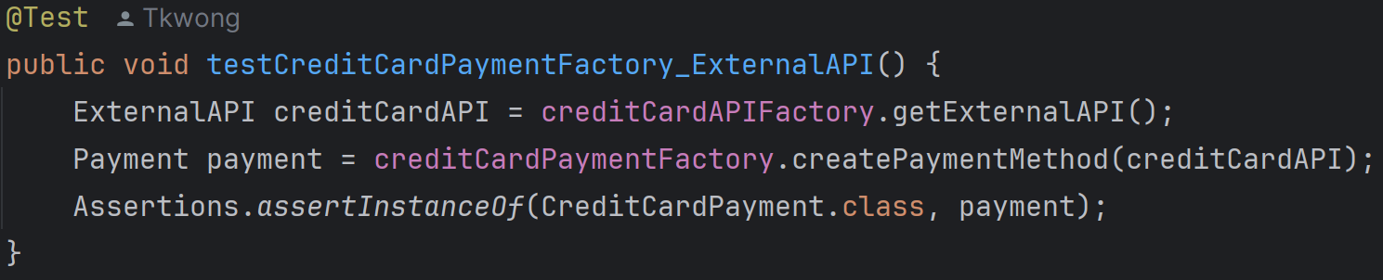

2. testCreditCardPaymentFactory_ExternalAPI:

It verifies that the CreditCardPaymentFactory can create an instance of CreditCardPayment with an

ExternalAPI object.

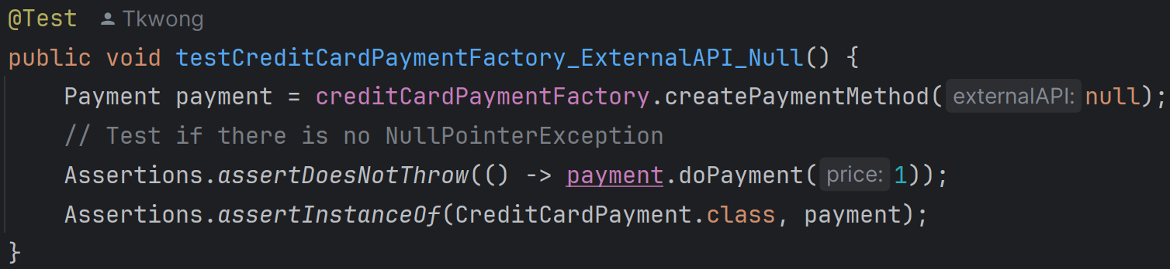

3. testCreditCardPaymentFactory_ExternalAPI_Null:

It verifies that the CreditCardPaymentFactory can create an instance of CreditCardPayment with a null ExternalAPI object and ensures that no NullPointerException is thrown.

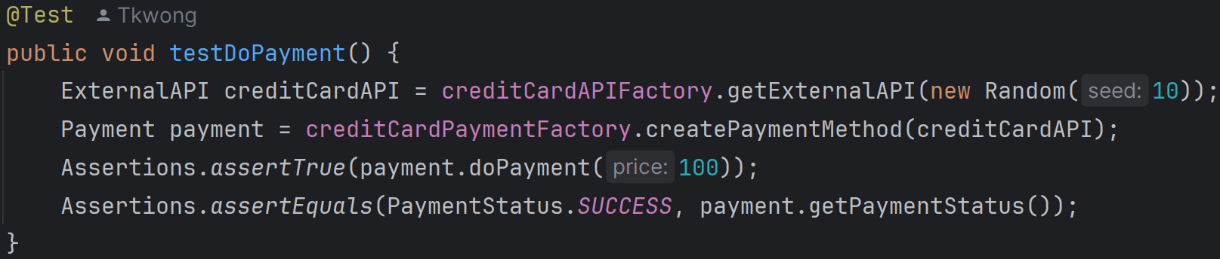

4. testDoPayment:

It verifies that the CreditCardPayment can successfully process a payment of 100 units, and the payment status should be SUCCESS.

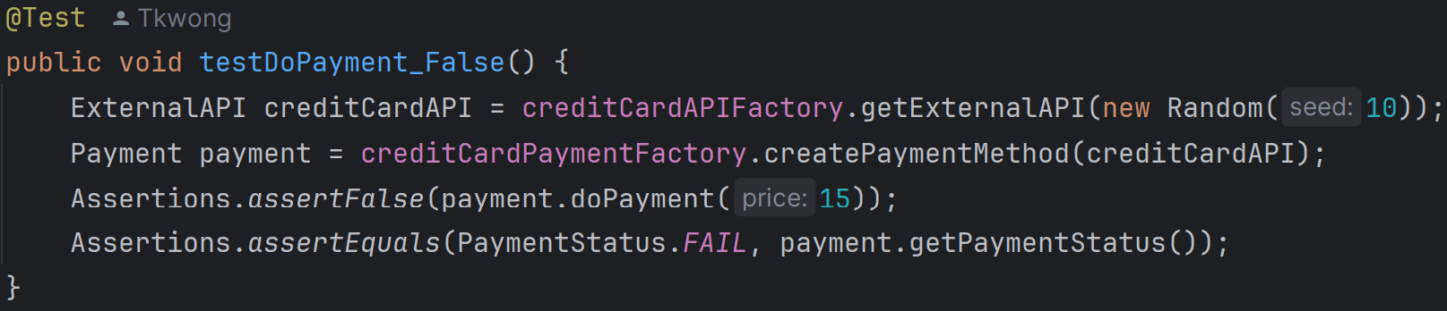

5. testDoPayment_False:

It verifies that the CreditCardPayment fails to process a payment of 15 units, and the payment status should be FAIL.

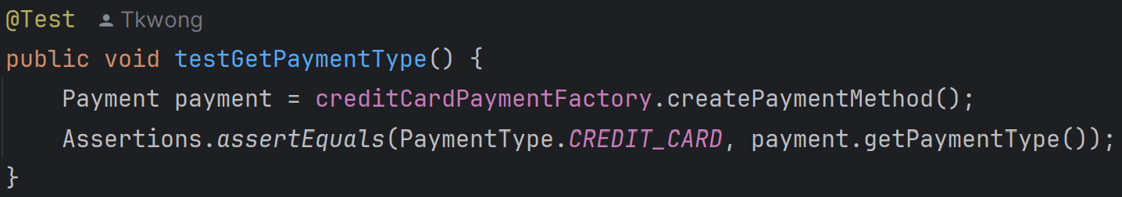

6. testGetPaymentType:

It verifies that the getPaymentType method in CreditCardPayment returns PaymentType.CREDIT_CARD.

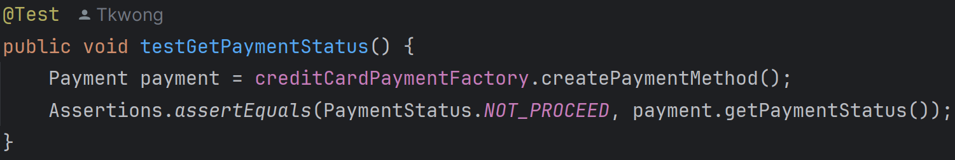

7. testGetPaymentStatus:

It verifies that the getPaymentStatus method in CreditCardPayment returns PaymentStatus.NOT_PROCEED before any payment is attempted.

**OctopusPaymentTest.java (Package payment_test)**

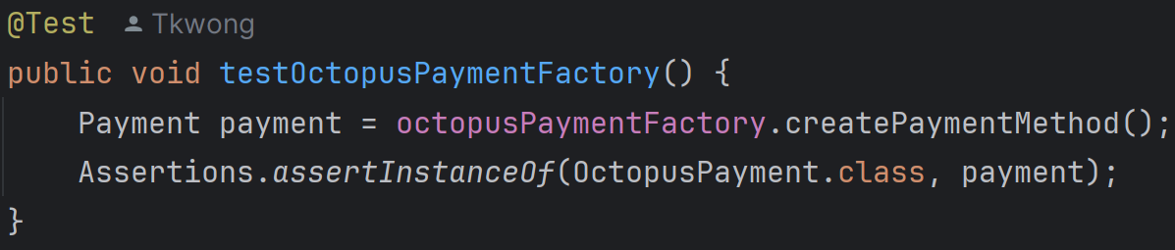

1. testOctopusPaymentFactory:

This test verifies that the OctopusPaymentFactory can create an instance of OctopusPayment. It uses the createPaymentMethod method of the factory and asserts that the created object is an instance of OctopusPayment.

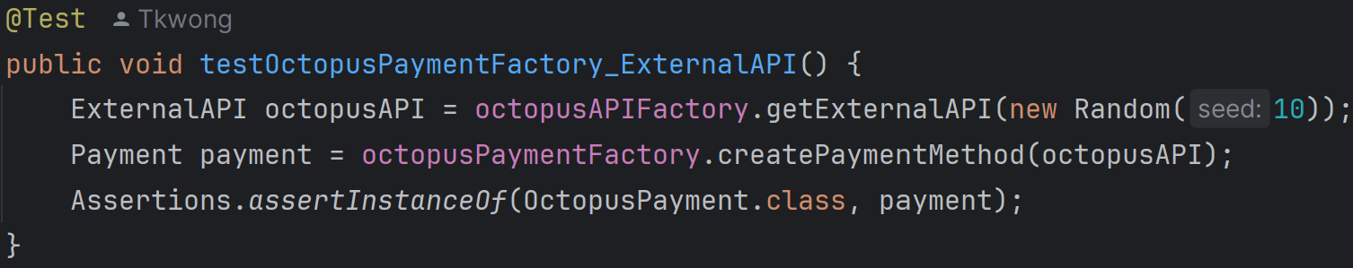

2. testOctopusPaymentFactory_ExternalAPI:

This test checks if the OctopusPaymentFactory can create an instance of OctopusPayment with an ExternalAPI object. It uses a Random object to simulate the ExternalAPI and asserts that the created object is an instance of OctopusPayment.

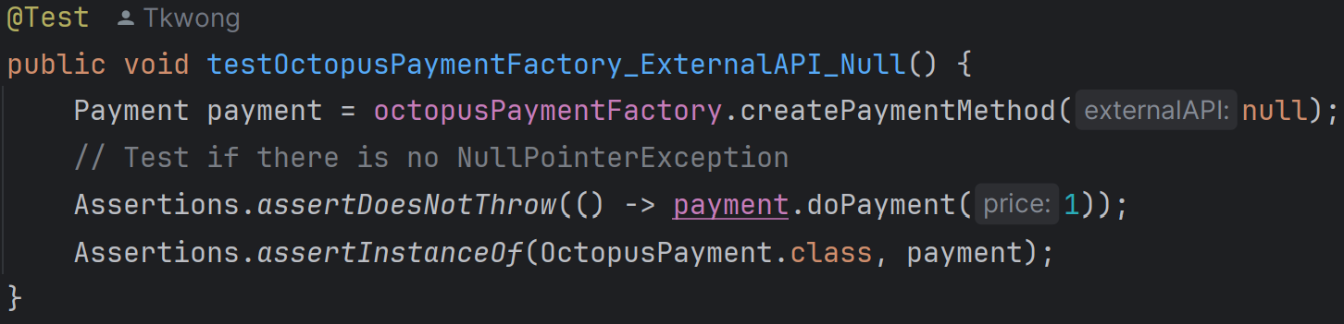

3. testOctopusPaymentFactory_ExternalAPI_Null:

This test verifies that the OctopusPaymentFactory can handle a null ExternalAPI object without throwing a NullPointerException. It asserts that the doPayment method does not throw an exception and that the created object is an instance of OctopusPayment.

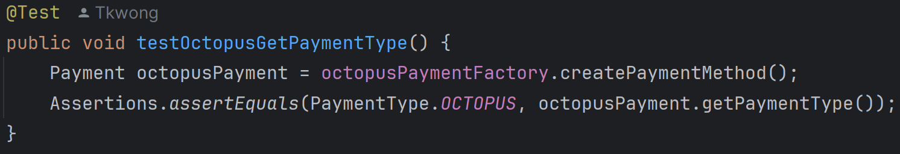

4. testOctopusGetPaymentType:

This test checks if the getPaymentType method in the OctopusPayment class returns PaymentType.OCTOPUS. It asserts that the payment type is correctly returned.

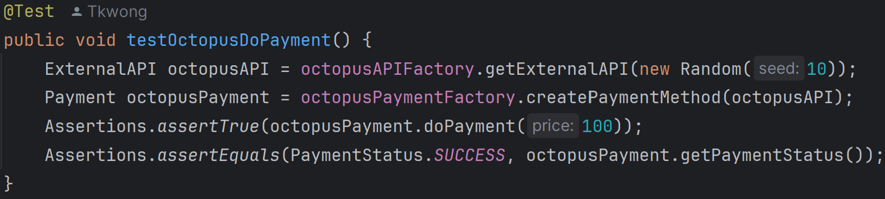

5. testOctopusDoPayment:

This test verifies that the doPayment method in the OctopusPayment class returns true for a successful payment. It uses a Random object to simulate the ExternalAPI and asserts that the payment status is PaymentStatus.SUCCESS.

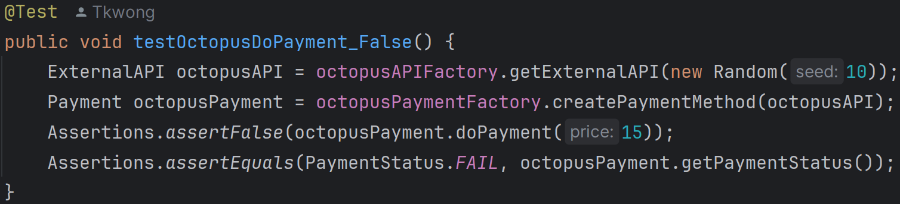

6. testOctopusDoPayment_False:

This test checks if the doPayment method in the OctopusPayment class returns false for a failed payment. It uses a Random object to simulate the ExternalAPI and asserts that the payment status is PaymentStatus.FAIL.

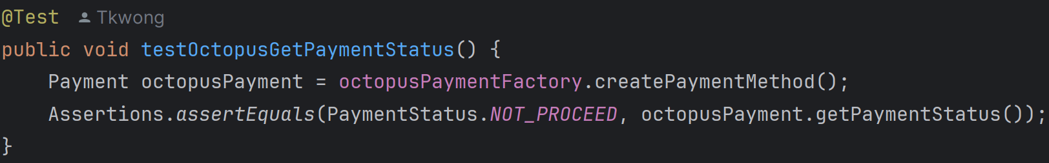

7. testOctopusGetPaymentStatus:

This test verifies that the getPaymentStatus method in the OctopusPayment class returns PaymentStatus.NOT_PROCEED before any payment is made. It asserts that the initial payment status is correctly returned.

**PayMePaymentTest.java (Package payment_test)**

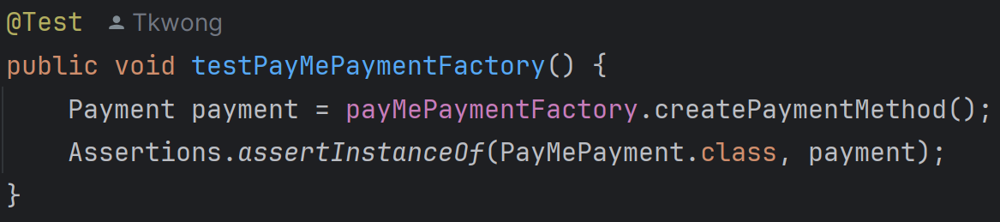

1. testPayMePaymentFactory:

This test verifies that the PayMePaymentFactory can create an instance of PayMePayment. It asserts that the created payment object is an instance of PayMePayment.

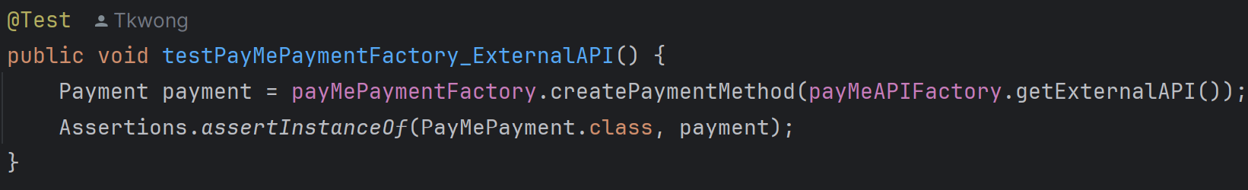

2. testPayMePaymentFactory_ExternalAPI:

This test checks if the PayMePaymentFactory can create an instance of PayMePayment using an ExternalAPI object. It asserts that the created payment object is an instance of PayMePayment.

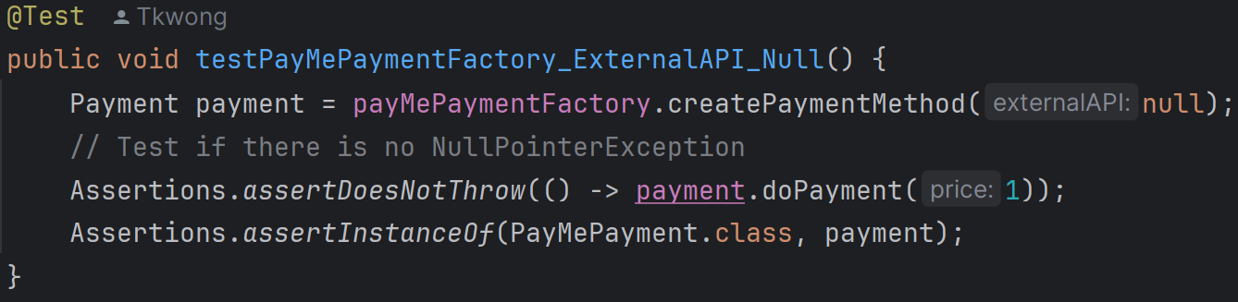

3. testPayMePaymentFactory_ExternalAPI_Null:

This test verifies that the PayMePaymentFactory can create an instance of PayMePayment with a null ExternalAPI object. It asserts that no NullPointerException is thrown when calling the doPayment method on the created payment object. It also asserts that the created payment object is an instance of PayMePayment.

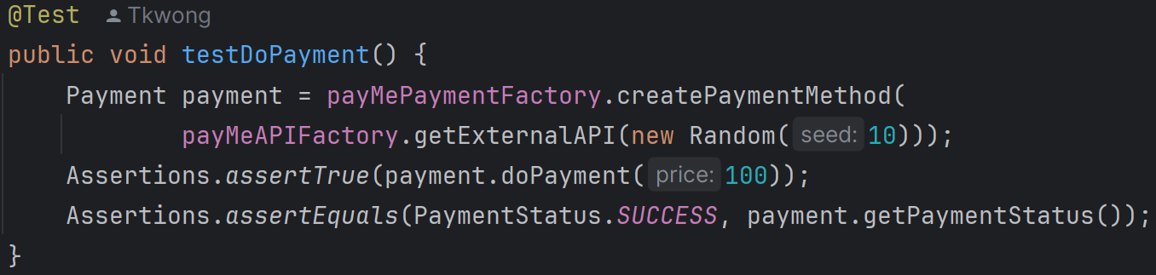

4. testDoPayment:

This test checks the doPayment method of the PayMePayment class. It asserts that the payment is successful (returns true) and the payment status is SUCCESS.

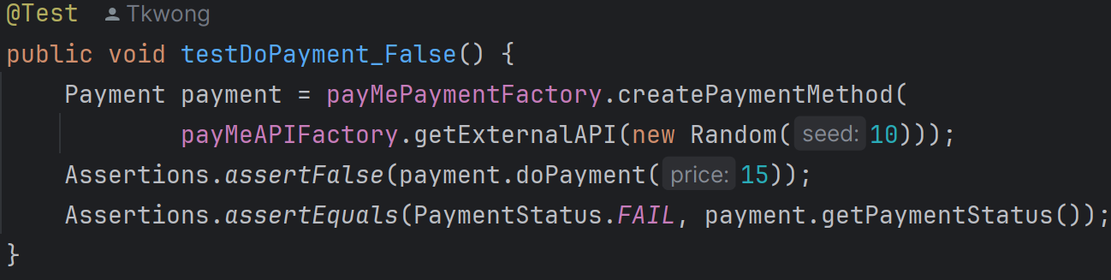

5. testDoPayment_False:

This test verifies the doPayment method of the PayMePayment class with a false payment scenario. It asserts that the payment fails (returns false) and the payment status is FAIL.

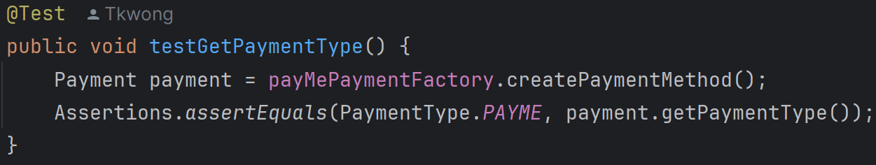

6. testGetPaymentType:

This test checks if the PayMePayment can get the payment type. It asserts that the payment type is PAYME.

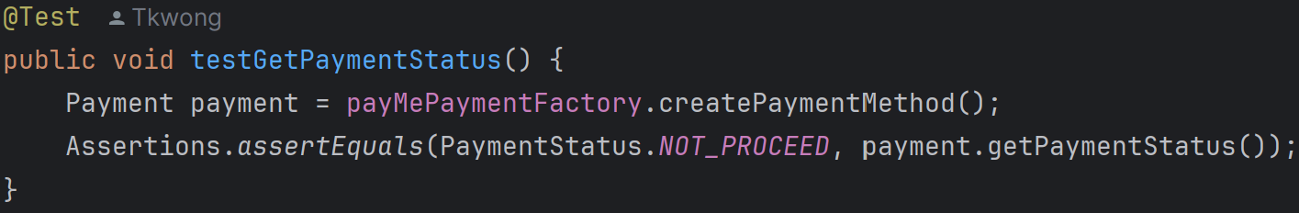

7. testGetPaymentStatus:

This test verifies if the PayMePayment can get the payment status. It asserts that the initial payment status is NOT_PROCEED.

**WeChatPayPaymentTest.java (Package payment_test)**

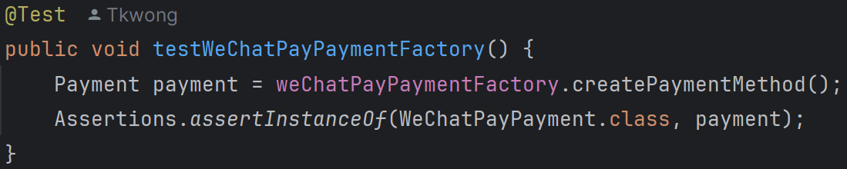

1. testWeChatPayPaymentFactory:

This test checks if the WeChatPayPaymentFactory can create an instance of WeChatPayPayment. It asserts that the created payment method is an instance of WeChatPayPayment.

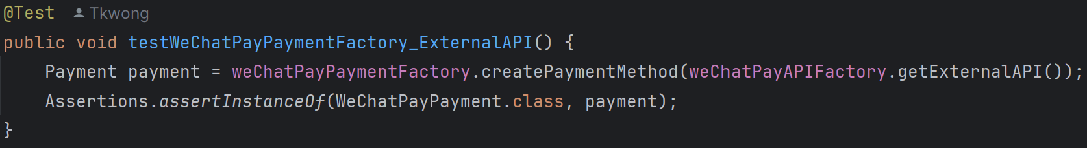

2. testWeChatPayPaymentFactory_ExternalAPI:

This test verifies if the WeChatPayPaymentFactory can create an instance of WeChatPayPayment using an ExternalAPI object. It asserts that the created payment method is an instance of WeChatPayPayment.

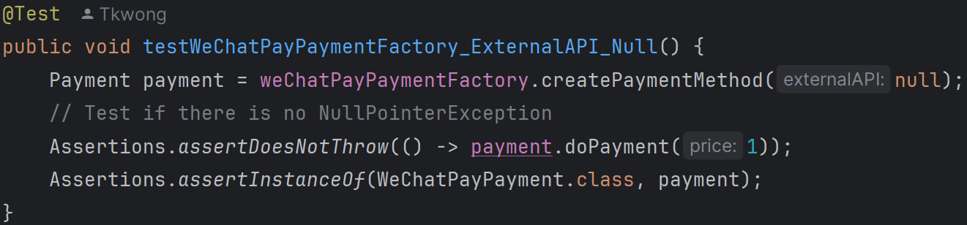

3. testWeChatPayPaymentFactory_ExternalAPI_Null:

This test checks if the WeChatPayPaymentFactory can create an instance of WeChatPayPayment with a null ExternalAPI object. It asserts that no NullPointerException is thrown when calling doPayment on the created payment method. It also asserts that the created payment method is an instance of WeChatPayPayment.

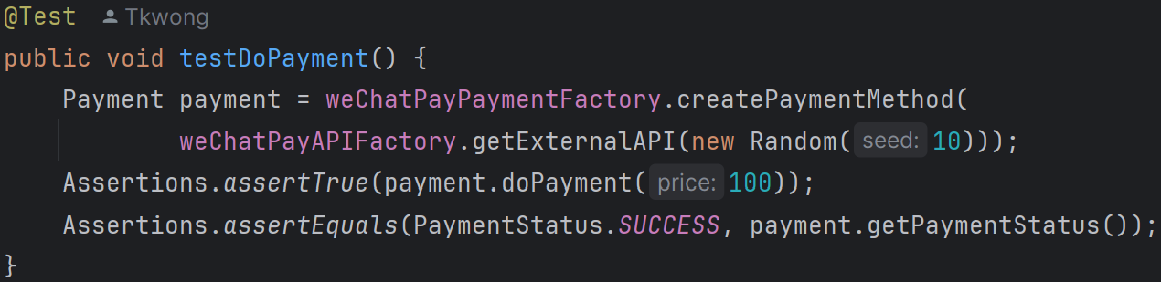

4. testDoPayment:

This test verifies if the WeChatPayPayment can successfully process a payment. It asserts that the doPayment method returns true for a payment of 100. It also asserts that the payment status is SUCCESS.

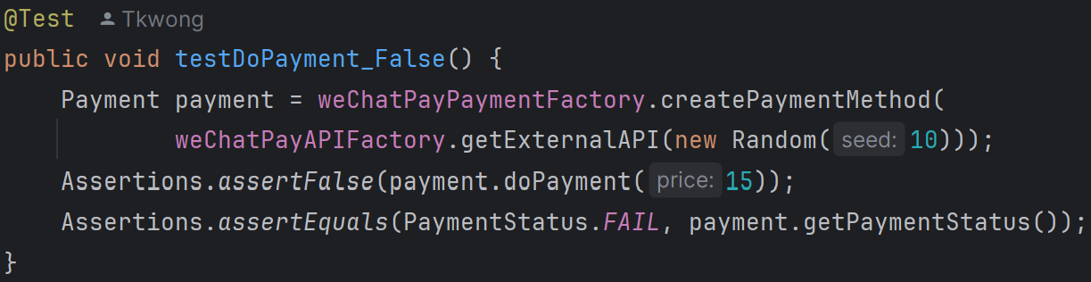

5. testDoPayment_False:

This test checks if the WeChatPayPayment can handle an unsuccessful payment. It asserts that the doPayment method returns false for a payment of 15. It also asserts that the payment status is FAIL.

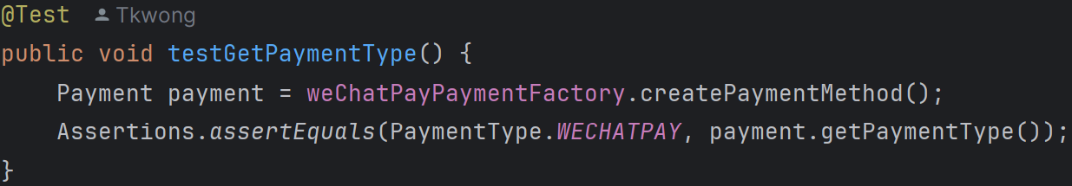

6. testGetPaymentType:

This test verifies if the WeChatPayPayment can return the correct payment type. It asserts that the payment type is WECHATPAY.

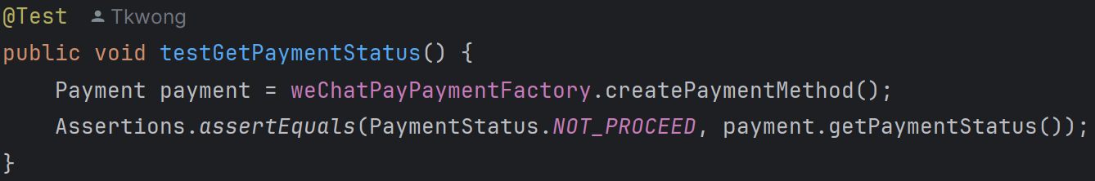

7. testGetPaymentStatus:

This test checks if the WeChatPayPayment can return the correct initial payment status. It asserts that the initial payment status is NOT_PROCEED.

**DrinkTest.java** **(Package product_test)**

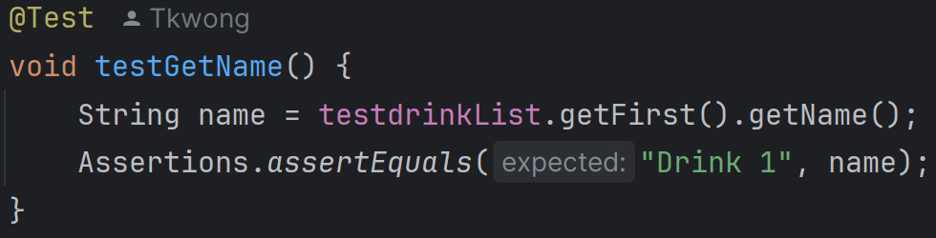

1. testGetName():

It tests if the getName() method returns the correct name of the drink.

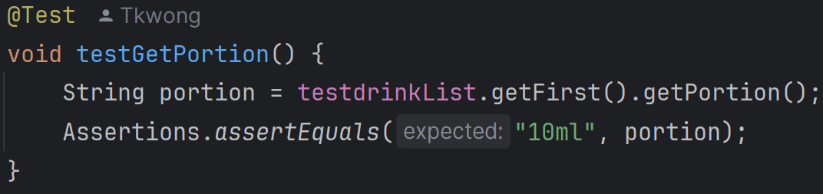

2. testGetPortion():

It tests if the getPortion() method returns the correct portion of the drink.

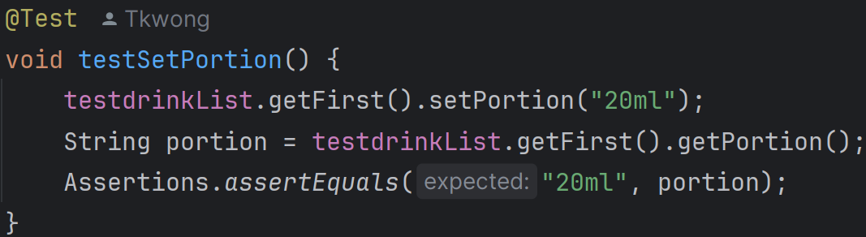

3. testSetPortion():

It tests if the setPortion() method correctly sets and returns the new portion of the drink.

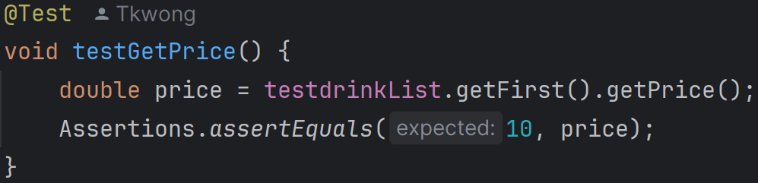

4. testGetPrice():

It tests if the getPrice() method returns the correct price of the drink.

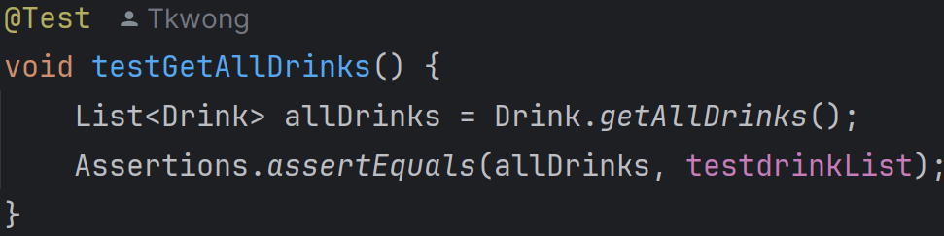

5. testGetAllDrinks():

It tests if the getAllDrinks() method returns the list of all drinks.

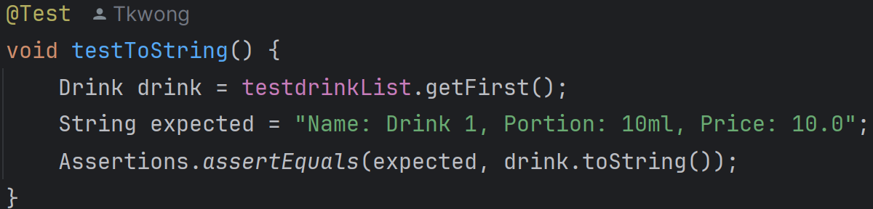

6. testToString():

It tests if the toString() method returns the correct string representation of the drink.

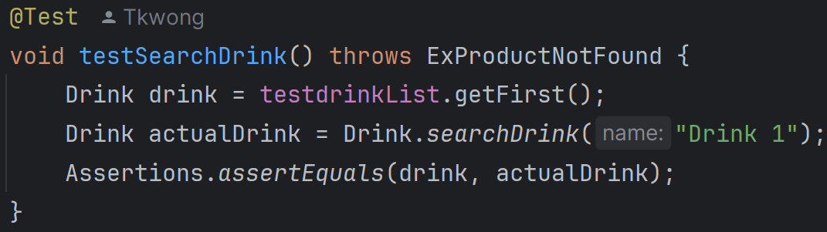

7. testSearchDrink():

It tests if the searchDrink() method correctly finds a drink by name.

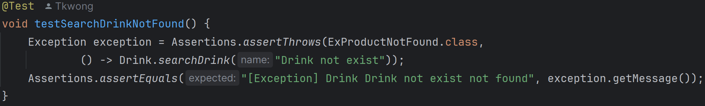

8. testSearchDrinkNotFound():

It tests if the searchDrink() method throws an ExProductNotFound exception when the drink is not found.

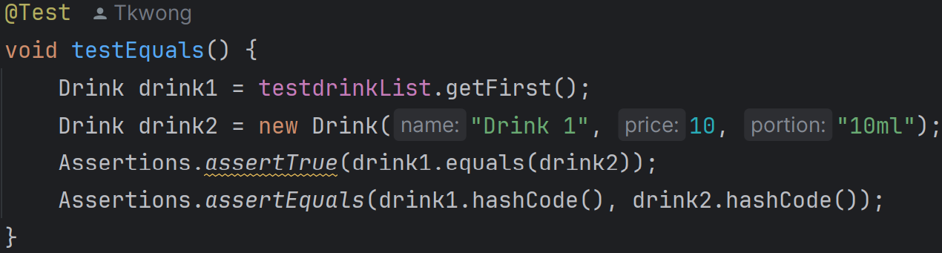

9. testEquals():

It tests if the equals() method correctly compares two drinks with the same attributes.

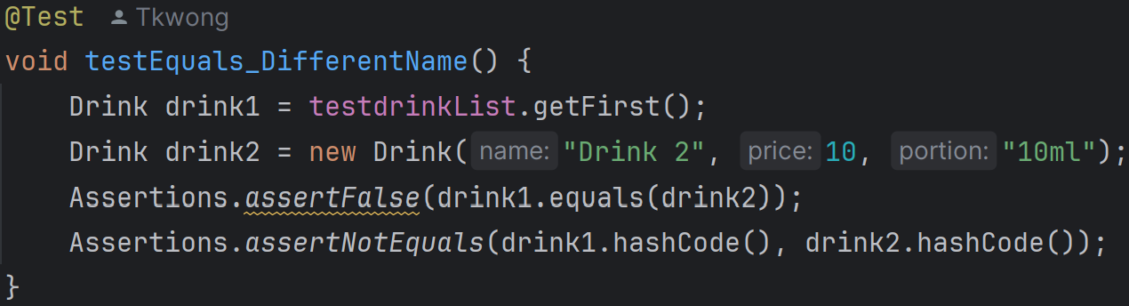

10. testEquals_DifferentName():

It tests if the equals() method returns false for drinks with different names.

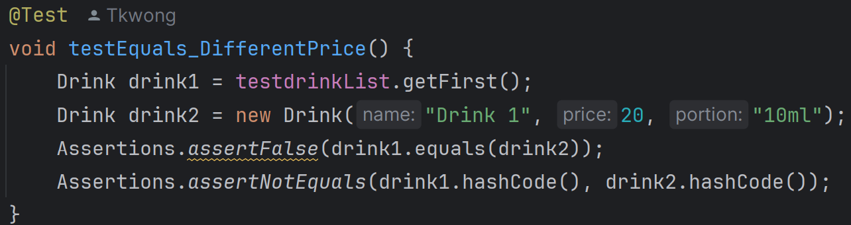

11. testEquals_DifferentPrice():

It tests if the equals() method returns false for drinks with different prices.

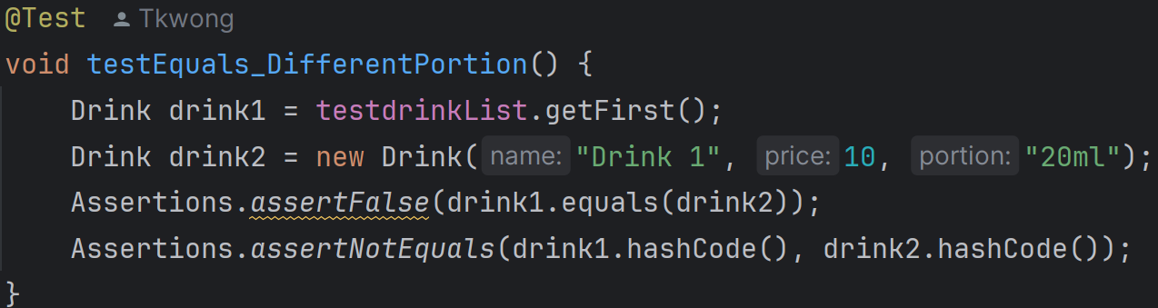

12. testEquals_DifferentPortion():

It tests if the equals() method returns false for drinks with different portions.

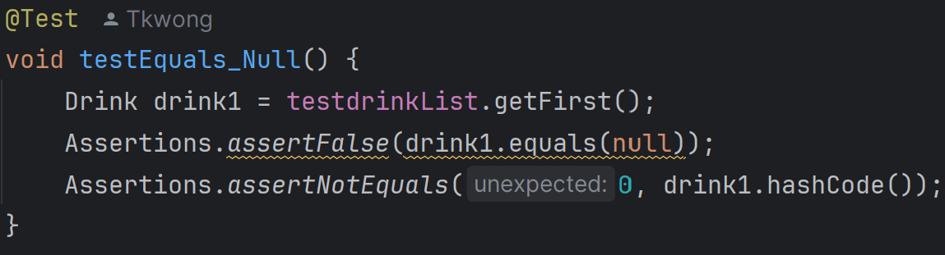

13. testEquals_Null():

It tests if the equals() method returns false when comparing a drink to null.

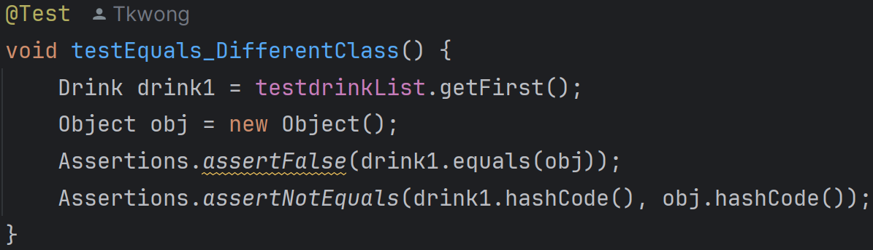

14. testEquals_DifferentClass():

It tests if the equals() method returns false when comparing a drink to an object of a different class.

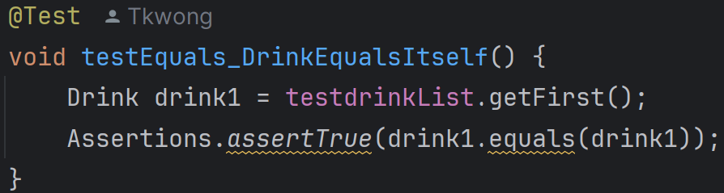

15. testEquals_DrinkEqualsItself():

It tests if the equals() method returns true when comparing a drink to itself.

**MovieTicketTest.java (Package product_test)**



1. testGetName:

It verifies that the getName method returns the correct movie name.



2. testGetPrice:

It verifies that the getPrice method returns the correct price of the movie ticket.



3. testGetMovie:

It verifies that the getMovie method returns the correct Movie object.



4. testGetMovieSession:

It verifies that the getMovieSession method returns the correct MovieSession object.



5. testGetSeat:

It verifies that the getSeat method returns the correct seat.

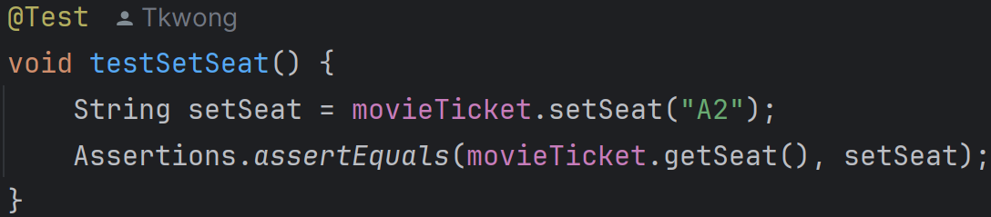

6. testSetSeat:

It verifies that the setSeat method correctly sets and returns the new seat.

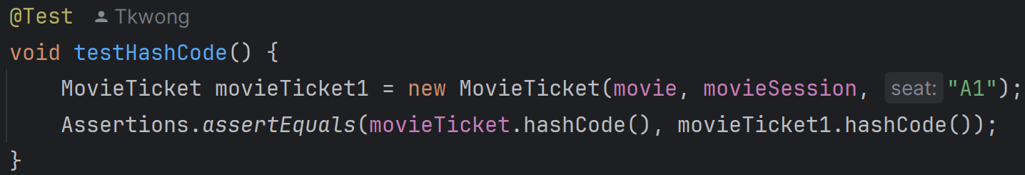

7. testHashCode:

It verifies that the hashCode method returns the same hash code for two equal MovieTicket objects.

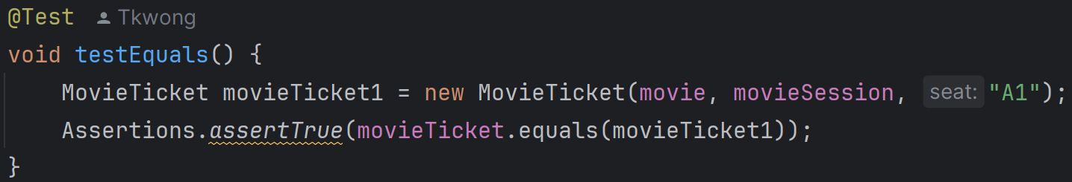

8. testEquals:

It verifies that the equals method returns true for two equal MovieTicket objects.



9. testEquals_sameObject:

It verifies that the equals method returns true when comparing the MovieTicket object to itself.



10. testEquals_Null:

It verifies that the equals method returns false when comparing the MovieTicket object to null.

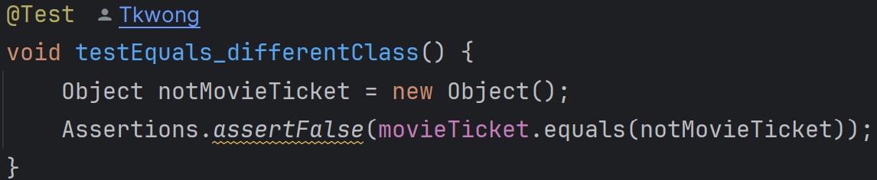

11. testEquals_differentClass:

It verifies that the equals method returns false when comparing the MovieTicket object to an object of a different class.

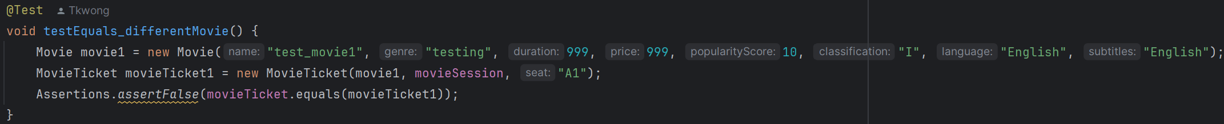

12. testEquals_differentMovie:

It verifies that the equals method returns false when comparing the MovieTicket object to another MovieTicket object with a different Movie.

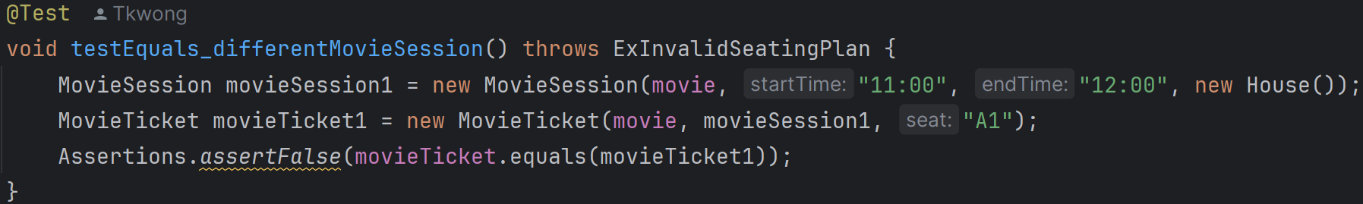

13. testEquals_differentMovieSession:

It verifies that the equals method returns false when comparing the MovieTicket object to another MovieTicket object with a different MovieSession.

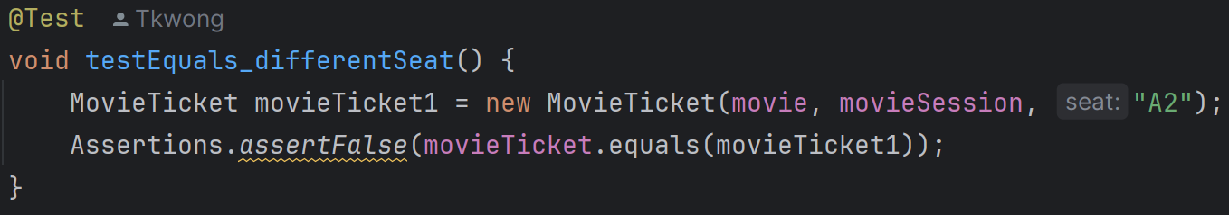

14. testEquals_differentSeat:

It verifies that the equals method returns false when comparing the MovieTicket object to another MovieTicket object with a different seat.

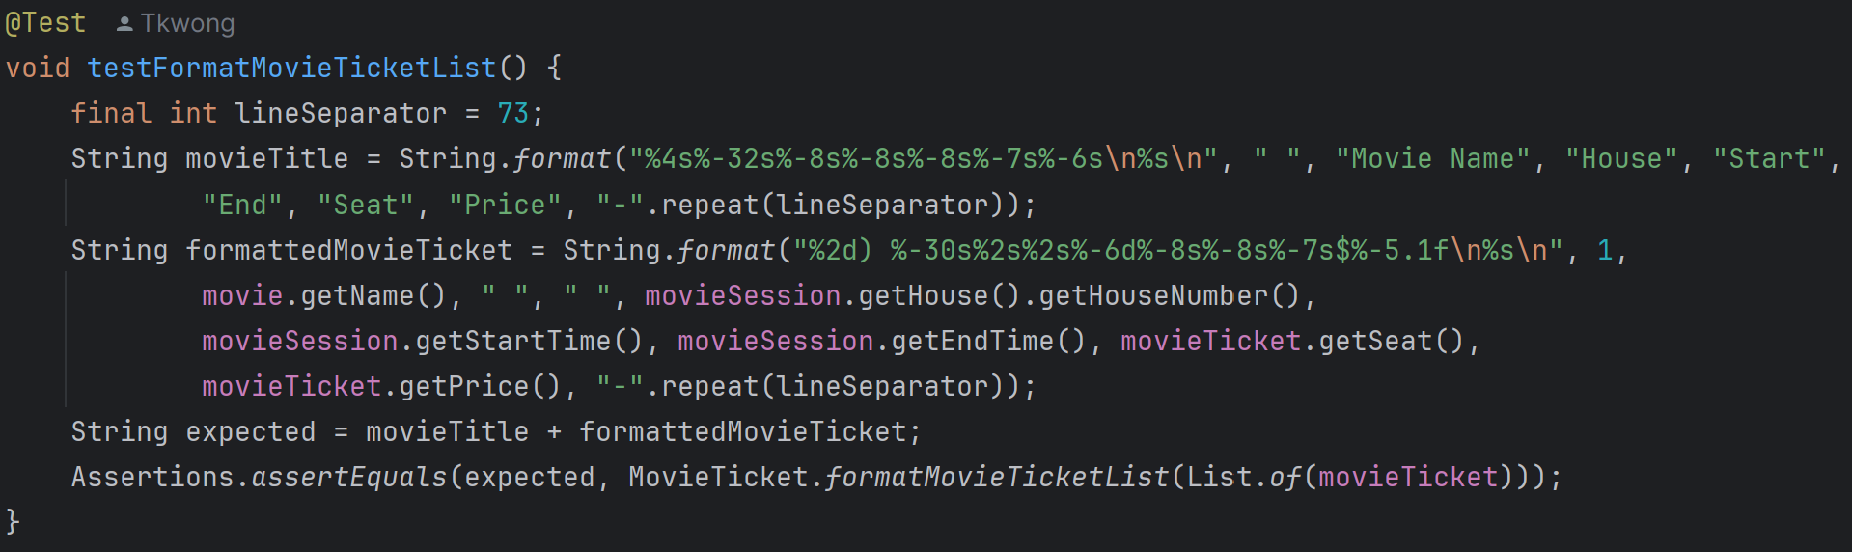

15. testFormatMovieTicketList:

It verifies that the formatMovieTicketList method returns the correctly formatted string for a list containing one MovieTicket.

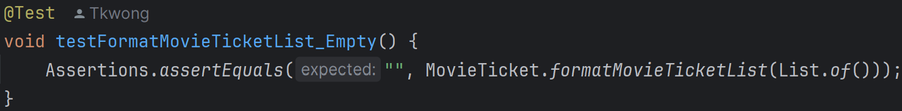

16. testFormatMovieTicketList_Empty:

It verifies that the formatMovieTicketList method returns an empty string when the list is empty.



17. testFormatMovieTicketList_Null:

It verifies that the formatMovieTicketList method returns an empty string when the list is null.

**ProductTest.java (Package product_test)**

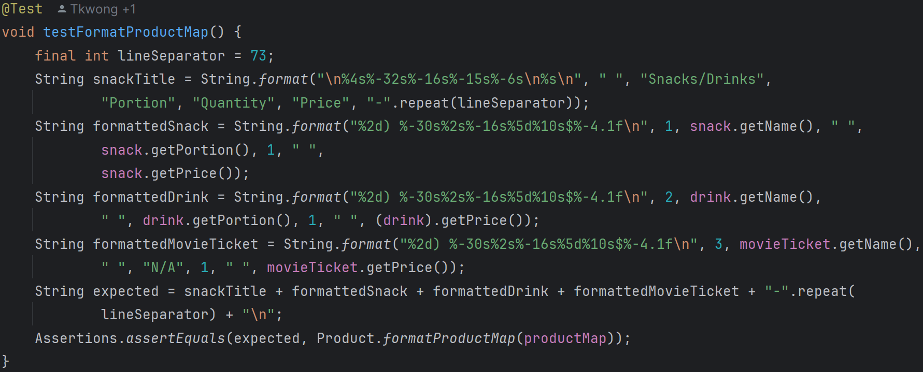

1. testFormatProductMap:

This test case verifies that the formatProductMap method correctly formats a non-empty product map. It sets up a productMap with a Snack, Drink, and MovieTicket, constructs the expected formatted string and asserts that the output of formatProductMap matches this expected string.



2. testFormatProductMapEmpty:

This test case checks the behavior of the formatProductMap method when given an empty map. It asserts that the method returns an empty string when the input map is empty.



3. testFormatProductMapNull:

This test case checks the behavior of the formatProductMap method when given a null map. It asserts that the method returns an empty string when the input map is null.

**SnackTest.java (Package product_test)**

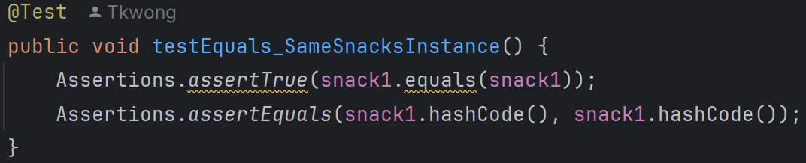

1. testEquals_SameSnacksInstance:

It verifies that a Snack object is equal to itself and that its hash code is consistent.

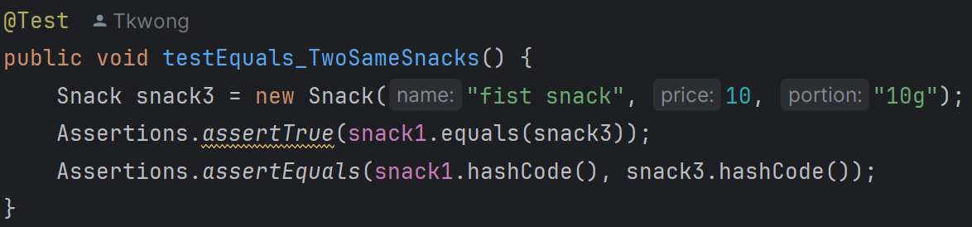

2. testEquals_TwoSameSnacks:

It verifies that two Snack objects with the same attributes are considered equal and have the same hash code.

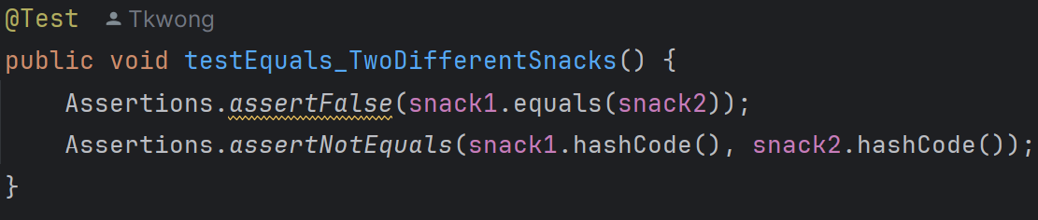

3. testEquals_TwoDifferentSnacks:

It verifies that two Snack objects with different attributes are not considered equal and have different hash codes.

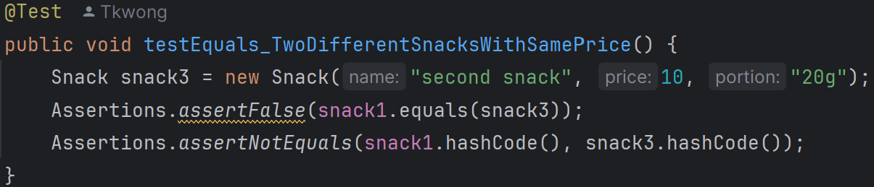

4. testEquals_TwoDifferentSnacksWithSamePrice:

It verifies that two Snack objects with the same price but different names and portions are not considered equal and have different hash codes.

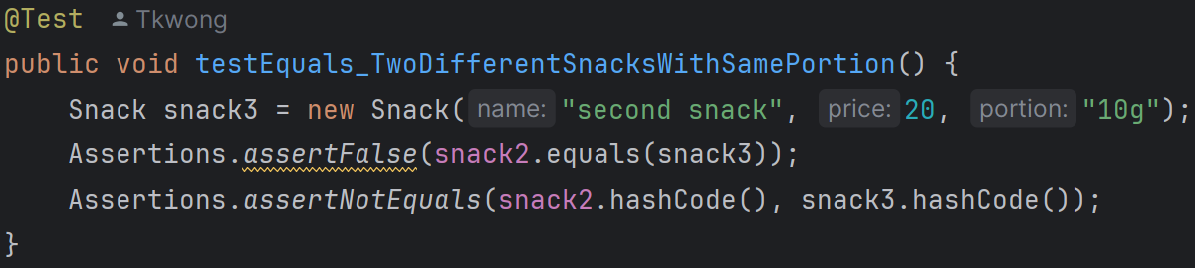

5. testEquals_TwoDifferentSnacksWithSamePortion:

It verifies that two Snack objects with the same portion but different names and prices are not considered equal and have different hash codes.

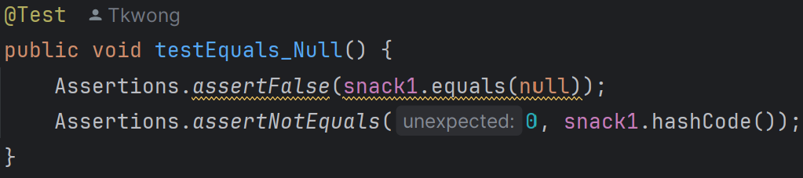

6. testEquals_Null:

It verifies that a Snack object is not equal to null and that its hash code is not zero.

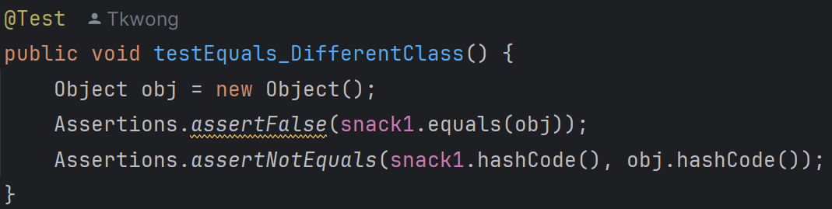

7. testEquals_DifferentClass:

It verifies that a Snack object is not equal to an object of a different class and that their hash codes are different.



8. testGetName:

It verifies that the getName method returns the correct name of the Snack.



9. testGetPortion:

It verifies that the getPortion method returns the correct portion of the Snack.

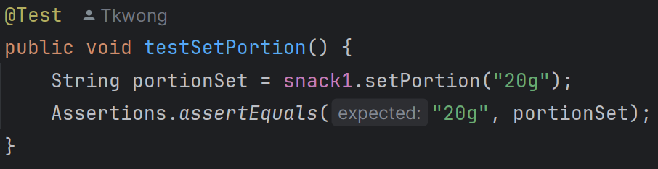

10. testSetPortion:

It verifies that the setPortion method correctly sets and returns the new portion of the Snack.



11. testGetPrice:

It verifies that the getPrice method returns the correct price of the Snack.

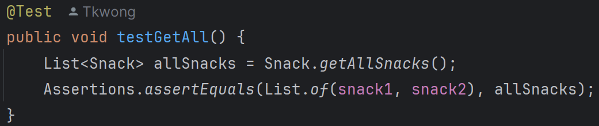

12. testGetAll:

It verifies that the getAllSnacks method returns a list containing all created Snack objects.

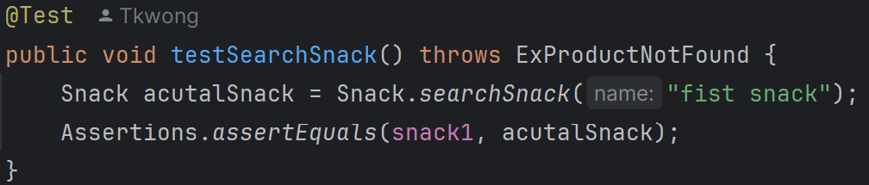

13. testSearchSnack:

It verifies that the searchSnack method correctly finds and returns a Snack object by its name.

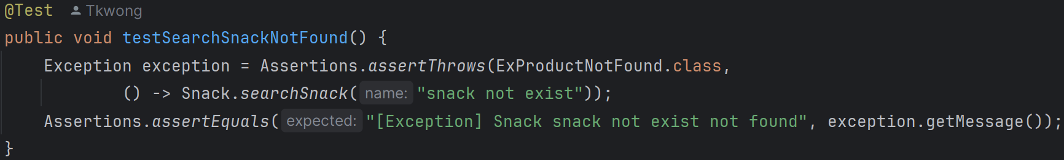

14. testSearchSnackNotFound:

It verifies that the searchSnack method throws an ExProductNotFound exception when a Snack with the specified name is not found.

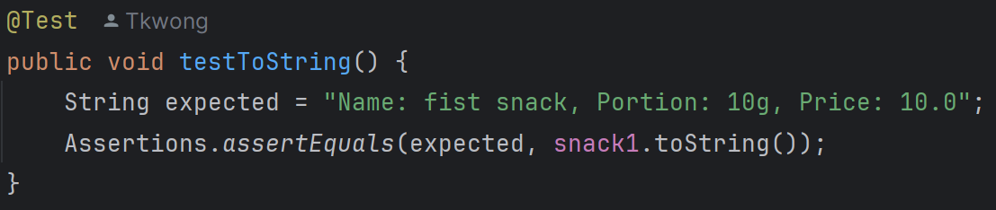

15. testToString:

It verifies that the toString method returns the correct string representation of the Snack.

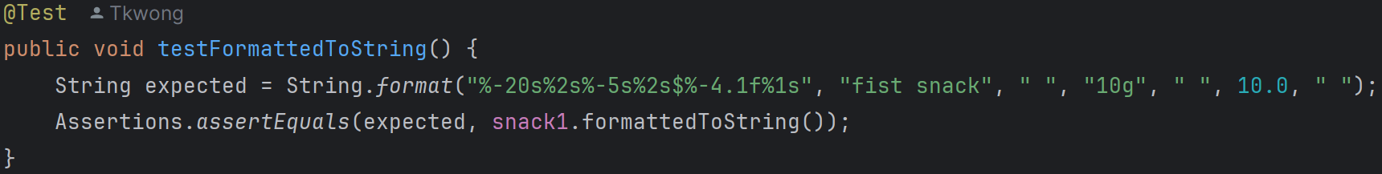

16. testFormattedToString:

It verifies that the formattedToString method returns the correctly formatted string representation of the Snack.

**PaymentRecordTest.java (Package record_test)**

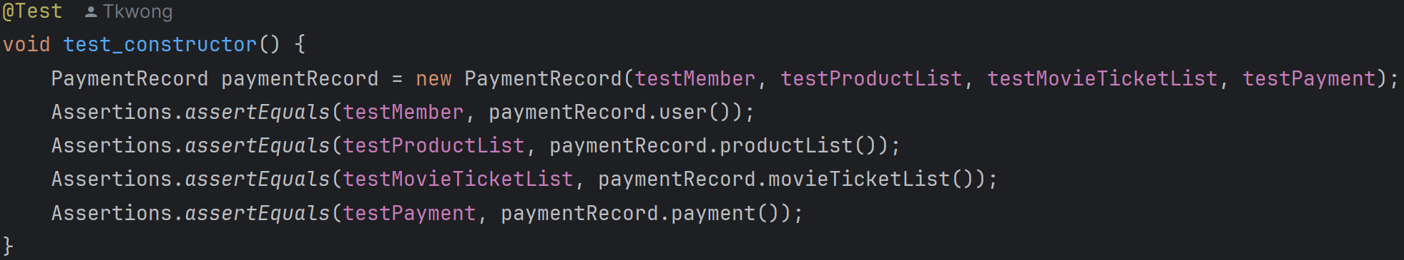

1. test_constructor:

This test verifies that the constructor of the PaymentRecord class correctly initializes the fields. It creates a PaymentRecord object and asserts that the fields (user, productList, movieTicketList, and payment) are correctly set.

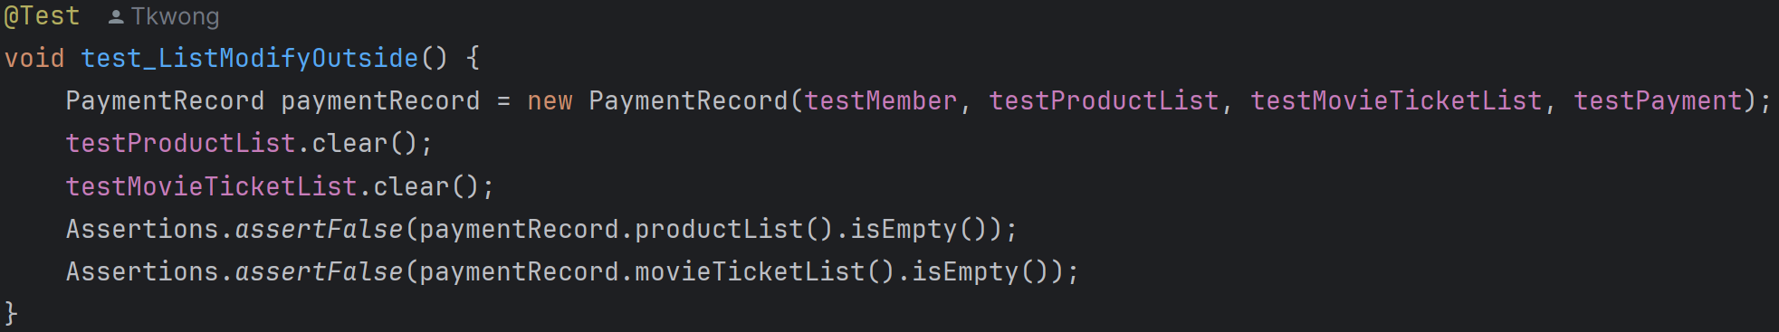

2. test_ListModifyOutside:

This test ensures that the PaymentRecord class creates deep copies of the productList and movieTicketList to prevent external modifications. It clears the original lists after creating a PaymentRecord object and asserts that the lists inside the PaymentRecord object remain unchanged.

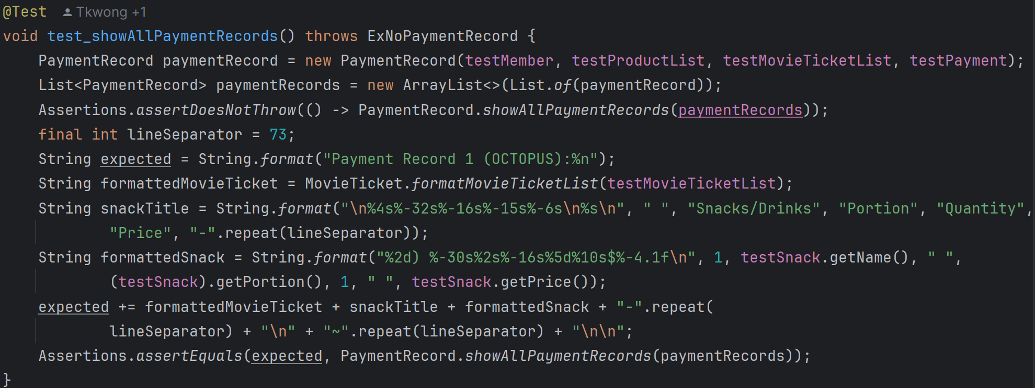

3. test_showAllPaymentRecords:

This test verifies the showAllPaymentRecords method when there is at least one payment record. It creates a PaymentRecord object, adds it to a list, and asserts that the method does not throw an exception. It also checks that the formatted string output matches the expected result.

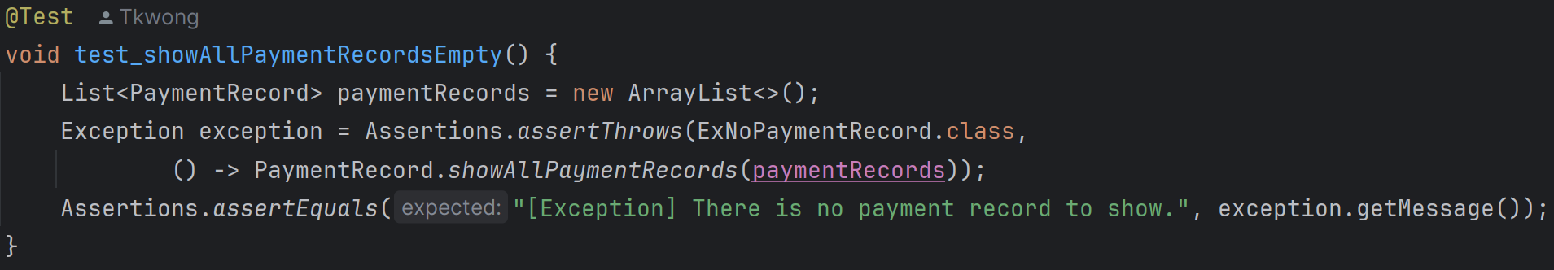

4. test_showAllPaymentRecordsEmpty:

This test verifies the showAllPaymentRecords method when there are no payment records. It creates an empty list of PaymentRecord objects and asserts that the method throws an ExNoPaymentRecord exception with the correct message.

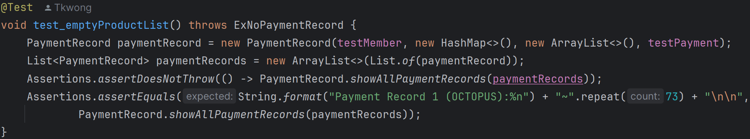

5. test_emptyProductList:

This test verifies the showAllPaymentRecords method when the productList and movieTicketList are empty. It creates a PaymentRecord object with empty lists, adds it to a list, and asserts that the method does not throw an exception. It also checks that the formatted string output matches the expected result for an empty product list.

**ShoppingCartTest.java (Package shopping_cart_test)**

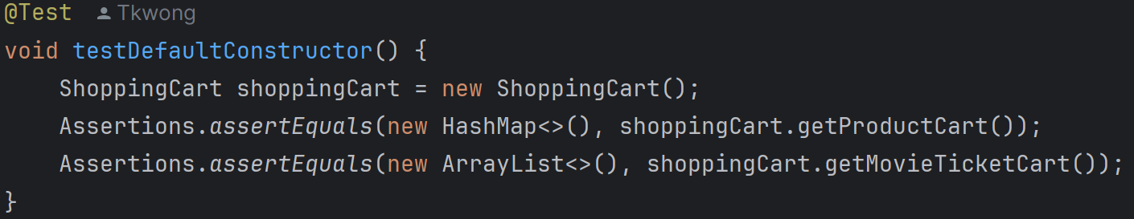

1. testDefaultConstructor:

It tests the default constructor of the ShoppingCart class to ensure it initializes an empty product cart and movie ticket cart.

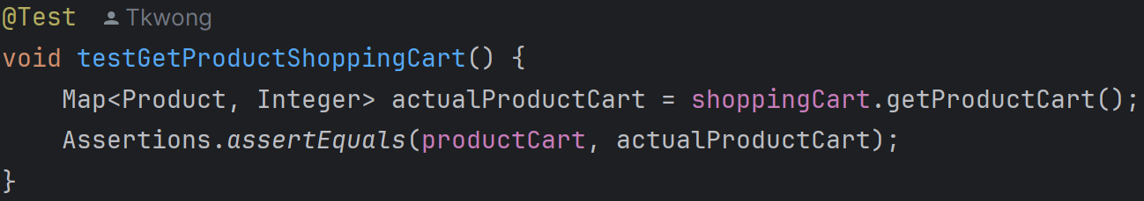

2. testGetProductShoppingCart:

It tests the getter method for the product cart to ensure it returns the correct product cart.

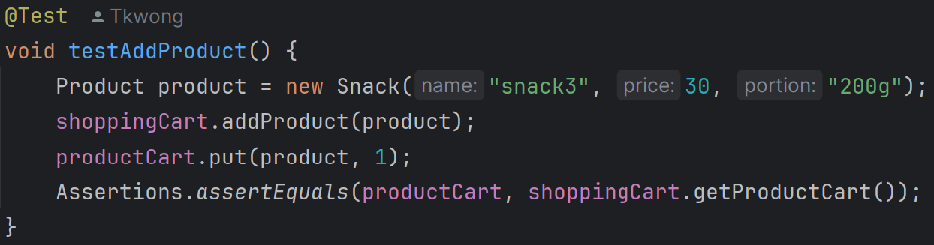

3. testAddProduct:

It tests the addProduct method to ensure a product can be added to the shopping cart.

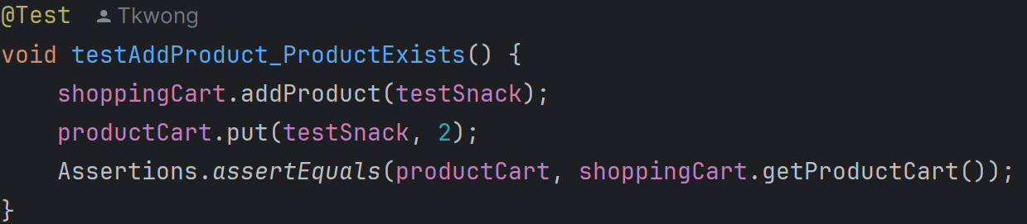

4. testAddProduct_ProductExists:

It tests the addProduct method when the product already exists in the cart to ensure the quantity is updated correctly.

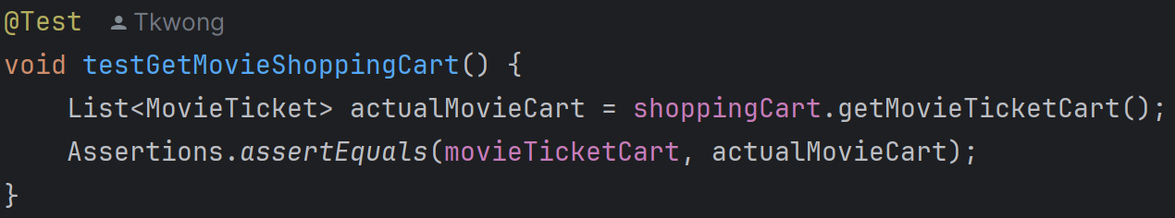

5. testGetMovieShoppingCart:

It tests the getter method for the movie ticket cart to ensure it returns the correct movie ticket cart.

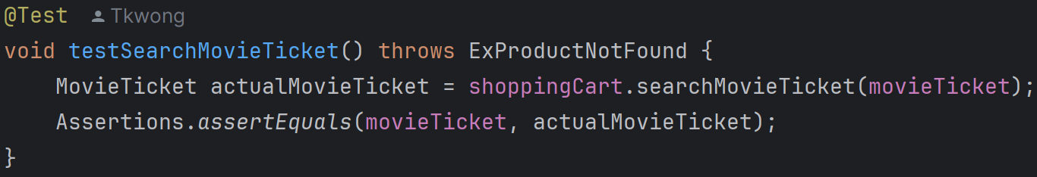

6. testSearchMovieTicket:

It tests the searchMovieTicket method to ensure it can find a movie ticket in the cart.

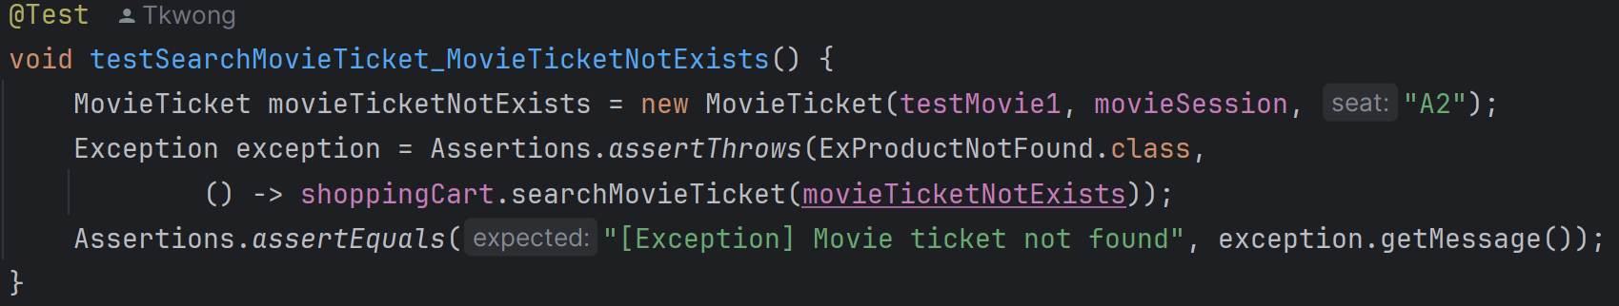

7. testSearchMovieTicket_MovieTicketNotExists:

It tests the searchMovieTicket method when the movie ticket does not exist to ensure it throws an ExProductNotFound exception.

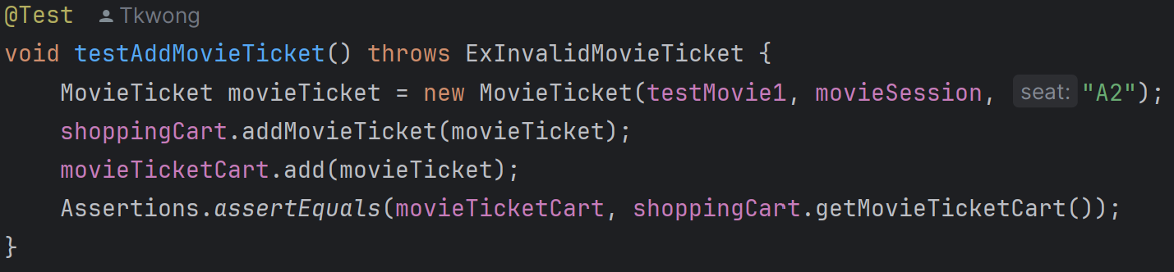

8. testAddMovieTicket:

It tests the addMovieTicket method to ensure a movie ticket can be added to the shopping cart.

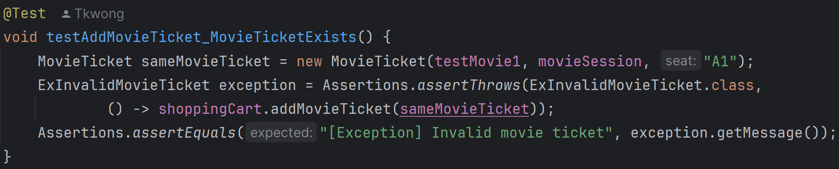

9. testAddMovieTicket_MovieTicketExists:

It tests the addMovieTicket method when the movie ticket already exists to ensure it throws an ExInvalidMovieTicket exception.

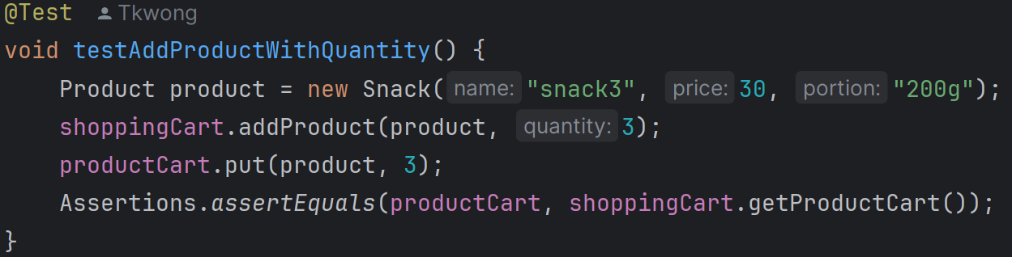

10. testAddProductWithQuantity:

It tests the addProduct method with a specific quantity to ensure the product is added with the correct quantity.

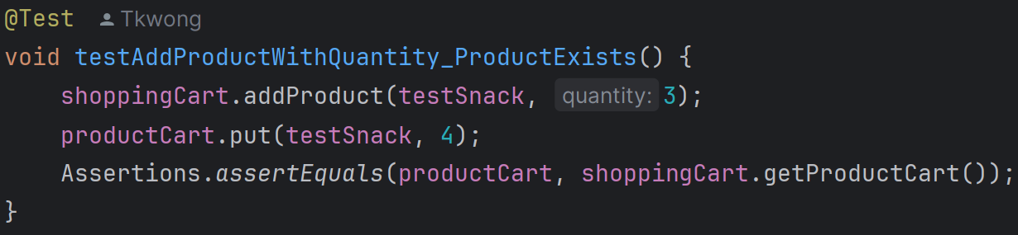

11. testAddProductWithQuantity_ProductExists:

It tests the addProduct method with a specific quantity when the product already exists to ensure the quantity is updated correctly.

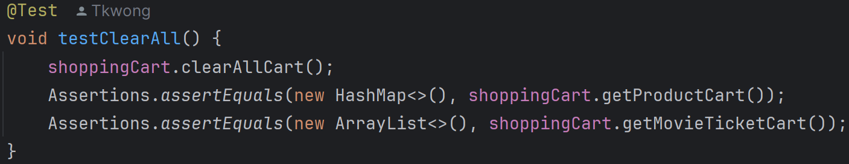

12. testClearAll:

It tests the clearAllCart method to ensure it clears both the product cart and movie ticket cart.

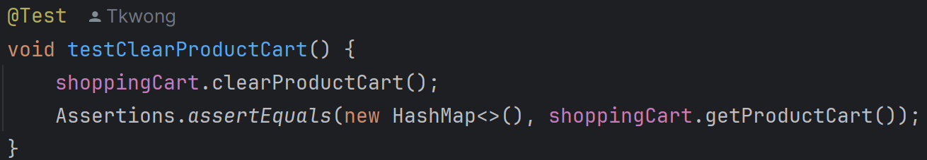

13. testClearProductCart:

It tests the clearProductCart method to ensure it clears only the product cart.

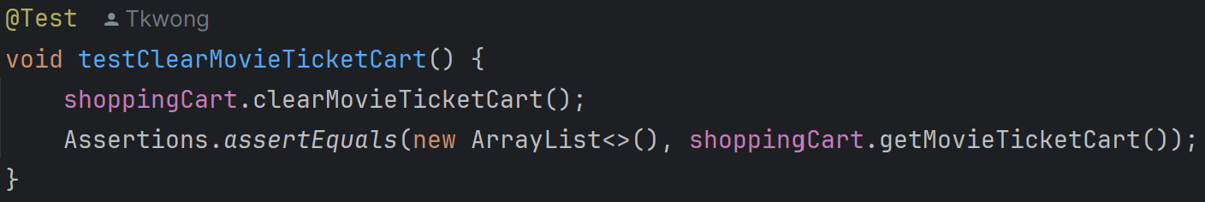

14. testClearMovieTicketCart:

It tests the clearMovieTicketCart method to ensure it clears only the movie ticket cart.

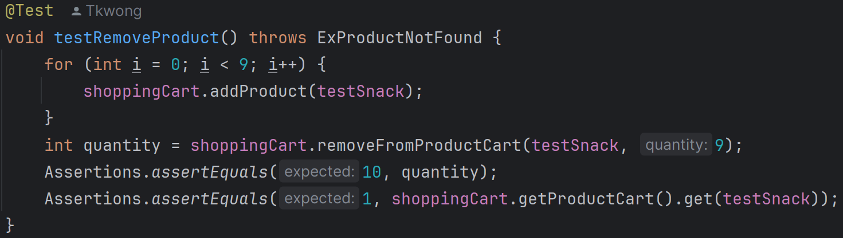

15. testRemoveProduct:

It tests the removeFromProductCart method to ensure a product can be removed from the cart and the quantity is updated correctly.

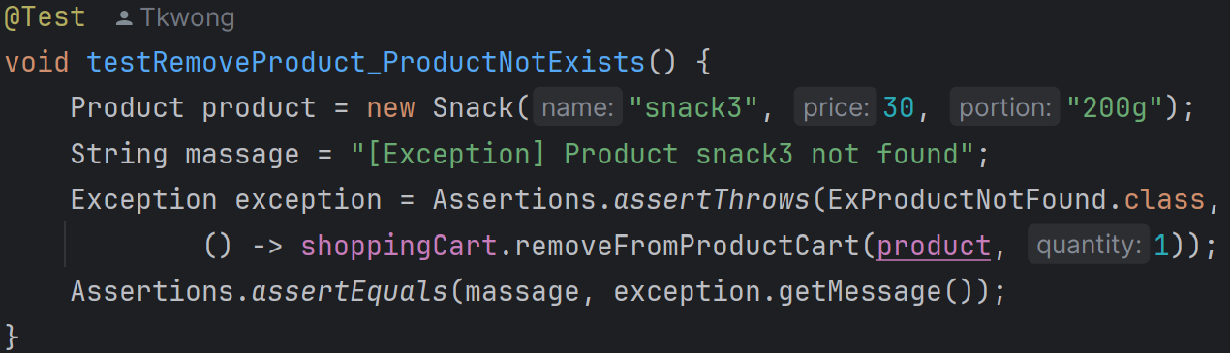

16. testRemoveProduct_ProductNotExists:

It tests the removeFromProductCart method when the product does not exist to ensure it throws an ExProductNotFound exception.

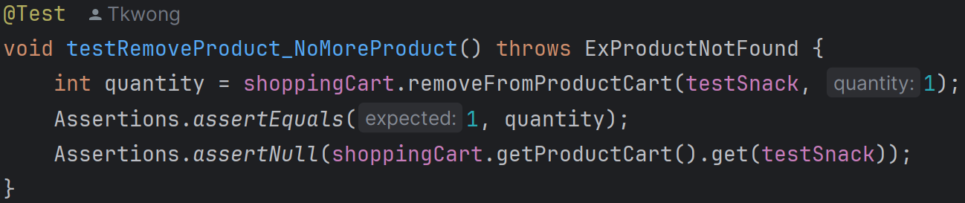

17. testRemoveProduct_NoMoreProduct:

It tests the removeFromProductCart method to ensure the product is removed from the cart when the quantity reaches zero.

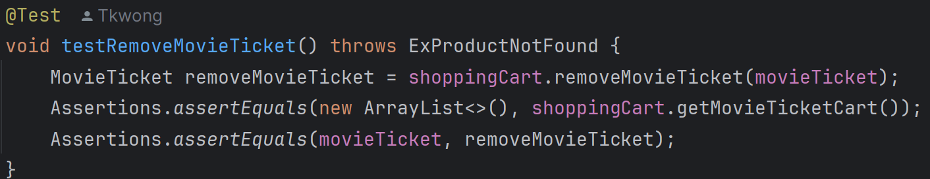

18. testRemoveMovieTicket:

It tests the removeMovieTicket method to ensure a movie ticket can be removed from the cart.

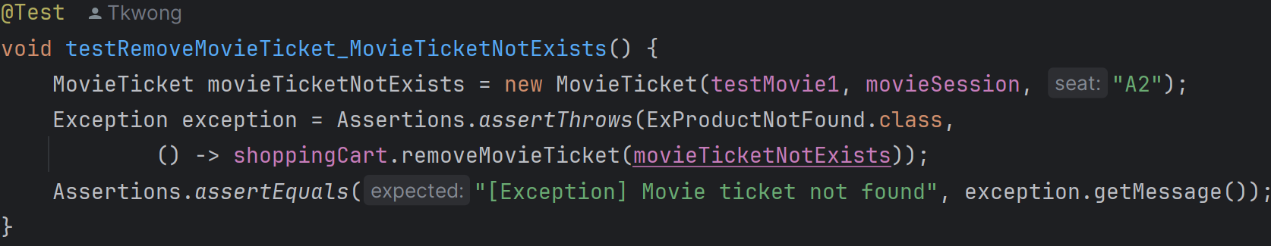

19. testRemoveMovieTicket_MovieTicketNotExists:

It tests the removeMovieTicket method when the movie ticket does not exist to ensure it throws an ExProductNotFound exception.

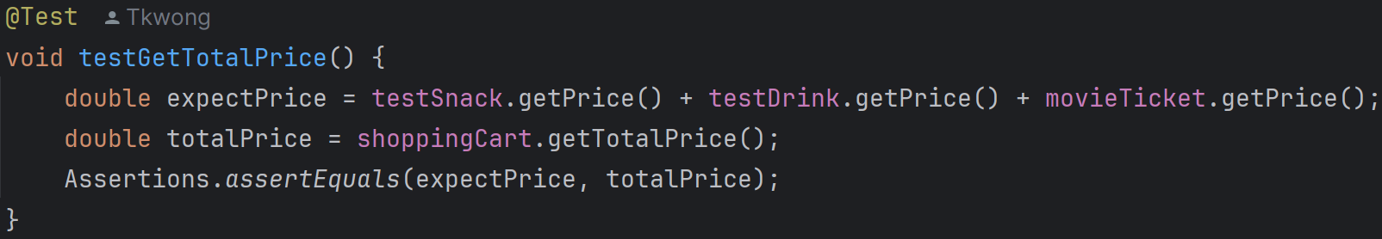

20. testGetTotalPrice:

It tests the getTotalPrice method to ensure it returns the correct total price of all products and movie tickets in the cart.

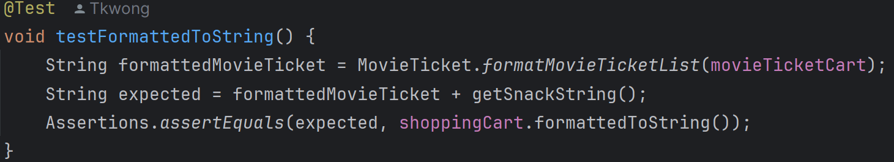

21. testFormattedToString:

It tests the formattedToString method to ensure it returns the correctly formatted string representation of the shopping cart.

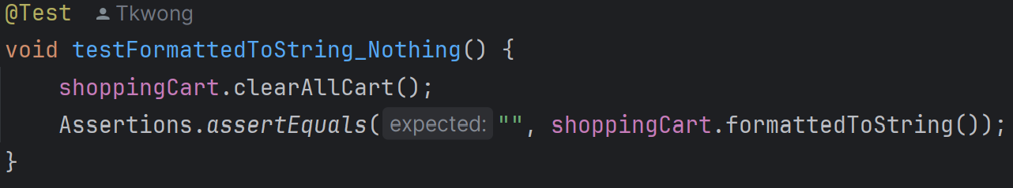

22. testFormattedToString_Nothing:

It tests the formattedToString method when the cart is empty to ensure it returns an empty string.

**CategoryTest.java (Package user_test)**

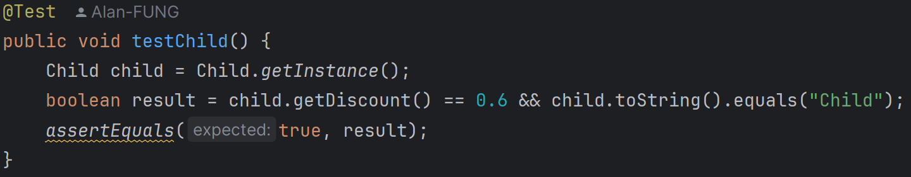

1. testChild:

It retrieves an instance of Child, checks if the discount is 0.6 and the string representation is "Child", and asserts that both conditions are true.

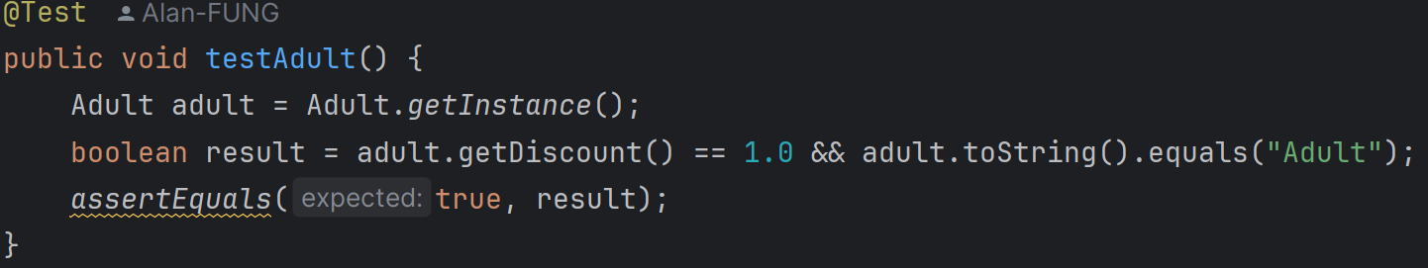

2. testAdult:

It retrieves an instance of Adult, checks if the discount is 1.0 and the string representation is "Adult", and asserts that both conditions are true.

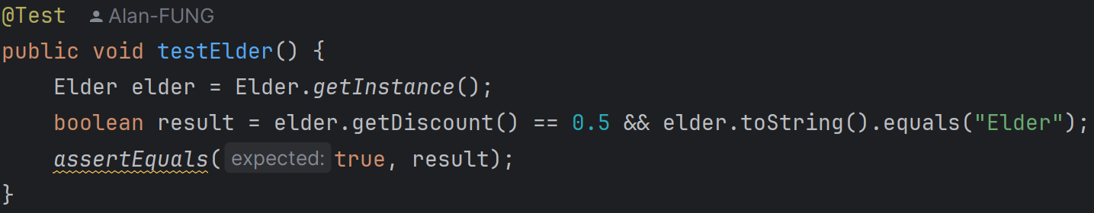

3. testElder:

It retrieves an instance of Elder, checks if the discount is 0.5 and the string representation is "Elder", and asserts that both conditions are true.

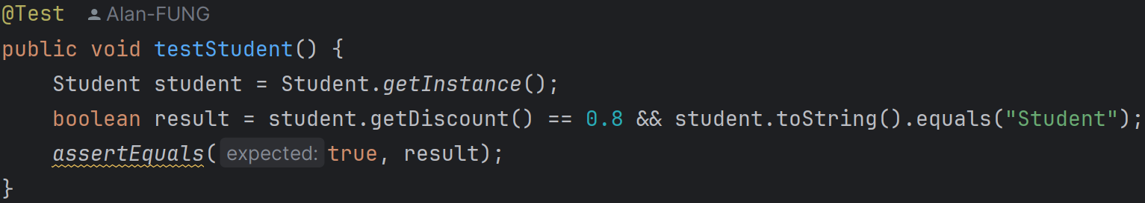

4. testStudent:

It retrieves an instance of Student, checks if the discount is 0.8 and the string representation is "Student", and asserts that both conditions are true.

**UserCenterTest.java (Package user_test)**

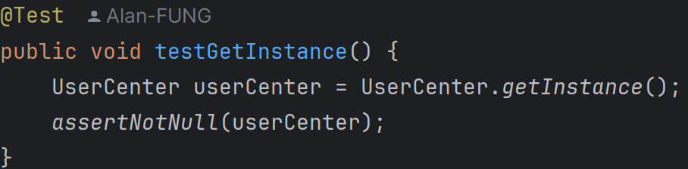

1. testGetInstance:

It verifies that the getInstance method returns a non-null UserCenter instance.

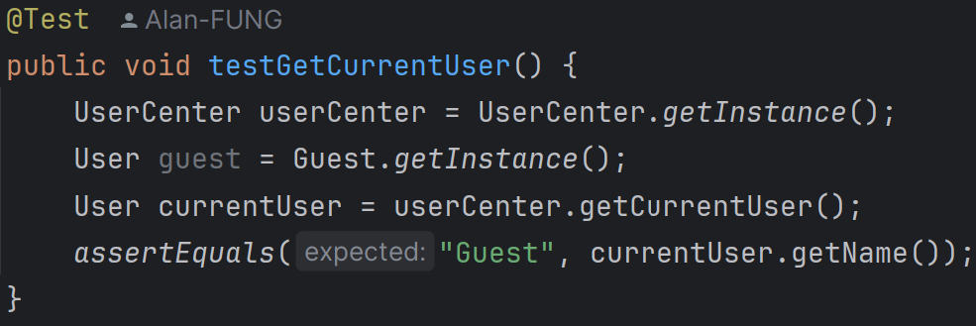

2. testGetCurrentUser:

It checks that the initial current user is a Guest.

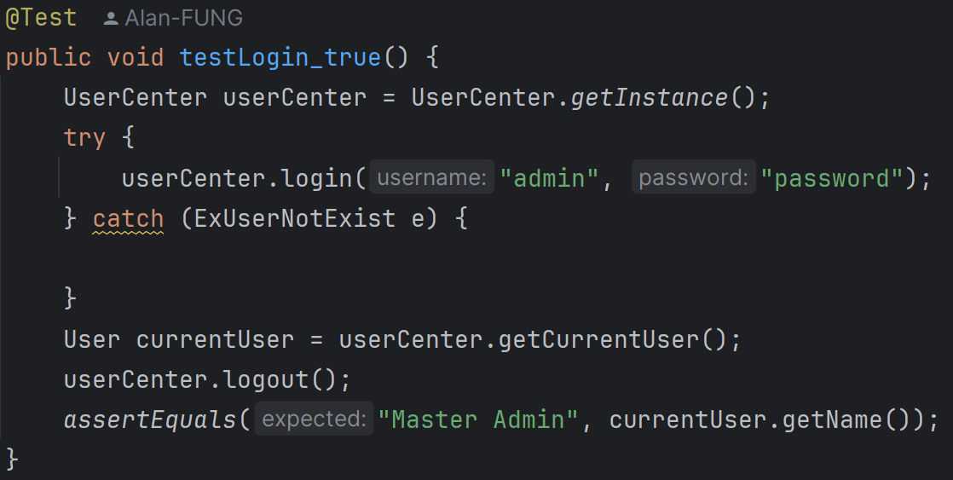

3. testLogin_true:

It tests successful login with valid credentials and verifies the current user is updated correctly.

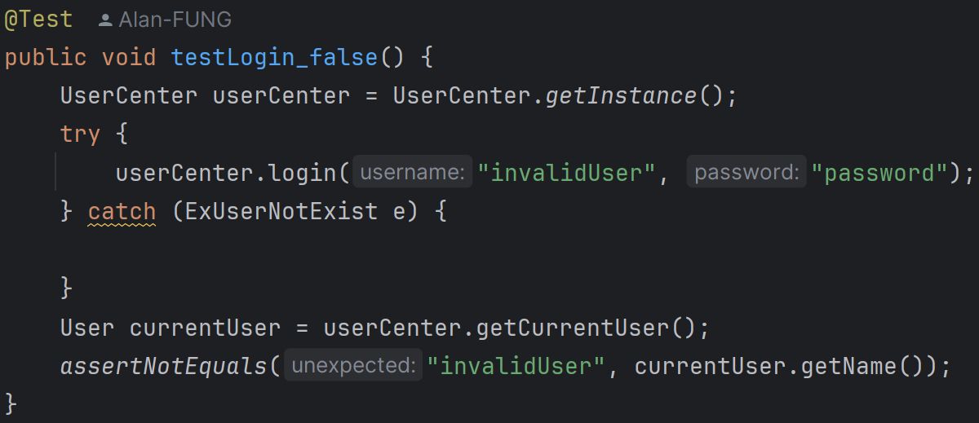

4. testLogin_false:

It tests login with invalid credentials and ensures the current user is not updated to the invalid user.

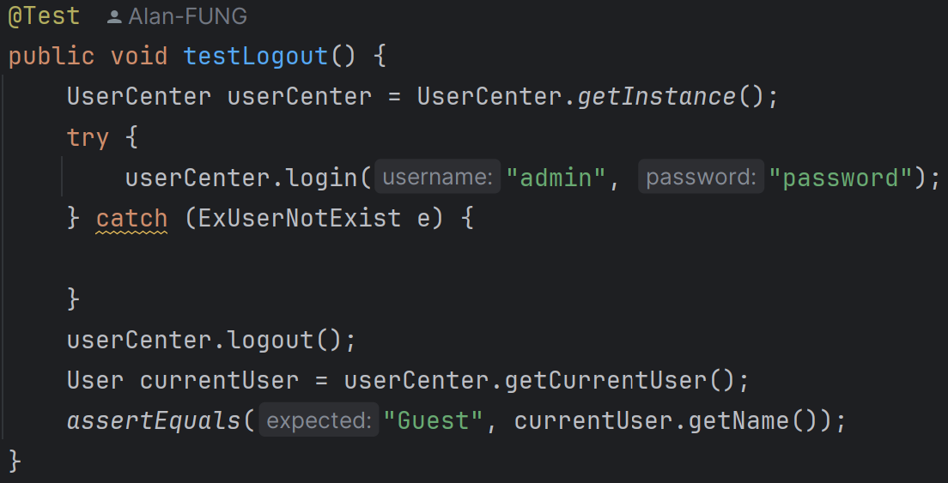

5. testLogout:

It verifies that the logout method resets the current user to Guest.

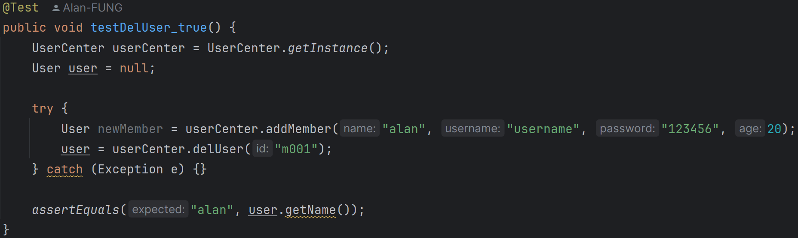

6. testDelUser_true:

It tests successful deletion of a user and verifies the correct user is deleted.

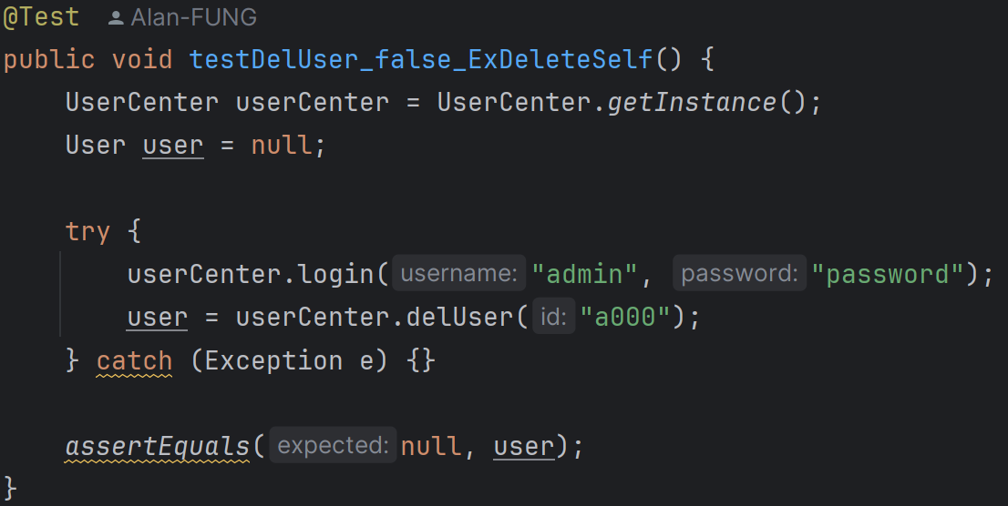

7. testDelUser_false_ExDeleteSelf:

It ensures that attempting to delete the currently logged-in user throws an ExDeleteSelf exception.

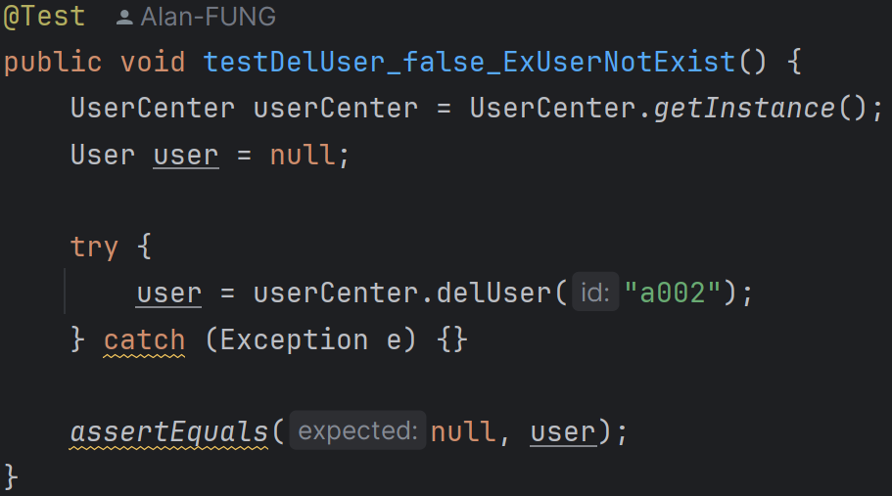

8. testDelUser_false_ExUserNotExist:

It ensures that attempting to delete a non-existent user throws an ExUserNotExist exception.

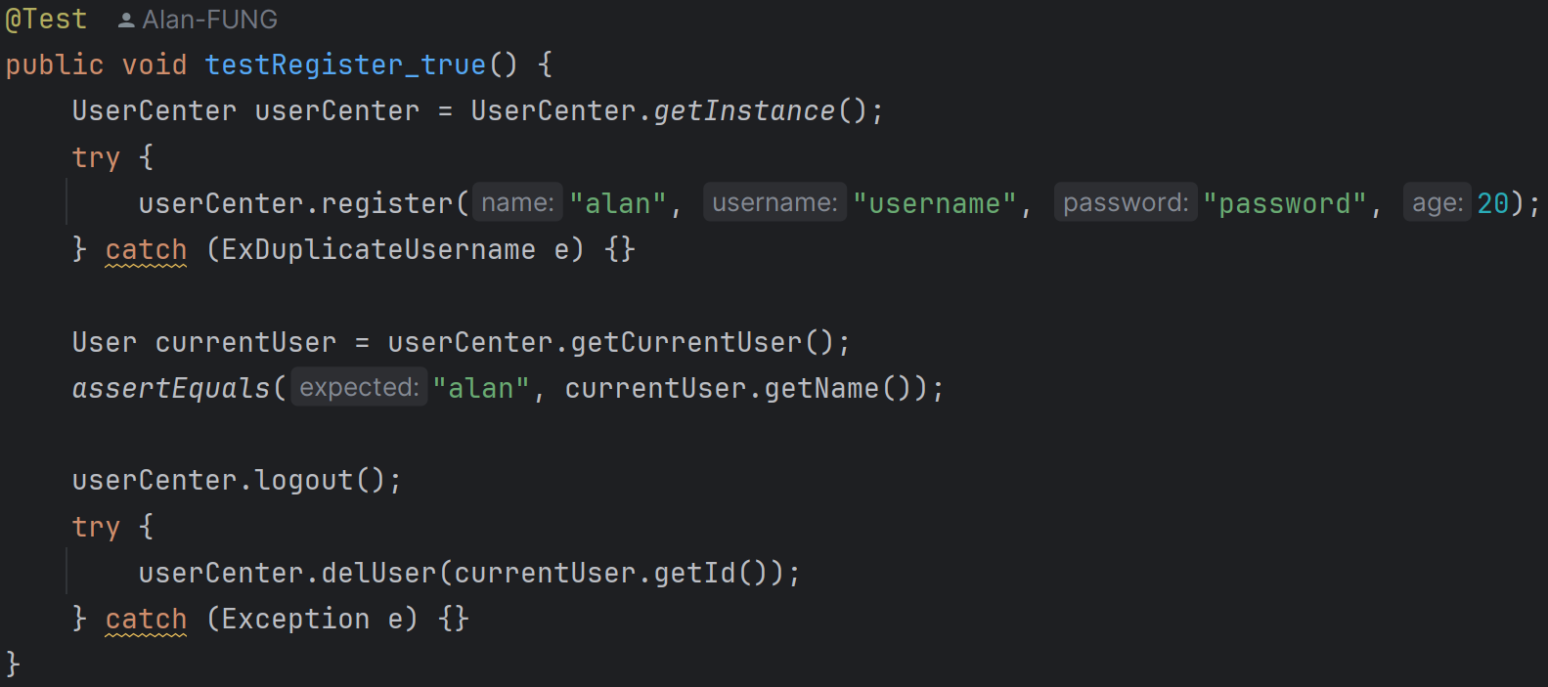

9. testRegister_true:

It tests successful registration of a new user and verifies the current user is updated correctly.

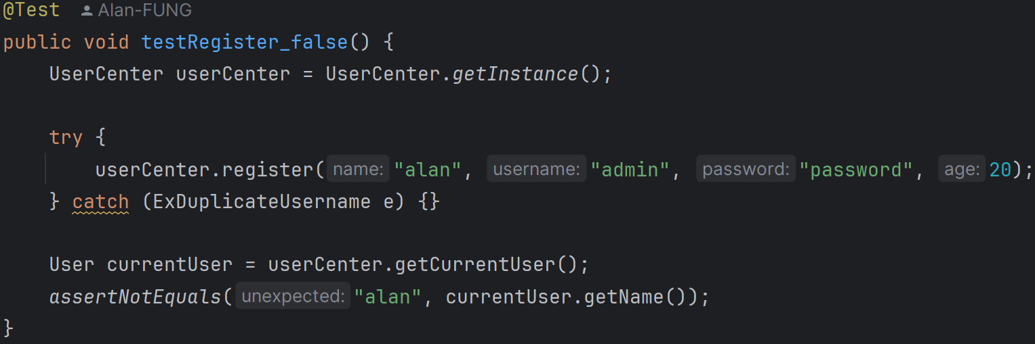

10. testRegister_false:

It ensures that attempting to register a user with a duplicate username throws an ExDuplicateUsername exception.

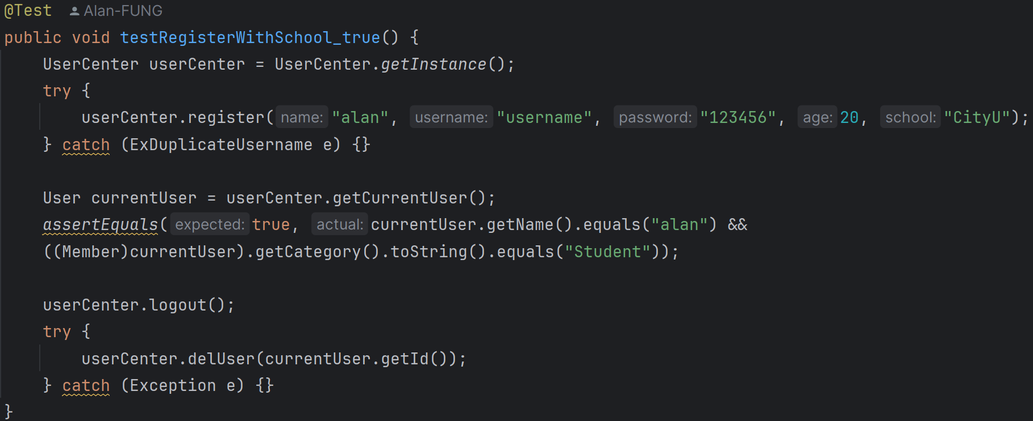

11. testRegisterWithSchool_true:

It tests successful registration of a new user with a school and verifies the current user is updated correctly.

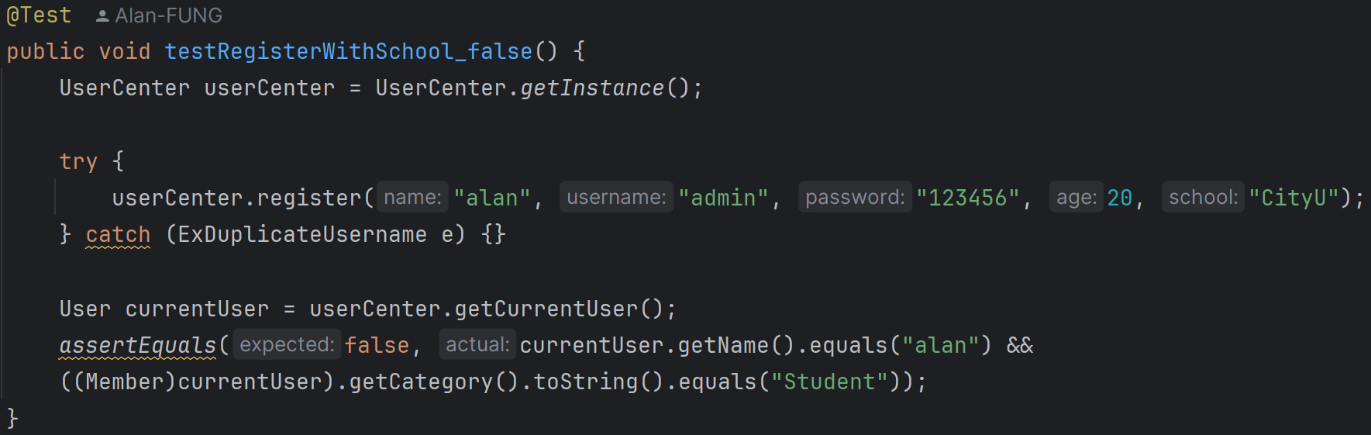

12. testRegisterWithSchool_false:

It ensures that attempting to register a user with a duplicate username and school throws an ExDuplicateUsername exception.

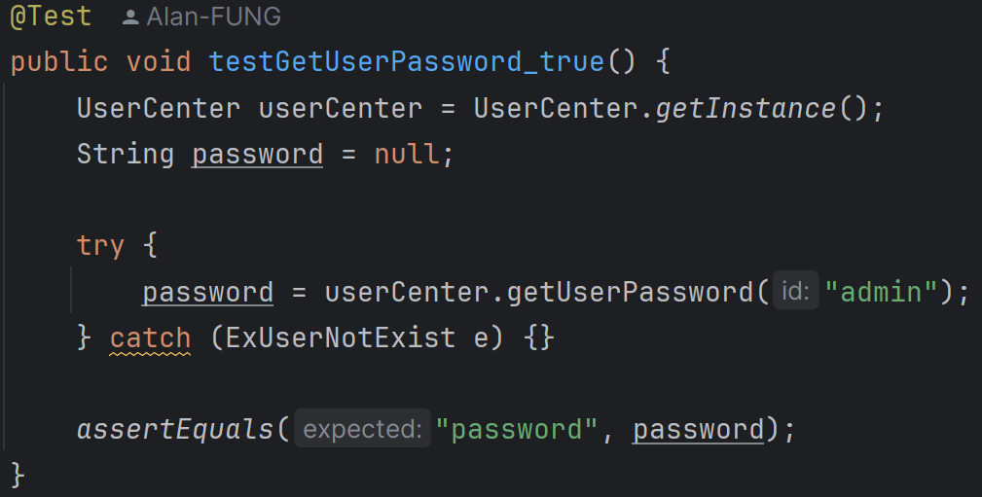

13. testGetUserPassword_true:

It tests retrieval of a user's password with a valid user ID.

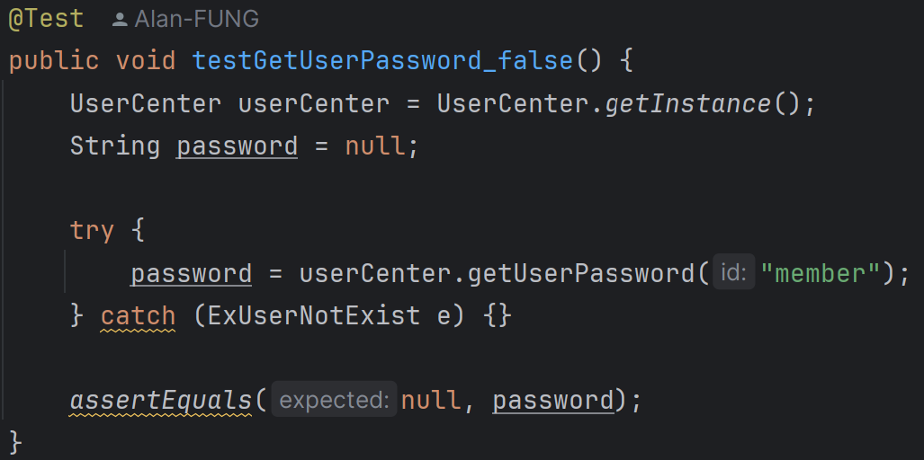

14. testGetUserPassword_false:

It ensures that attempting to retrieve a password for a non-existent user throws an ExUserNotExist exception.

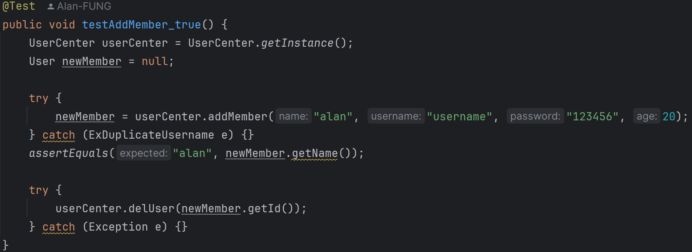

15. testAddMember_true:

It tests successful addition of a new member and verifies the member is added correctly.

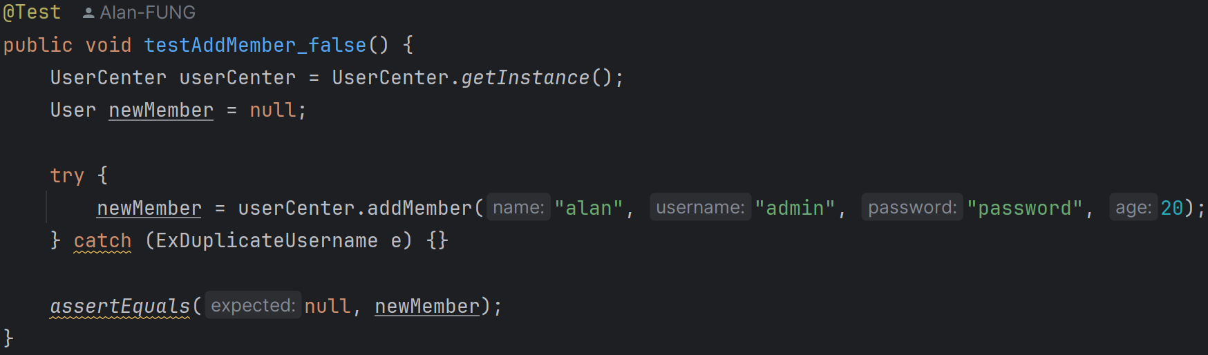

16. testAddMember_false:

It ensures that attempting to add a member with a duplicate username throws an ExDuplicateUsername exception.

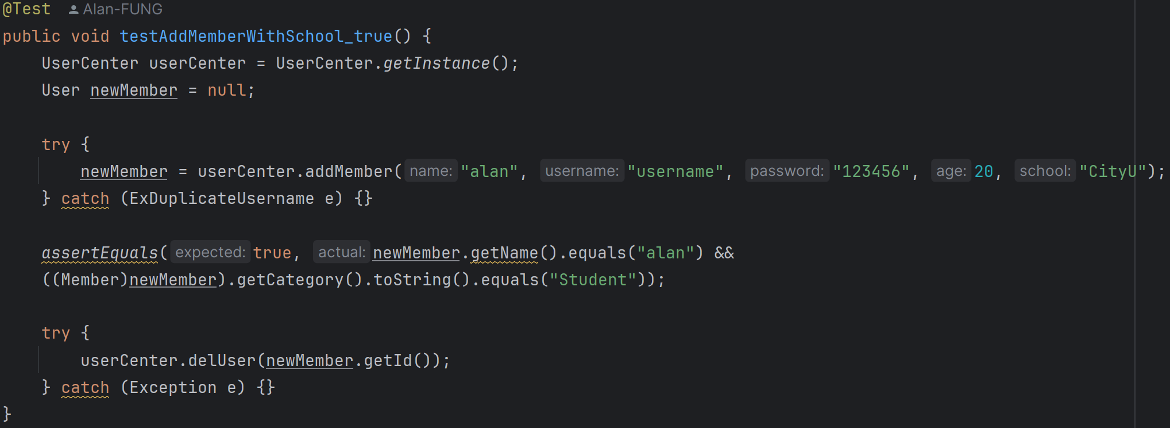

17. testAddMemberWithSchool_true:

It tests successful addition of a new member with a school and verifies the member is added correctly.

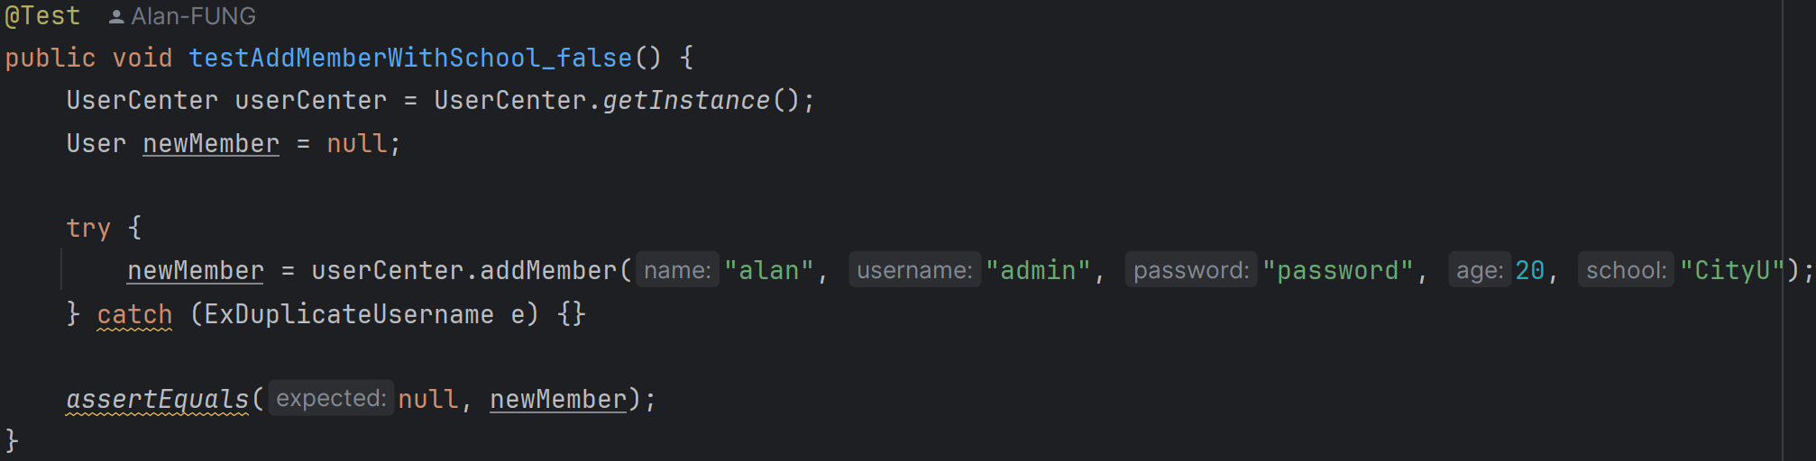

18. testAddMemberWithSchool_false:

It ensures that attempting to add a member with a duplicate username and school throws an ExDuplicateUsername exception.

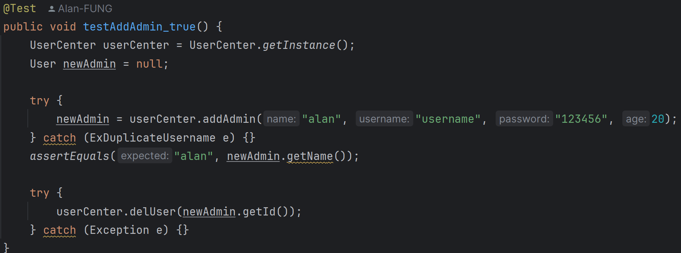

19. testAddAdmin_true:

It tests successful addition of a new admin and verifies the admin is added correctly.

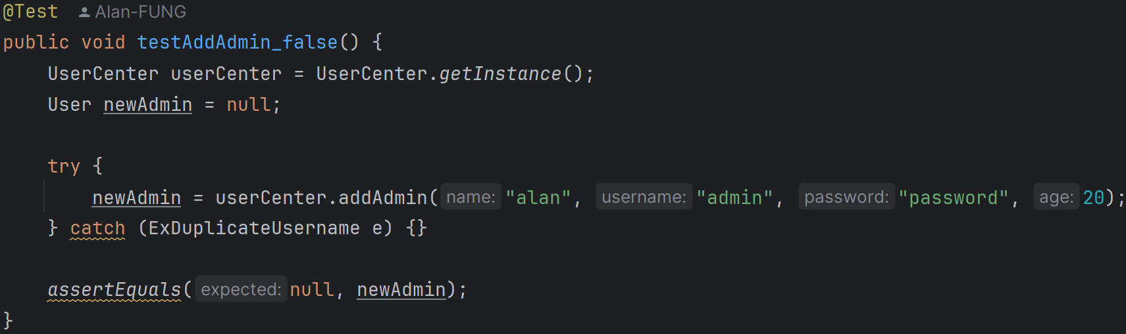

20. testAddAdmin_false:

It ensures that attempting to add an admin with a duplicate username throws an ExDuplicateUsername exception.

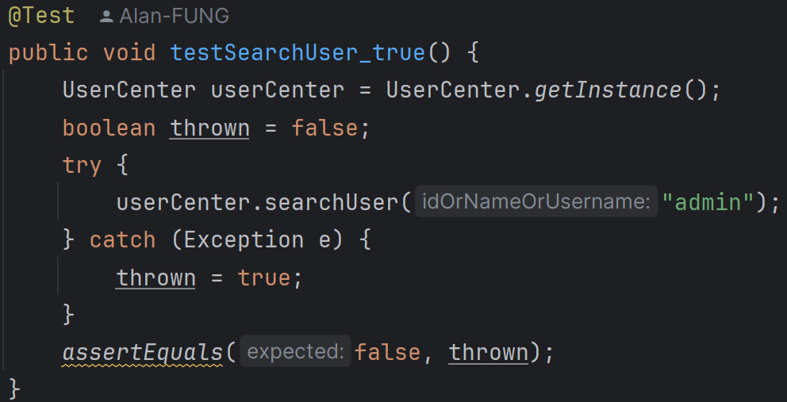

21. testSearchUser_true:

It tests successful search for a user and verifies no exception is thrown.

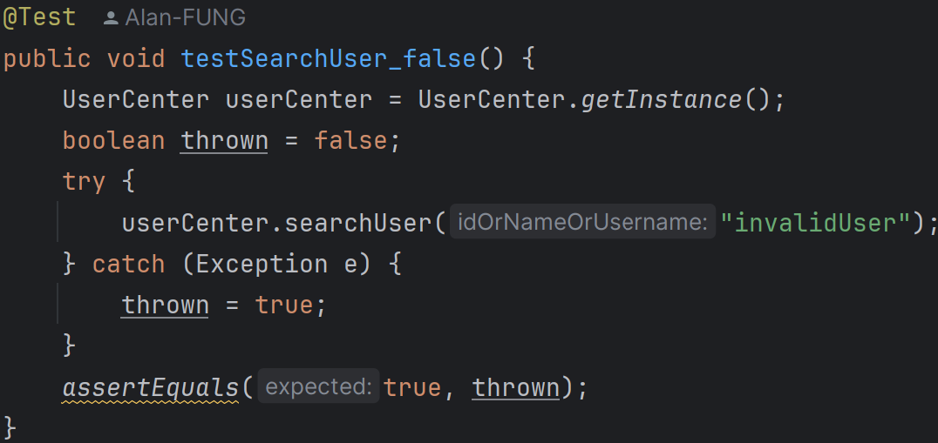

22. testSearchUser_false:

It ensures that attempting to search for a non-existent user throws an ExUserNotExist exception.

**UserTest.java (Package user_test)**

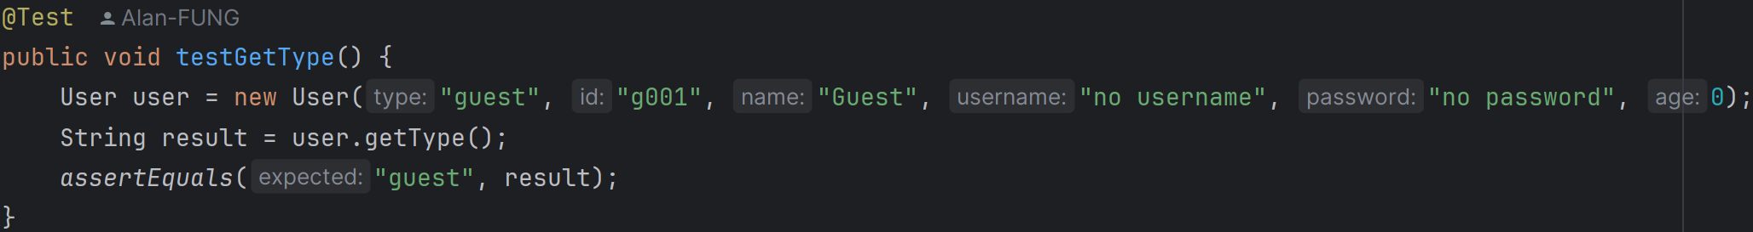

1. testGetType:

It verifies that the getType method returns the correct user type.

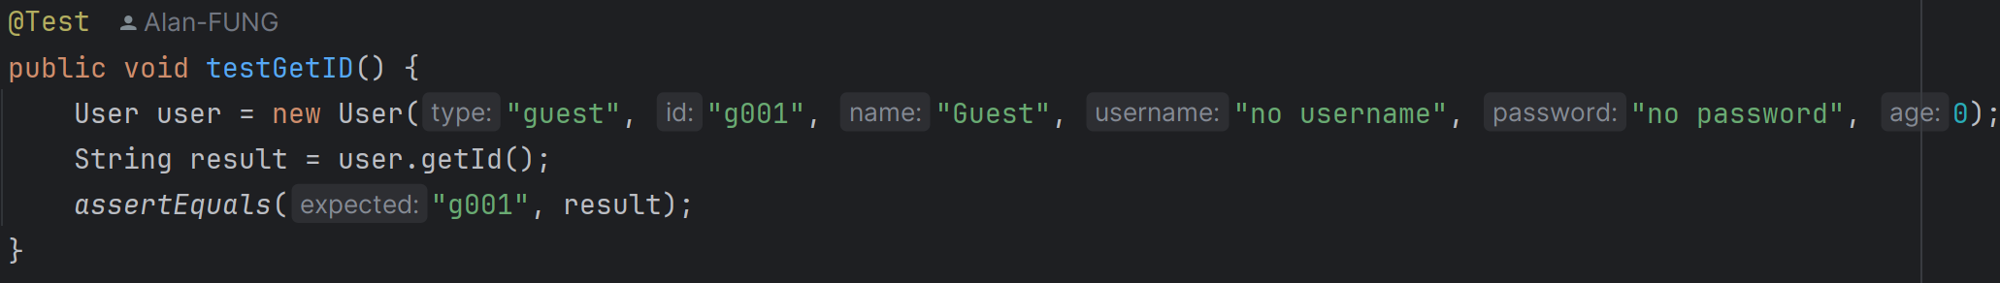

2. testGetID:

It verifies that the getId method returns the correct user ID.

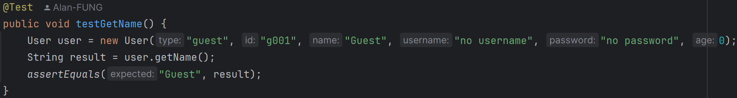

3. testGetName:

It verifies that the getName method returns the correct user name.

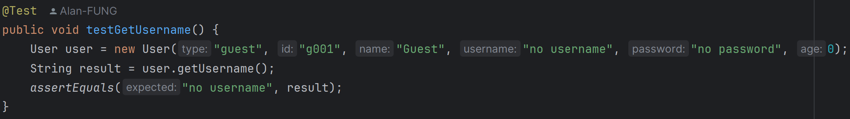

4. testGetUsername:

It verifies that the getUsername method returns the correct username.

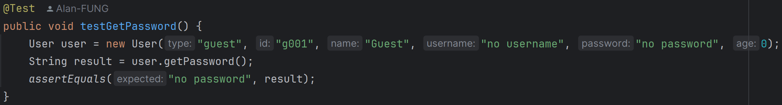

5. testGetPassword:

It verifies that the getPassword method returns the correct password.

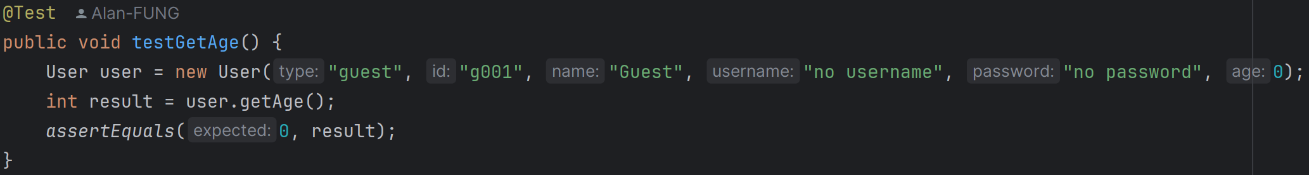

6. testGetAge:

It verifies that the getAge method returns the correct age.

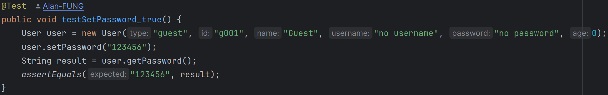

7. testSetPassword_true:

It verifies that the setPassword method correctly sets a new password.

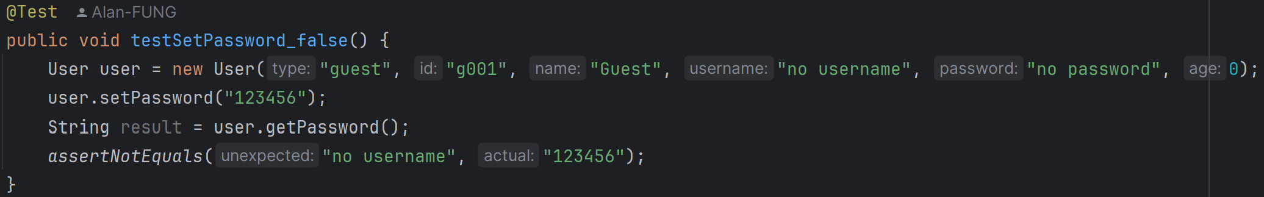

8. testSetPassword_false:

It verifies that the setPassword method does not incorrectly set a password.

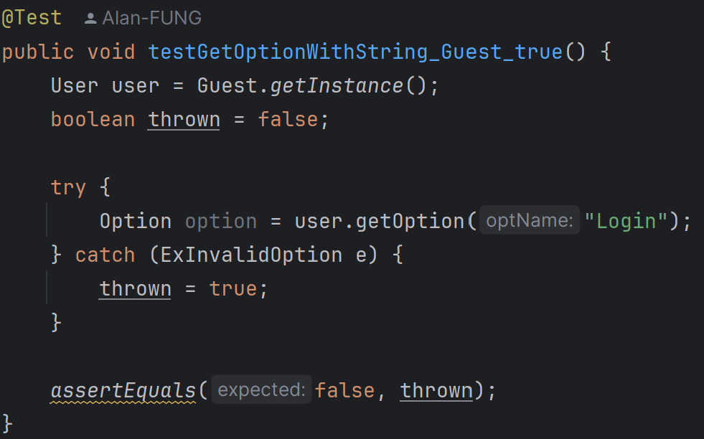

9. testGetOptionWithString_Guest_true:

It verifies that a Guest user can retrieve a valid option by name.

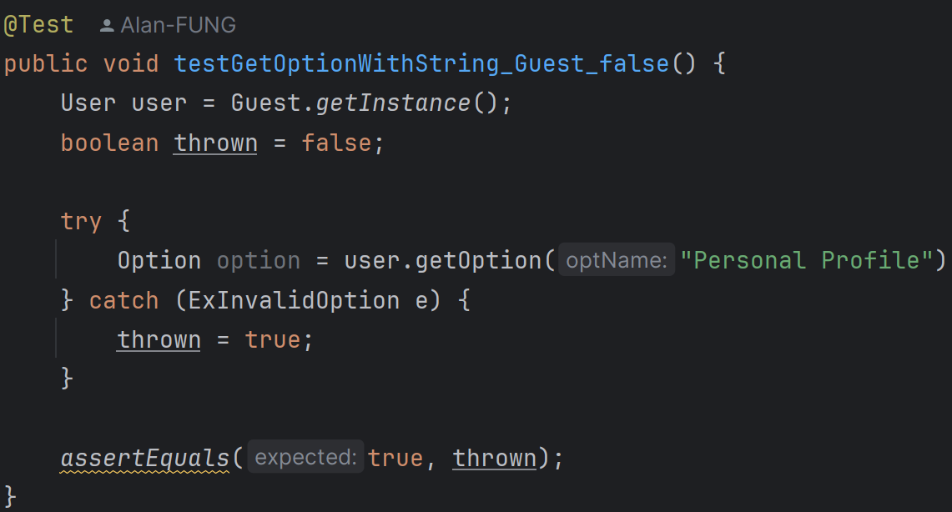

10. testGetOptionWithString_Guest_false:

It verifies that a Guest user cannot retrieve an invalid option by name.

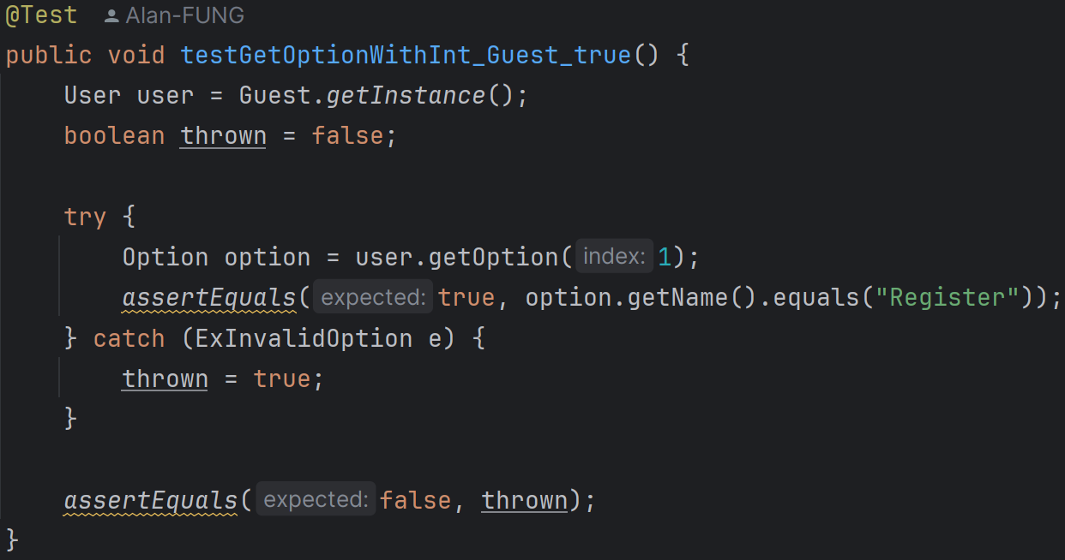

11. testGetOptionWithInt_Guest_true:

It verifies that a Guest user can retrieve a valid option by index.

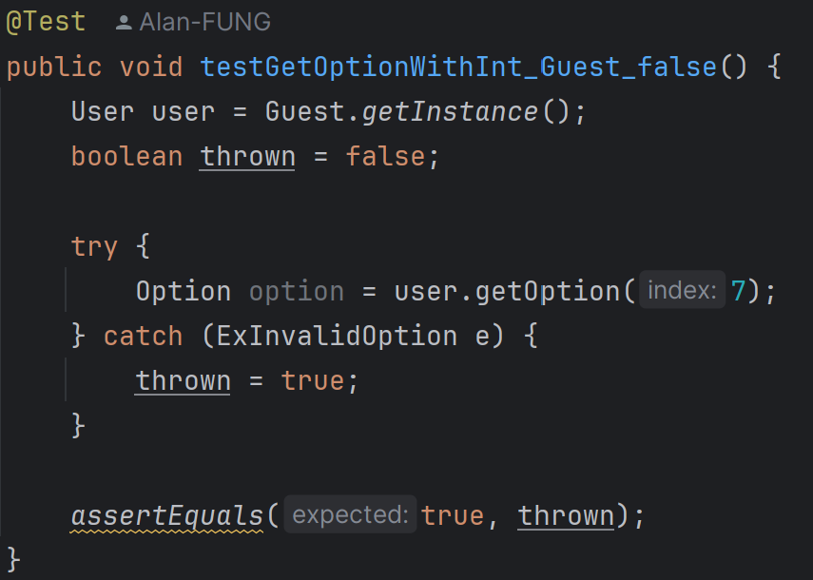

12. testGetOptionWithInt_Guest_false:

It verifies that a Guest user cannot retrieve an invalid option by index.

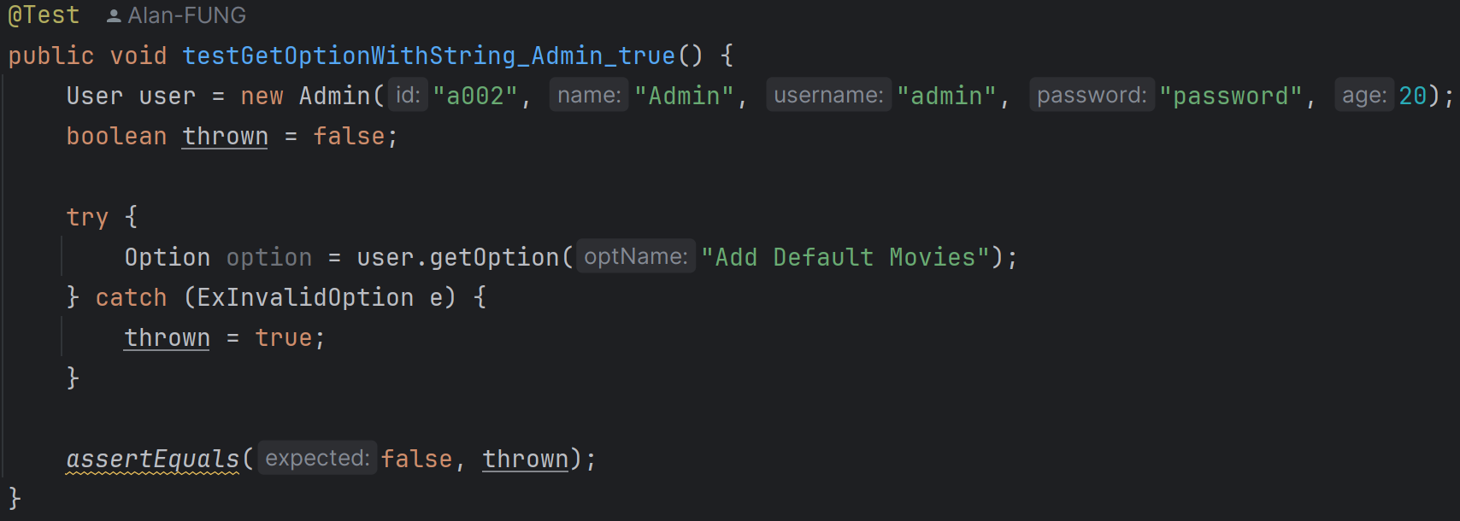

13. testGetOptionWithString_Admin_true:

It verifies that an Admin user can retrieve a valid option by name.

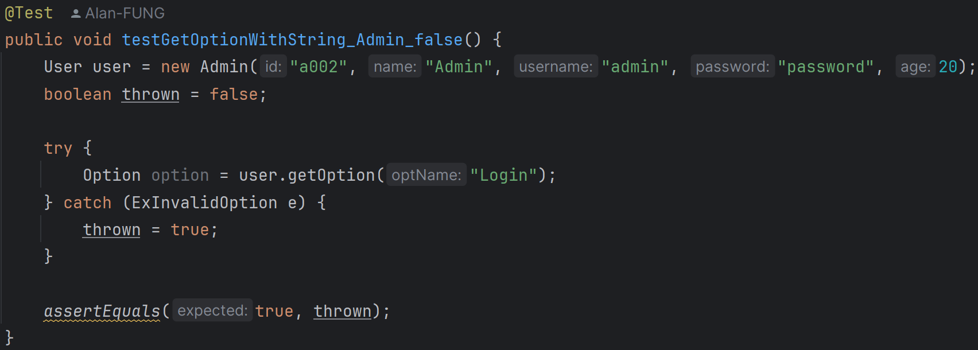

14. testGetOptionWithString_Admin_false:

It verifies that an Admin user cannot retrieve an invalid option by name.

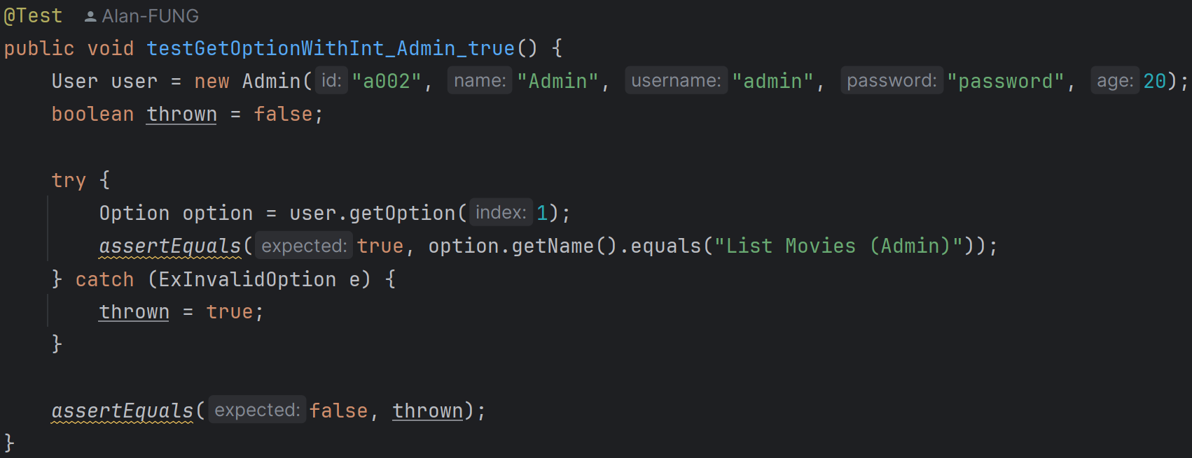

15. testGetOptionWithInt_Admin_true:

It verifies that an Admin user can retrieve a valid option by index.

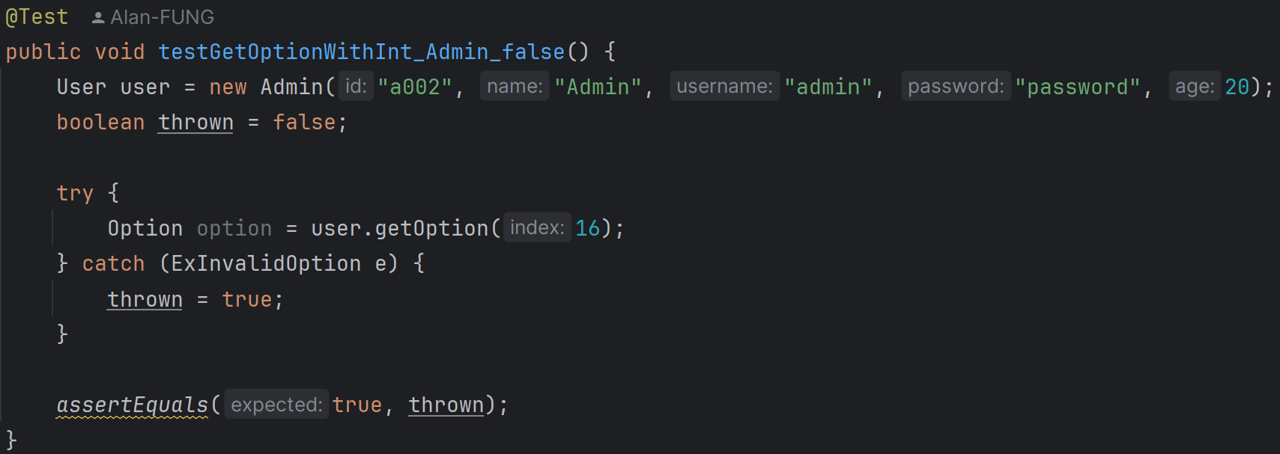

16. testGetOptionWithInt_Admin_false:

It verifies that an Admin user cannot retrieve an invalid option by index.

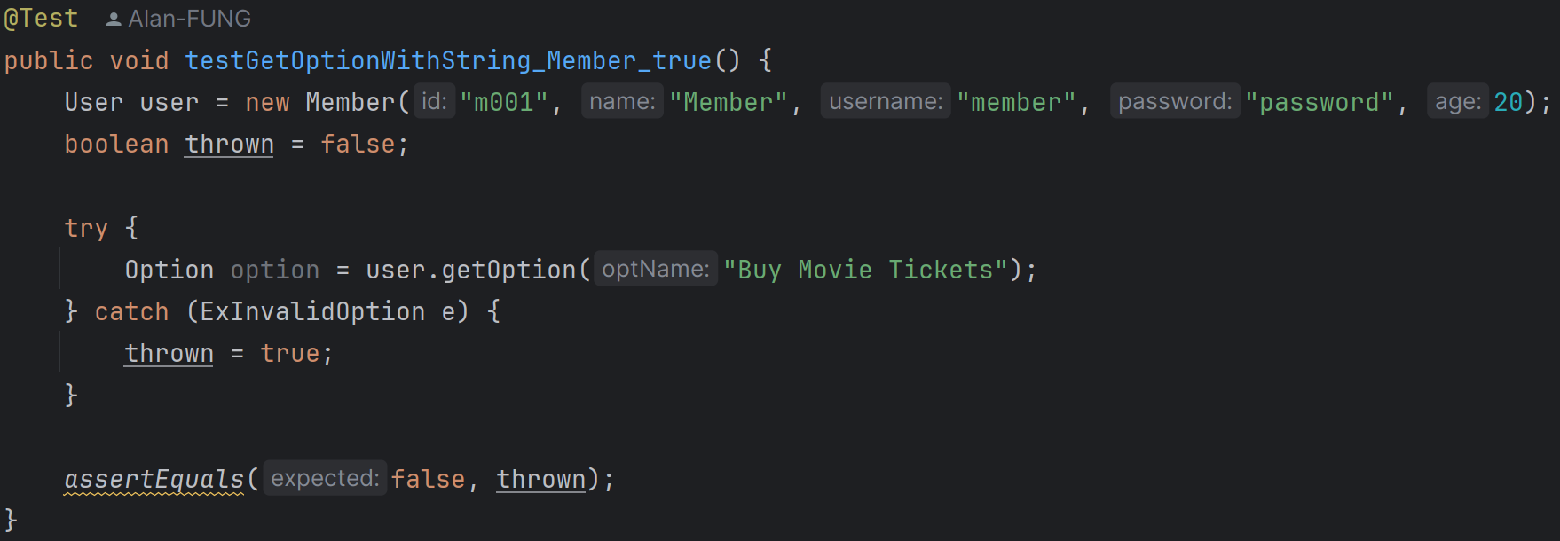

17. testGetOptionWithString_Member_true:

It verifies that a Member user can retrieve a valid option by name.

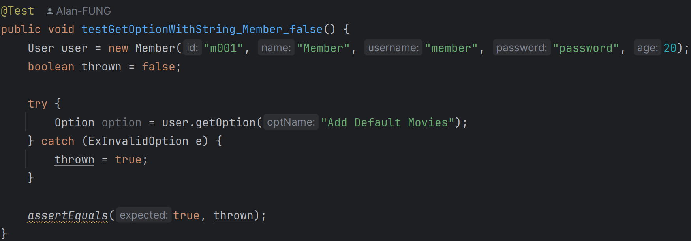

18. testGetOptionWithString_Member_false:

It verifies that a Member user cannot retrieve an invalid option by name.

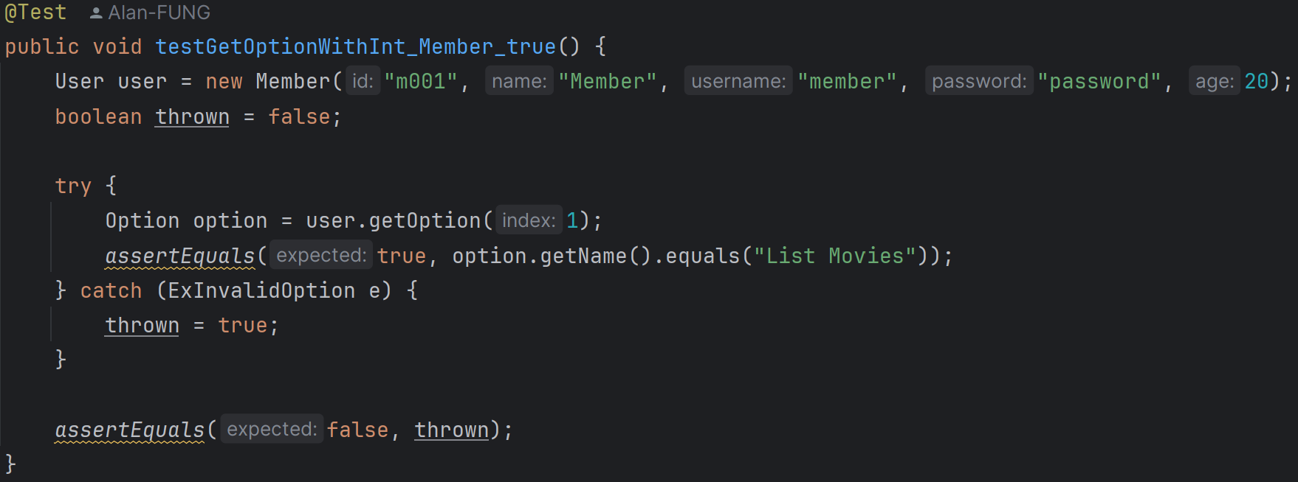

19. testGetOptionWithInt_Member_true:

It verifies that a Member user can retrieve a valid option by index.

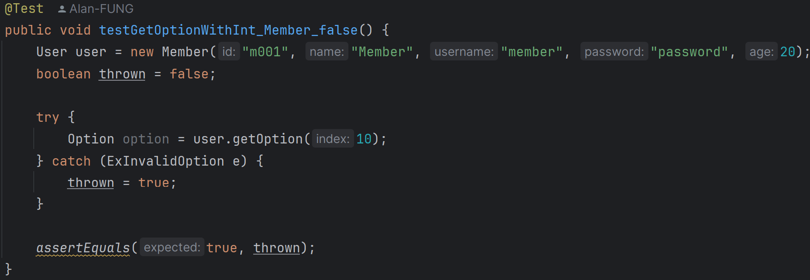

20. testGetOptionWithInt_Member_false:

It verifies that a Member user cannot retrieve an invalid option by index.

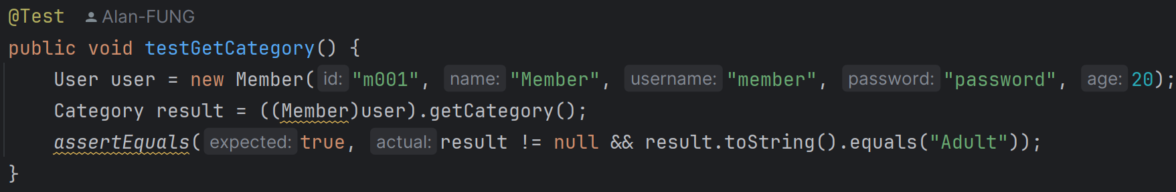

21. testGetCategory:

It verifies that a Member user can retrieve their category.

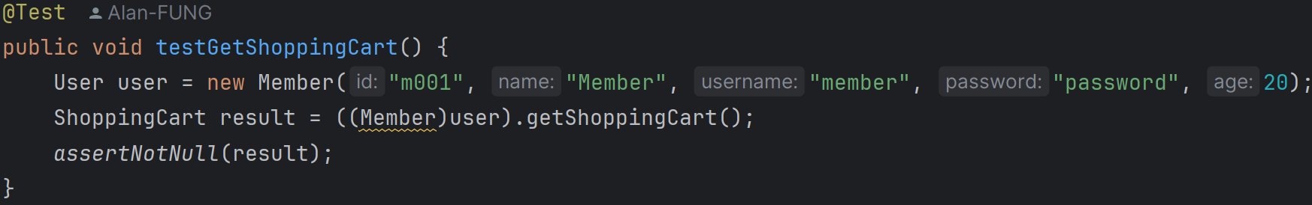

22. testGetShoppingCart:

It verifies that a Member user can retrieve their shopping cart.

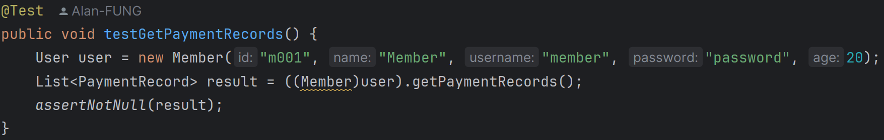

23. testGetPaymentRecords:

It verifies that a Member user can retrieve their payment records.

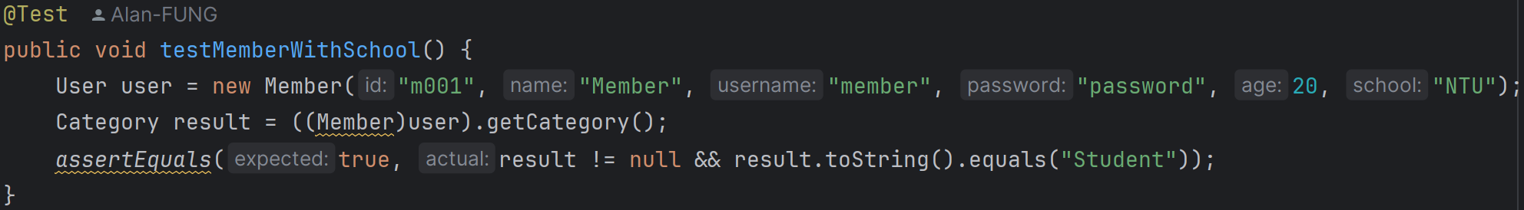

24. testMemberWithSchool:

It verifies that a Member user with a school can retrieve their category as "Student".